**Project Edulead**

**USER MANUAL**

**Procurement & Inventory System**



**Sustainable Outreach and Universal Leadership Limited**

#### 

**VERSION HISTORY**

|  |  |  |  |  |
| --- | --- | --- | --- | --- |
| **Date** | **Version No.** | **Created By** | **Updated Section** | **Updated By** |
| 28-09-2023 | Version 0.1 | Nehal Kumar |  |  |
|  |  |  |  |  |

**Content**

General Procedures 4

1. Item Group 15

2. Item 18

3. Item Price 23

4. Price List 26

5. Supplier 27

6. Supplier Group 30

7. Quality Inspection Template 30

8. Quality Inspection Parameter 31

9. Payment Term 31

10. Payment Terms Template 32

11. Unit of Measure (UoM) 33

12. Store Type 33

13. Store 33

14. Purchase Taxes and Charges Template 36

15. Item Wise Tax Category 37

16. Terms and Conditions 37

17. Tax Withholding Category 38

18. Purchase Requisition 39

19. Request for quotation 42

20. Supplier quotation 43

21. Purchase Order 45

22. Purchase Receipt 46

23. Purchase Invoice 48

24. Stock Entry 51

25. Stock Settings 54

26. Serial No 59

27. Batch 61

28. Assets 63

29. Location 66

30. Asset Category 67

31. Asset Movement 68

32. Asset Maintenance Team 69

33. Asset Maintenance 70

34. Asset Maintenance Log 72

35. Asset Repair 72

36. Asset Capitalization 74

37. Buying Settings 76

38. Procurement & Inventory Management Department Email 78

39. Stock Balance 79

40. Stock Ledger 80

41. Stock Summary 80

42. Price Impanelement Report 81

43. Asset Summary Report 82

44. L1 Vendor Selection 82

**General Procedures**

**General Procedures for a Save Screen**

**Create of New document**

1. Login in to the system
2. Go the required workspace, If user have more workspace

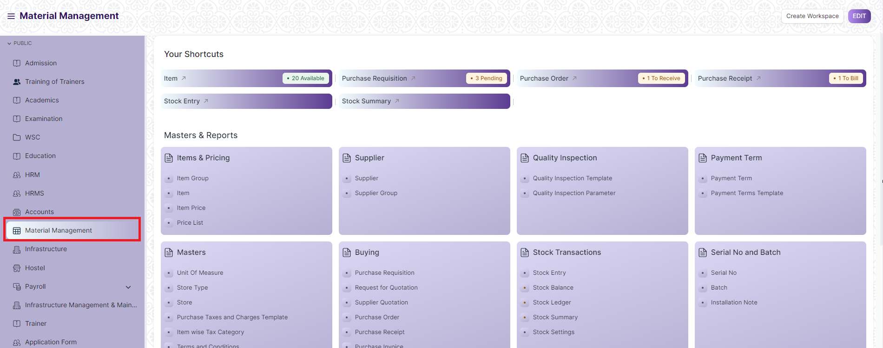

1. Go to the required screen.
2. Click on the ***“+Add Screen Name”*** button in the right corner of the screen.

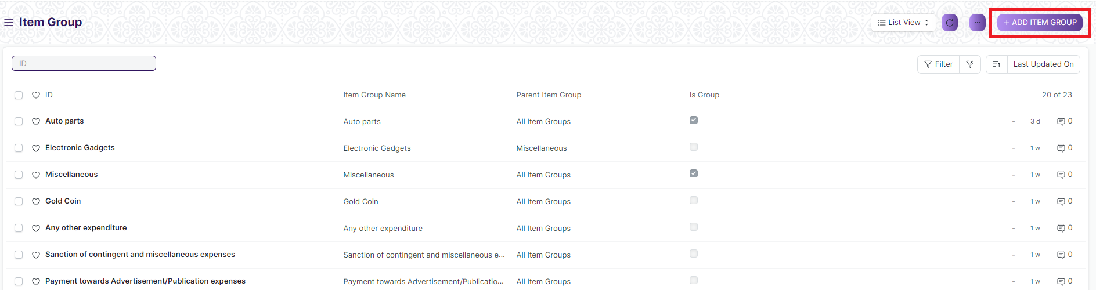

(Example : For addition in the new Item Group , click +Add Item Group button).

1. Enter the required data.
2. Click on “***Save”*.**
3. After saving , the record will be visible in the List View of the screen.

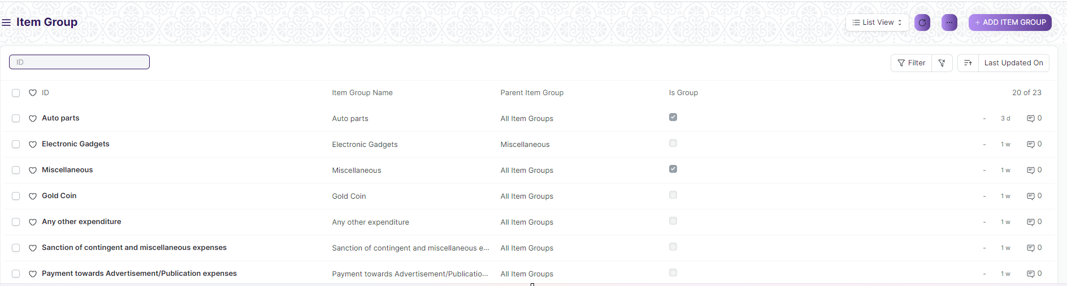

(Example : List view of saved Item Group)

**Note :** The process of creation can only be carried out by User who have necessary permission.Kindly refer to the Screen wise permission section in the document.

**View a Saved Document**

1. Log in to the system.
2. Go to the required workspace
3. Go to the required screen.
4. Click on the required document from the list view of the screen.

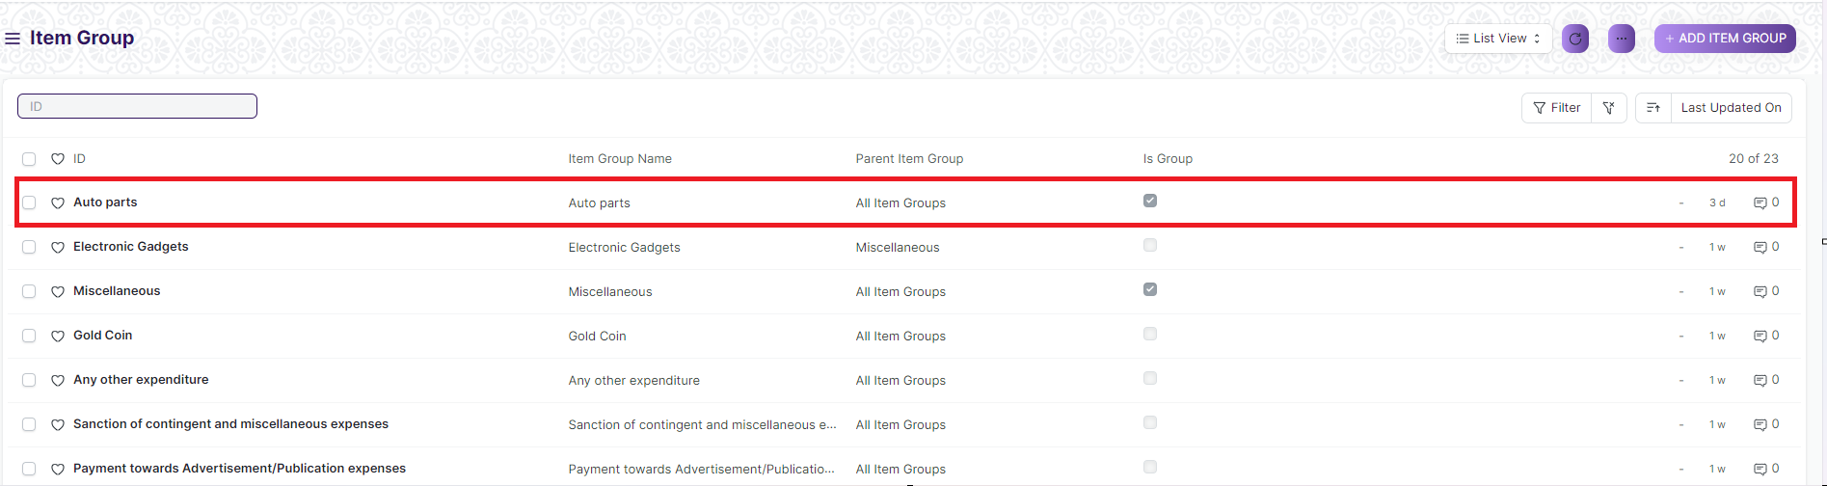

(Example : View of “Auto Parts” Document of Item Group Screen)

1. View the clicked document.

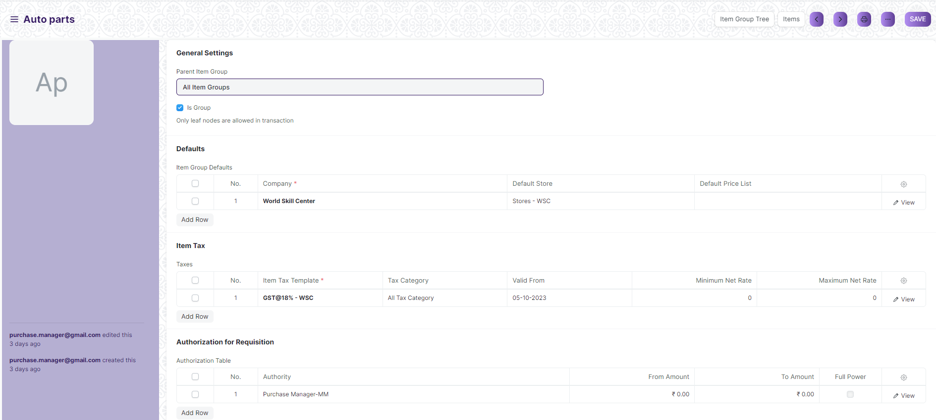

(Example : View of the “Auto Parts” Item Group)

**Note :** The process of view can only be carried out by user who have necessary permission.Kindly refer to the Screen wise permission section in the document.

**Delete a Saved Document**

1. Log in to the system
2. Go to the required workspace
3. Go to the required screen.
4. Click on the required document from the list view of the screen.
5. Click on the 3 dots in the right corner of the screen.
6. Click on *“****Delete”*.**

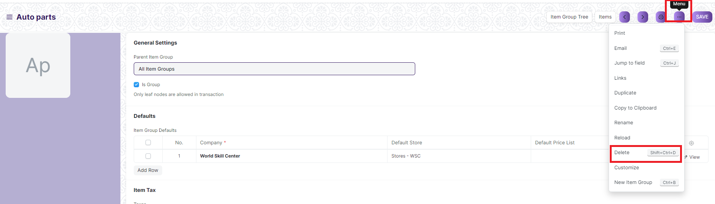

(Example : Deletion of “Auto Parts” document of Item Group)

1. Click yes if you want to delete the selected document.

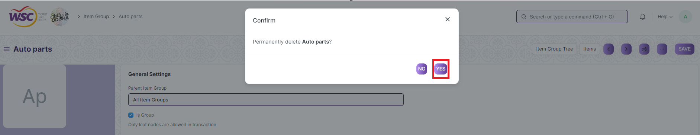

(Example : Clicking Yes to Delete permanently the document)

**Note :** The process of deletion can only be carried out by user who have necessary permission.Kindly refer to the Screen wise permission section in the document.

**Rename a Saved Document**

1. Login to the screen.
2. Go to the required workspace
3. Go to the required screen.
4. Click on the required document from the list view of the screen.
5. Click on the 3 dots in the right corner of the screen.
6. Click on *“****RENAME”*** .

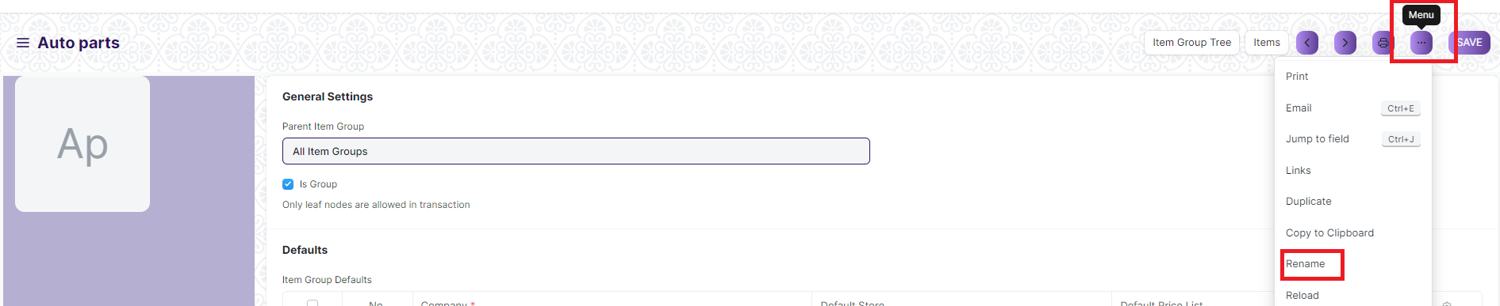

1. Click on *“****Rename”*** button to rename the document.

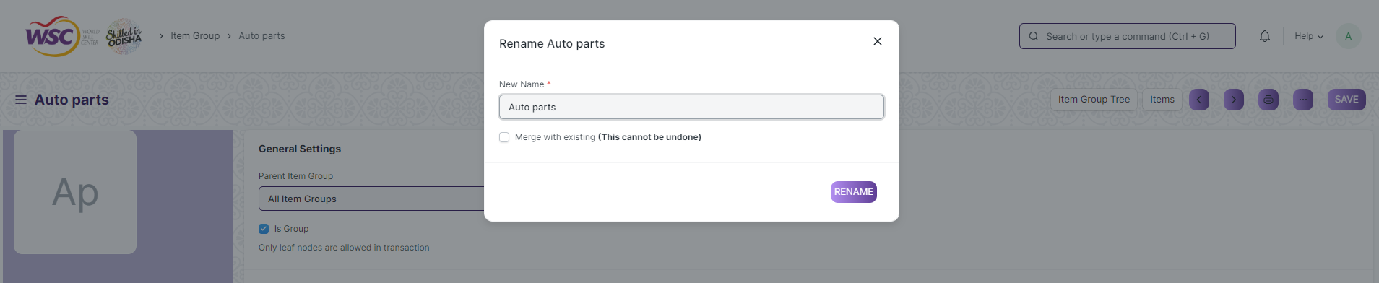

**Note :** The process of deletion can only be carried out by user who have necessary permission.Kindly refer to the Screen wise permission section in the document.

**Print a Saved Document type**

1. Login to the system
2. Go to the required workspace
3. Go to the required screen.
4. Click on a saved document in the screen.
5. Click on the print button present in the right corner of the screen.

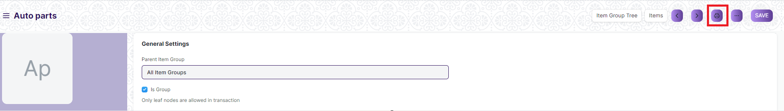

1. A new screen will open.
2. Click on the print button to Print the document.

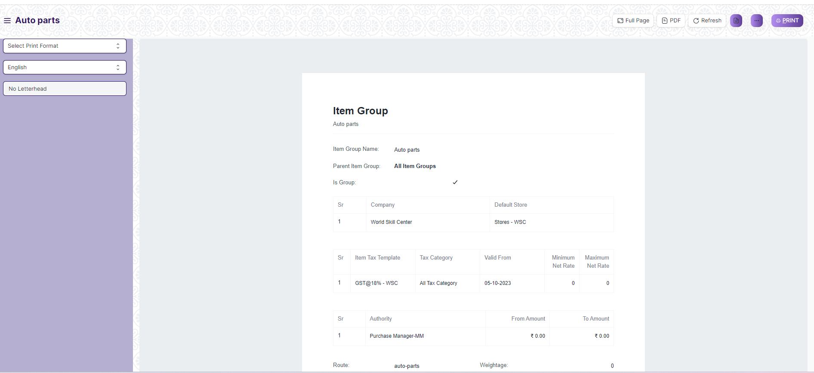

1. To download the employment type as PDF , click on the PDF button .

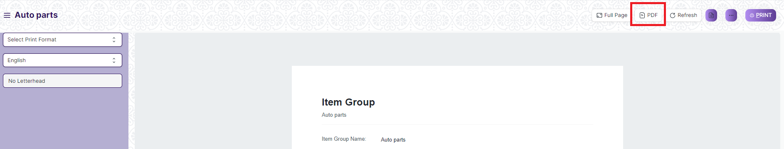

**Note :** The process of printing can only be carried out by user who have the necessary permission.

**View the saved document in different format.**

1. Login to the system
2. Go to the required workspace
3. Go to the required screen.
4. Click on the List View Button in the screen.

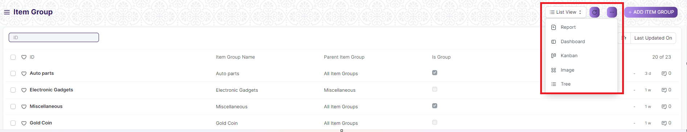

1. Select the appropriate view type that you want.

**Note :** The List view button can only be showed to the user who have necessary permission.

**View the saved documents by applying filters.**

1. Login to the screen.
2. Go to the required workspace.
3. Go to the required screen.
4. Click on the ***“Filter”***.

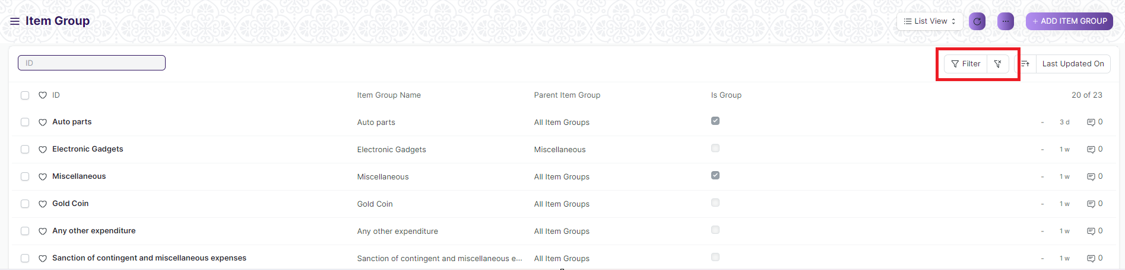

1. Select the field of the document based on which you wish to filter the records. All the fields in a form will be selectable in this list.

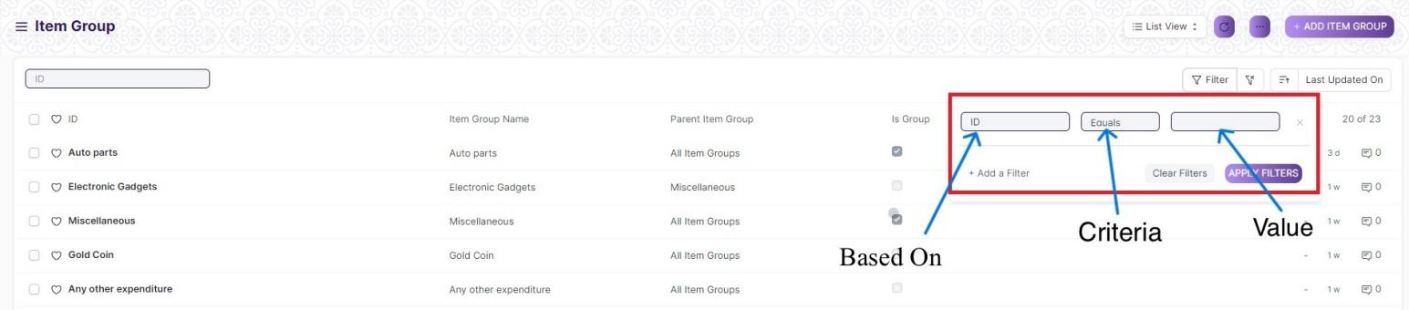

**Based On :** For the field, you will be required to put a value of the field. In the 'based on' field.

**Criteria :** You can define criteria based on which the system will search the document.The different conditions on which the filters are based are: Equals, Not Equal, Like, Not Like, In, Not In, =,>,< etc.

**Value :** Here, you will be required to enter the value for which you are running the document search.

**Some Examples of Viewing the documents in the list view after applying filters.**

Filter on Item Group screen where Is Group Equals to Yes. After clicking the Apply Filter button, all the filtered document will show in the screen.

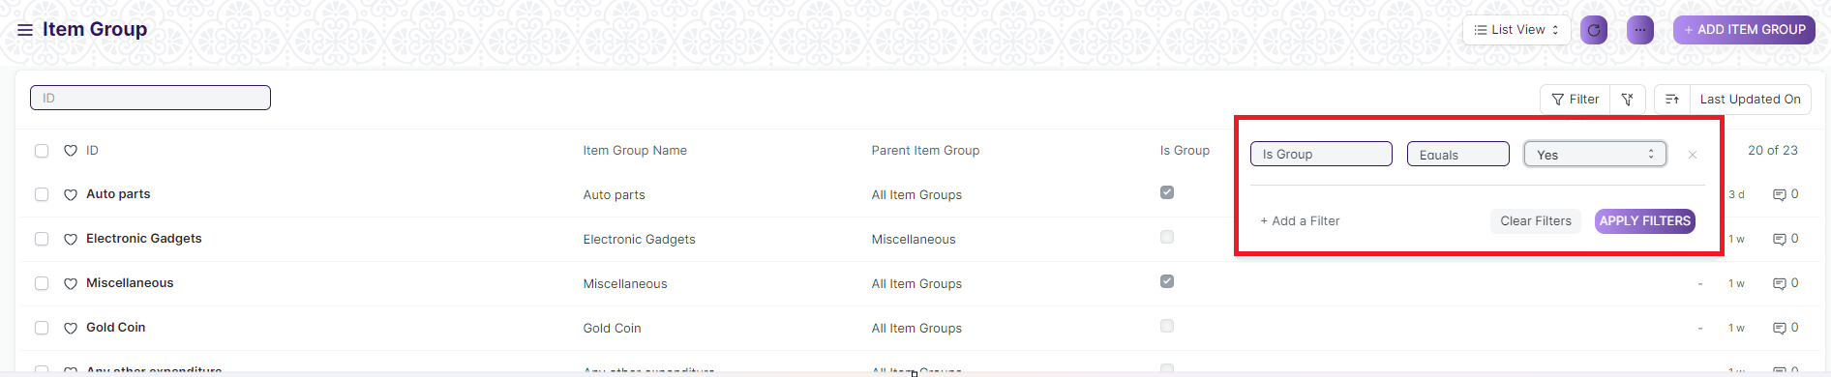

Filter on Item Group Screen where, the Item Group Name starts with ‘A’.

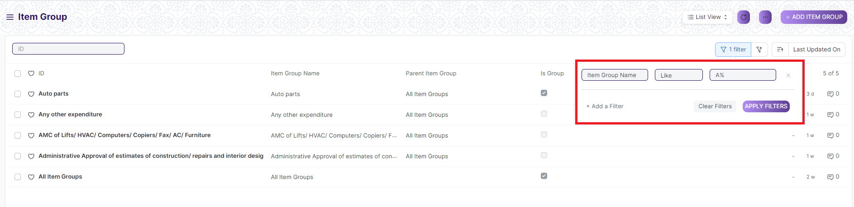

You can also apply multiple filters at a time. To remove a specific filter, just click on 'x' sign on it. To add another filter Click on the +Add a Filter button.

**Example of Multiple filter .**

Applying filter in the Item Group screen , where the Item Group Name starts with ‘A’. and Item Group screen where Is Group Equals to Yes.

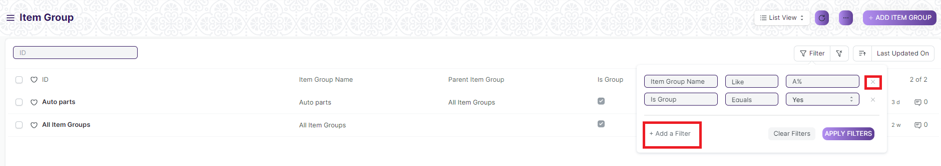

**Default Filters**

There are some filters present out of the box for the views which can be used for filtering the search results.

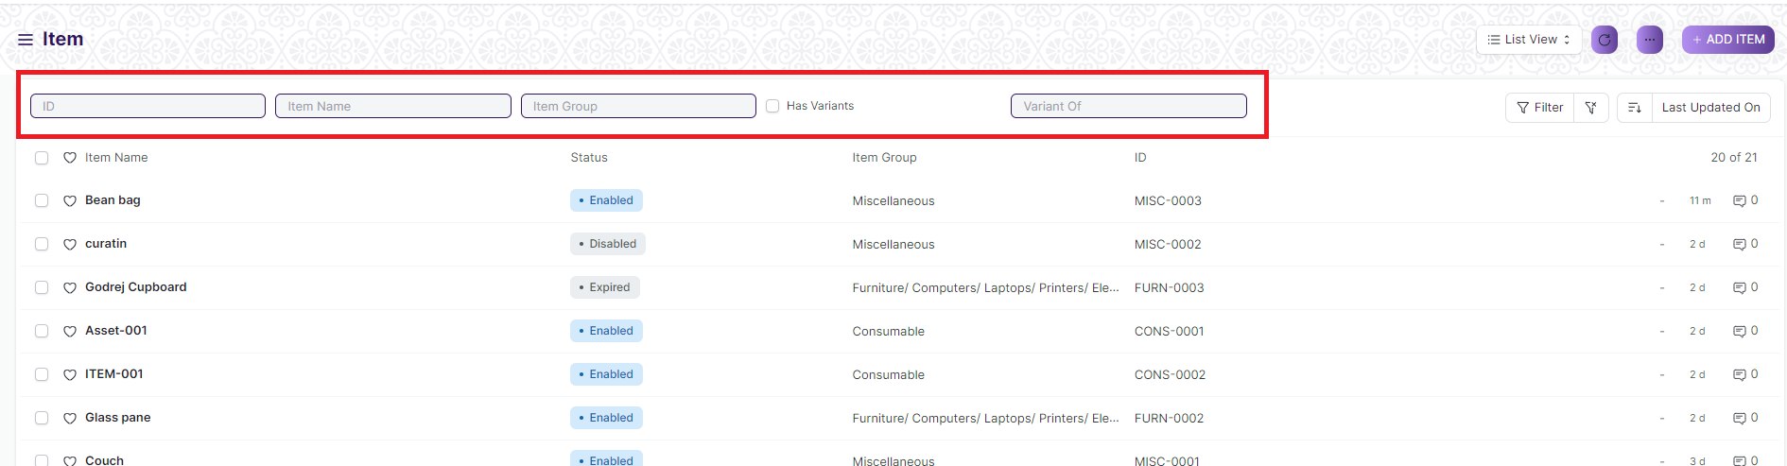

**Note :** The Filter Option can only be showed to the User who have necessary permission.

**General Procedure for a Submittable Screen**

**Create of New document**

1. Login in to the system
2. Go the required workspace
3. Go to the required screen.
4. Click on the ***“+Add Screen Name”*** button in the right corner of the screen.

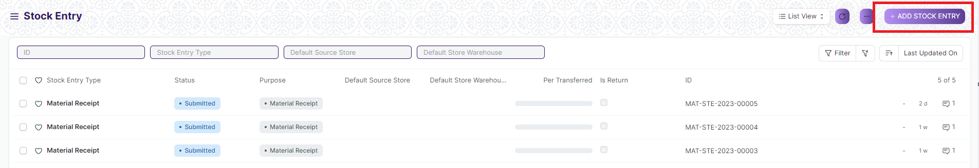

(Example : For addition in the new Stock Entry Type , click +Add Stock Entry button).

1. Enter the required information in the document.
2. Once you are finished entering the information , click the ***“Save”*** button.
3. After saving it , a submit button will appear.

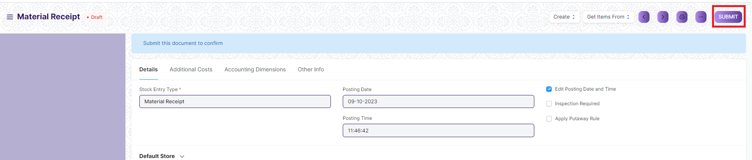

1. Click on the **“Submit”** button.
2. A confirmation dialog box will appear . Click the Yes button to submit the document.

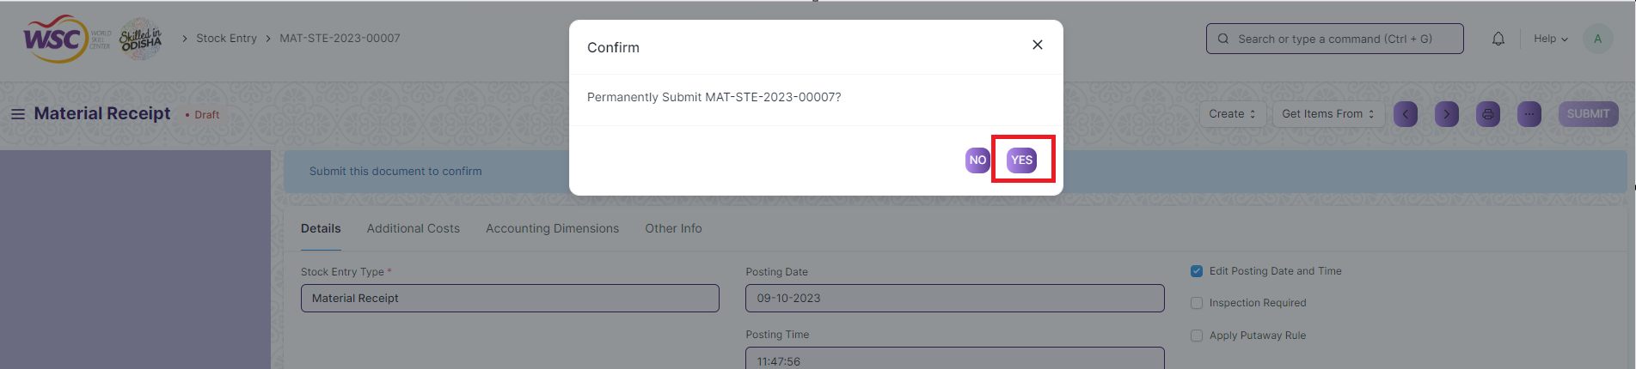

1. After submitting , the record will be visible in the List View of the screen.

**Note :** The process of creation can only be carried out by user who have necessary permission.Kindly refer to the Screen wise permission section in the document.

**Cancel a Submitted Document**

1. Log in to the system.
2. Go to the required workspace
3. Go to the required screen.
4. Click on the required document from the list view of the screen.
5. Click the ***“Cancel”*** Button .

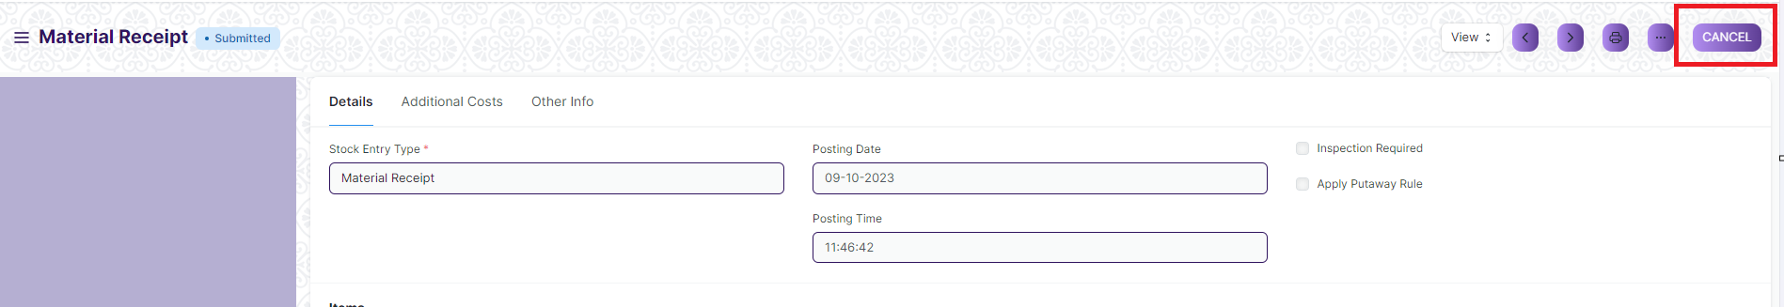

1. A confirmation dialog box will appear . Click the Yes button to cancel the document.

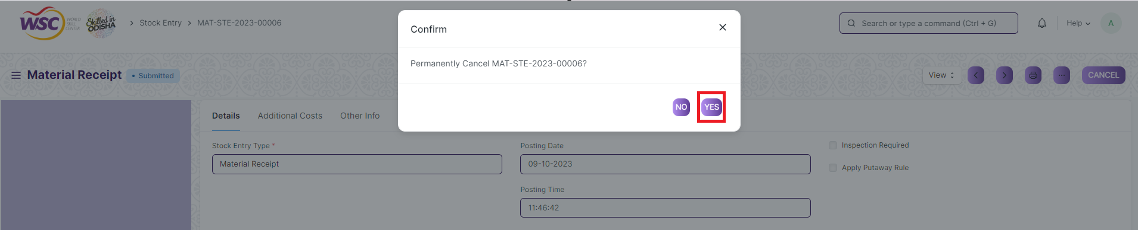

**Note :** The process of cancellation can only be carried out by user who have necessary permission. Kindly refer to the Screen wise permission section in the document.

**Amend a Submittable Document**

1. Log in to the system.
2. Go to the required workspace
3. Go to the required screen.
4. Click on the required document from the list view of the screen.
5. After cancellation of the document , an Amend button will appear on the screen.

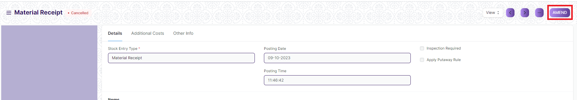

1. Click the “***Amend”*** button.
2. A new document will be created with the same information as the original document .

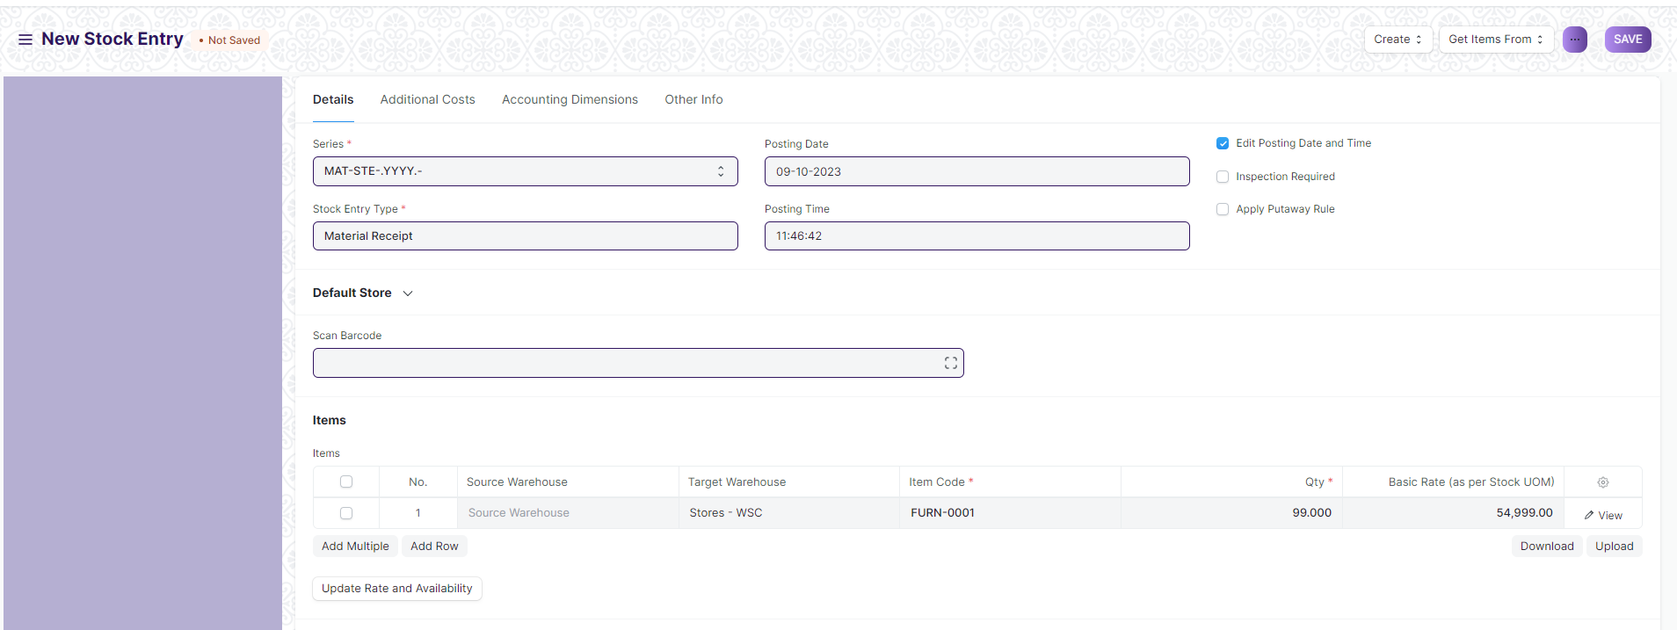

1. You can now make changes to the document as needed.

**Note :** The process of Amend can only be carried out by user who have necessary permission.Kindly refer to the Screen wise permission section in the document.

**Action Menu on a document.**

The three dots menu, located in the right corner of a document in a Screen , offers a range of actions and options to manage and interact with the document.

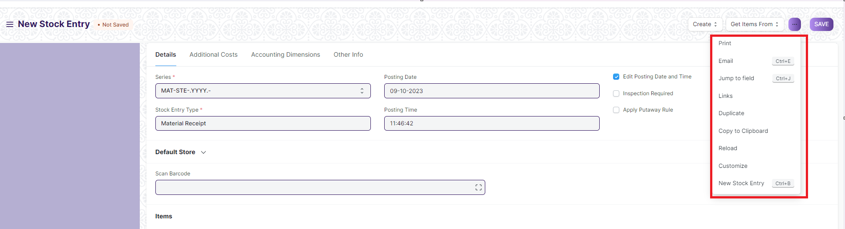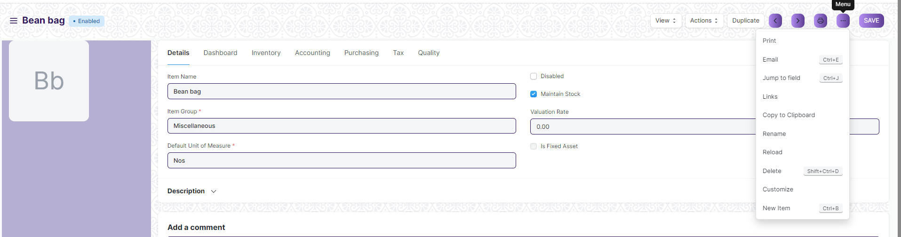

The functionalities available in the three dots menu are given below .

**Print :** Print Enables you to generate a printable version of the document ., which you can save as a PDF or send to a printer.

**Email :** Click on Email allows you to send the document as an attachment via email to specified recipients.

**Duplicate :** Create a new document with the same information as the current one.

**Delete :** Permanently remove the document.

**Cancel :** Cancel the submitted document.

**Submit :** Submit the document . If the document is submittable.

**Links :** This Option displays a list of document that are linked to the current document. You can navigate these linked documents from here.

**Jump to field :** You can directly go the required field by clicking this option and giving appropriate field name.

**Copy to Clipboard :** By clicking this option you can copy the content of the document .

**Rename :** By clicking the Rename option you can Rename the document.

**Note :** These options will be visible to User who have necessary permission.

### Item Group

An Item Group is a way to classify items based on types.

Depending on the type of product, you can categorize an item under its respective field. If the product is service-oriented, assign it under the Item Group - service. If the product is used as a raw-material, assign it under the Raw Material category. In case, an item is used only in trading, you can categorize it under an Item Group called Trading.

To access the Item Group list, go to:

Home > Material Management > Items and Pricing > Item Group

This is what the Item Group tree Looks Like (Demo Data):

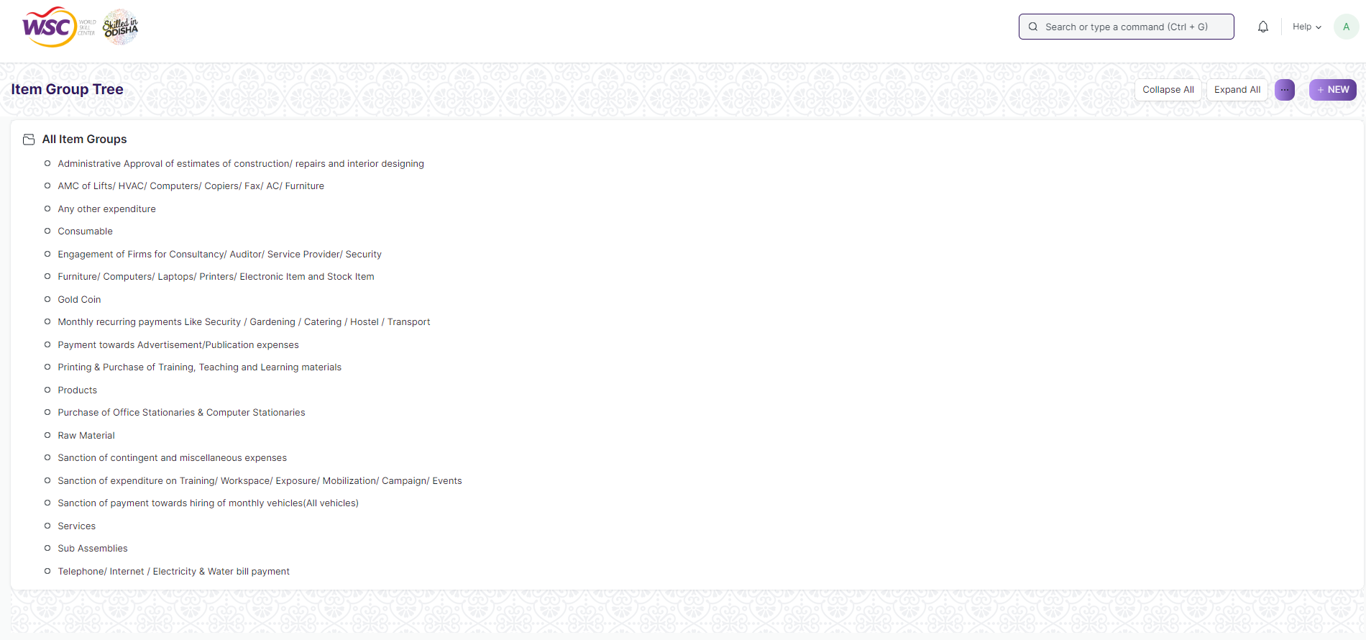

#### 1.1 How to create an Item Group

1. Go to the Item Group list, click on New.
2. Select a group node under which you wish to create the Item Group, the default root is 'All Item Groups'.
3. Select 'Add Child' or click on the New button.
4. To make this child a category/group node, tick on Group Node/Is Group.
5. Click on Create New.

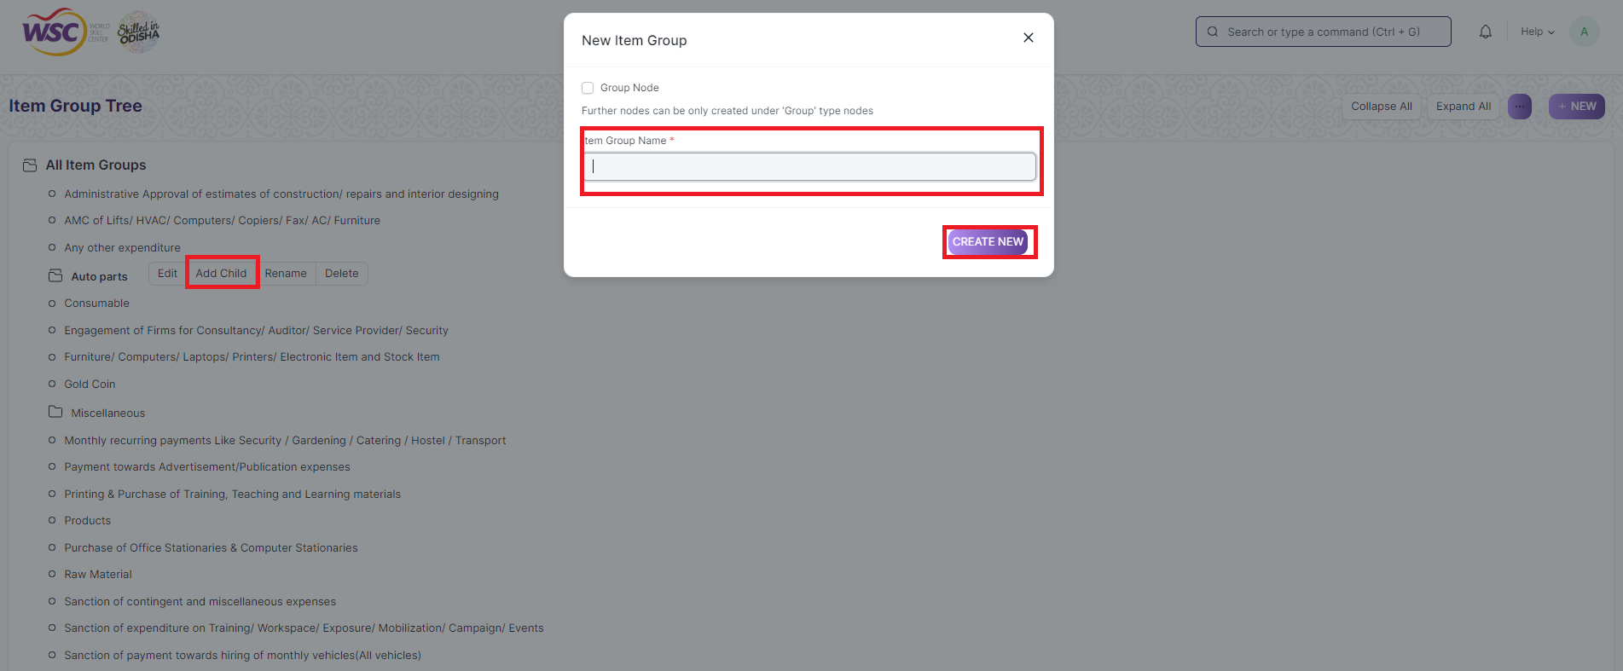

#### 1.2 Delete an Item Group

1. Select the Item Group you want to delete.
2. Select 'Delete'.
3. Click on Yes.

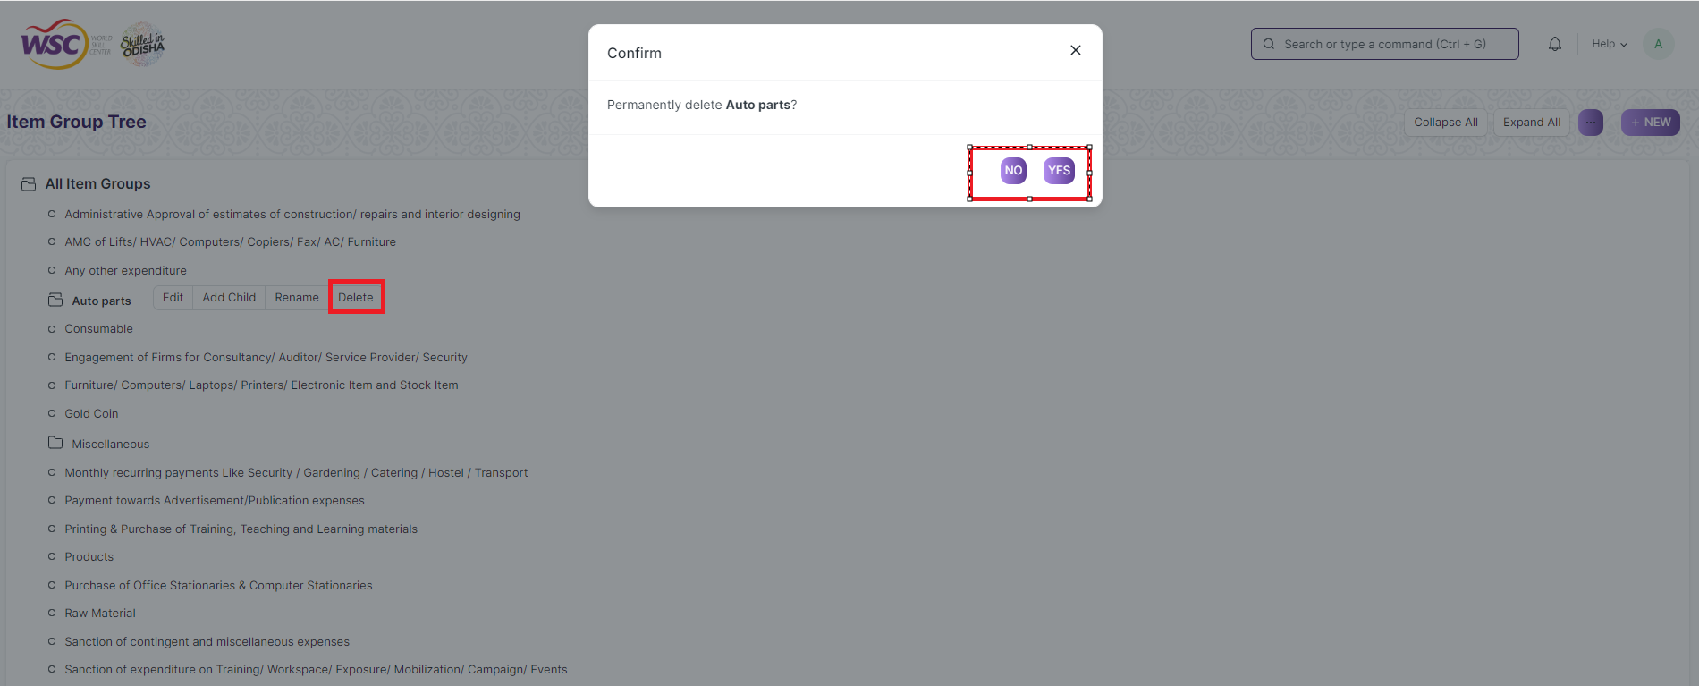

#### 1.3 Parent Item Group

You can change the parent Item Group of an item by choosing another one under General Settings.

#### 1.4 Defaults

* Default Price List: A default price list that'll determine the Item Prices for this Item Group.
* Default Store: Default Store set in transactions for the items that belong to this group.
* Default Buying/Selling Cost Center: The default Buying/Selling Cost Center to which items in this group will be billed against.
* Default Expense/Income Account: The default accounts for items that belong to this group.
* Default Supplier: On setting a supplier here, this supplier will be chosen in purchase transactions by default for items in this group.

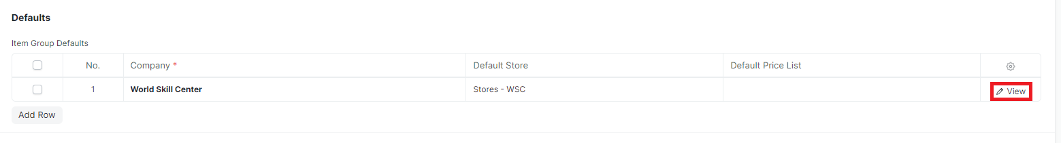

**Note** : Click view to fill all default data

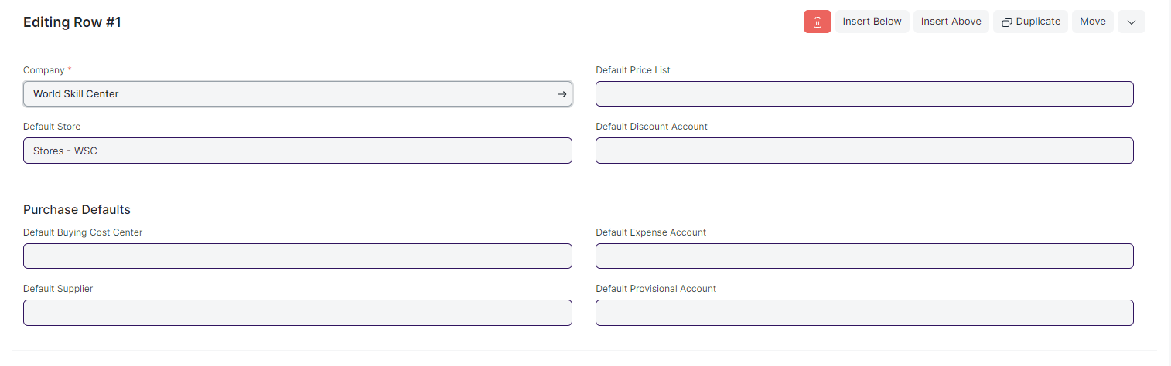

#### 1.5 Item Tax

A default item tax template will be applied to all items belonging to this group.

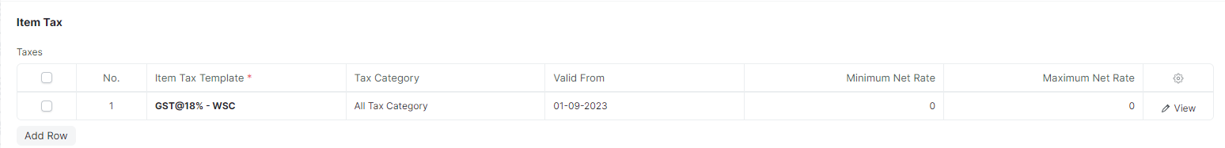

#### 1.6 Authorization for Requisition

In Authorization Table user will assign Authority. On the basis of this Authority will approve Purchase Requisition item.

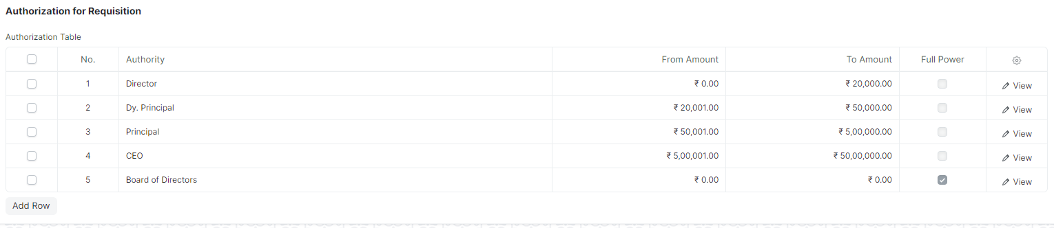

### Item

An Item is a product or a service offered by your company.

The term Item is also applicable to raw materials or components of products yet to be produced (before they can be sold to customers). It allows you to manage all sorts of items, like raw-materials, sub-assemblies, finished goods, item variants, and service items.

It is optimized for itemized management of your sales and purchase. If you are in services, you can create an Item for each service that you offer. Completing the Item Master is very essential for the successful implementation.

To access the Item list, go to:

Home > Material Management > Items and Pricing > Item

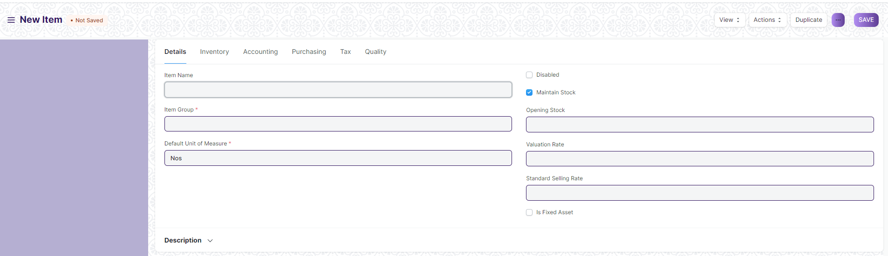

#### 2.1 Prerequisites

Before creating and using an Item, it is advised that you create the following first:

* Item Group
* Store
* A Unit of Measure if required

#### 2.2 How to create an Item

1. Go to the Item list, click on new.
2. Select an Item Group.
3. On the basis of item group Item Code and Item Name Will will auto-fill, You can change Item Name but not Item code.
4. Enter the opening stock units and standard selling rate.

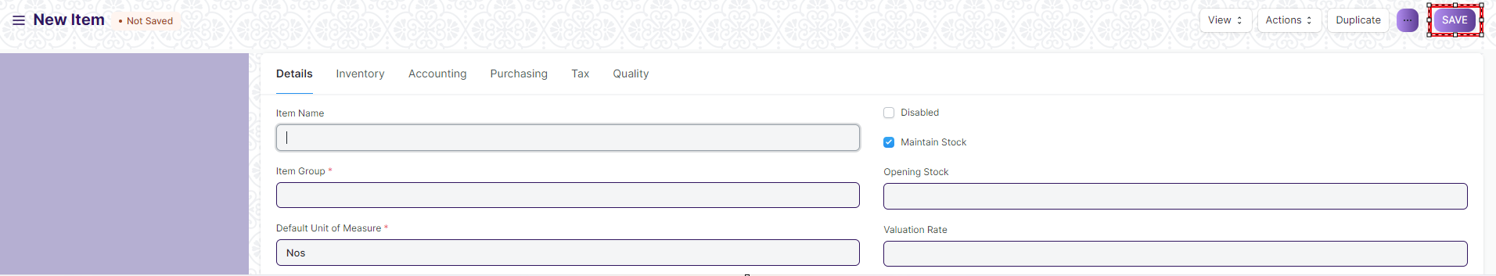

1. Click on Save.

#### 2.3 Item Properties

* Item Name: Item name is the actual name of your product or service.
* Item Code: Item Code is a short-form to denote your Item. This helps new users to recognize and update Item details in all transactions.
* Item Group: Item Group is used to categorize an Item under various criteria like products, raw materials, services, sub-assemblies, consumables or all Item groups. Create your default Item Group list under Item Group and pre-select the option while filling your New Item details under Item Group. Item groups can be sub- assemblies, raw materials, etc, or based on your business use case.
* Default Unit of Measure: This is the default measuring unit that you will use for your product. It could be Nos, Kgs, Meters, etc. You can store all the UOMs that your product will require under Set Up> Master Data > UOM. These can be pre-selected while filling New Item by using % sign to get a pop up of the UOM list. Visit the UoM page for more details

#### 2.4 Options when creating an item

* Disabled: If you disable an Item, it cannot be selected in any transaction.
* Maintain Stock: If you are maintaining stock of this Item in your Inventory, It will make a stock ledger entry for each transaction of this item. Ensure to keep this option unchecked when creating a non-stock Item (make to order/engineer) or a service.
* Standard Selling Rate: When *creating* an Item, entering a value for this field will automatically create an Item Price at the back-end. Entering a value after the Item has been saved will not work. In this case, the Item Price is created from any transactions with the Item. The rate at which you'll sell the item. This will be fetched in Sales Orders and Sales Invoices.
* Is Fixed Asset: Tick this checkbox if this item is a company Asset.
* Auto Create Assets on Purchase: If Item is a Company Asset, tick this checkbox if you want to auto create assets while purchasing this item through Purchase Cycle.
* Allowance Percentage: This option will be available only when you create and save the item. This is the percent by which you will be allowed to over-bill or over-deliver this Item. If not set, it will select from Stock Settings.
* Uploading an Image: To upload an image for your icon that will appear in all transactions, save the partially filled form. Only after your file is saved the 'Change' button will appear on the Image icon. Click on Change, then click on Upload, and upload the image.

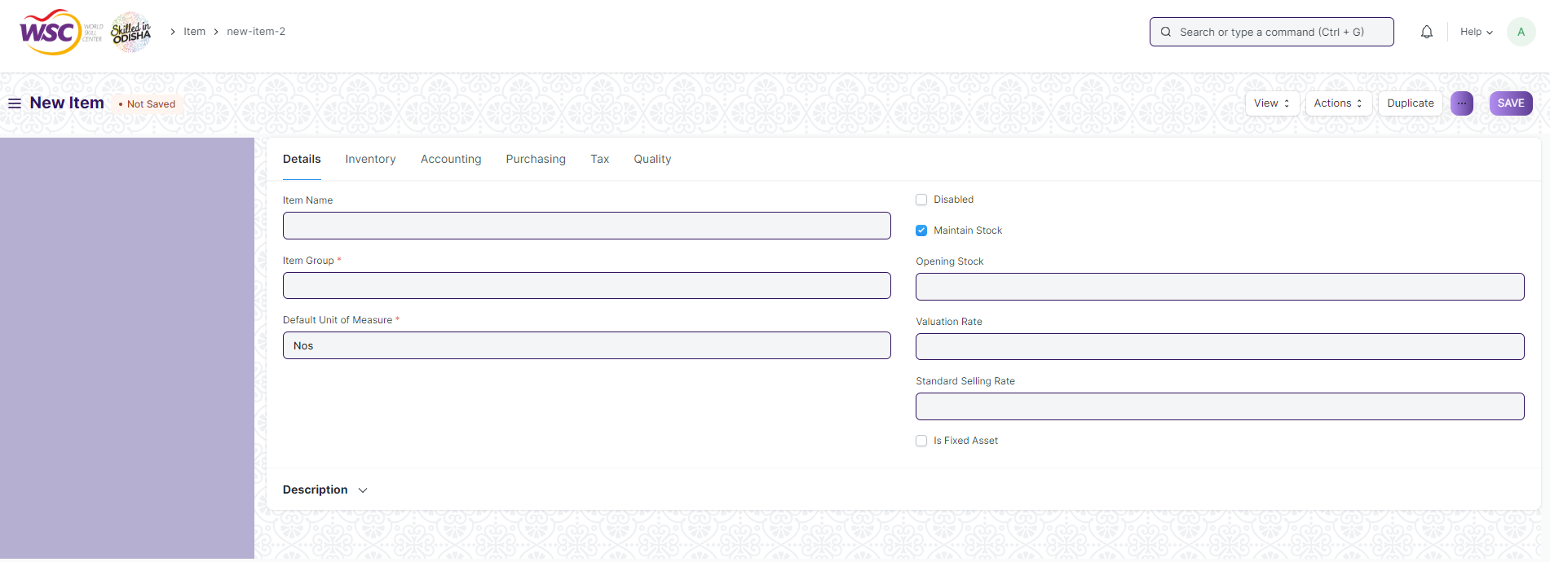

#### 2.5 Features

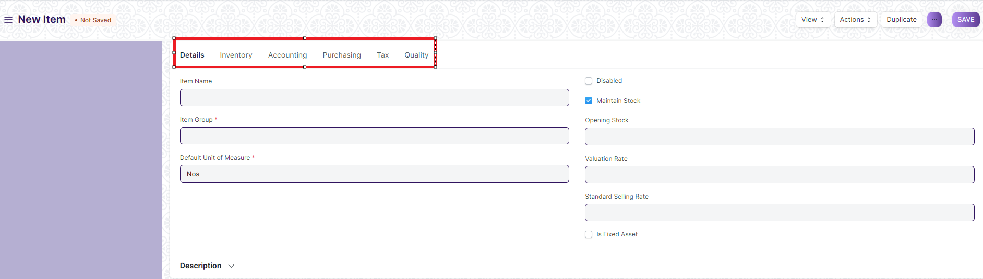

**Note**: Use Tab break to fill all type of data

**2.5.1 Description**

* Description: Description of the item. The text from the Item Code will be fetched by default.

#### 2.5.2 Inventory

* Shelf Life In Days: This is for a product Batch. The number of days after which product batch will be unusable. For example, medicines.
* End of Life: For a single item/product, the date after which it'll be completely unusable. That is, the item will be unusable in transactions and manufacturing. For example, you're using plastic crystals for manufacturing Items for the next 5 years after which you want to use plastic beads.
* Warranty: To track a warranty period, it is necessary that the Item is serialized. When this Item is delivered, the delivery date and the expiry period is saved in the Serial Number master. Through the serial number master, you can track the warranty status.

A warranty period is a time period in which a purchased product may be returned or exchanged.

* Weight UOM: The Unit of Measure for the item. This can be Nos, Kilo, etc. The Weight UoM which you use internally can be different from the purchase UoM.
* Weight Per Unit: The actual weight per unit of the item. Eg: 1 kilo biscuits or 10 biscuits per pack.
* Default Material Request Type: When you create a new Purchase Requisition for this item, the field set here will be selected by default in the new Purchase Requisition. This is also known as an 'indent'.
* Valuation Method: Select the Valuation Method whether FIFO or Moving Average.

#### 2.5.3 Multiple Units of Measure

You can add alternate UoMs for an Item. If the default UoM in which you sell is numbers (NoS) but you receive it in Kilos, you can set an additional UoM with an appropriate conversion factor. For example, 500 Nos of screws = 1 Kilogram, so select Kilogram/Litre as UOM and set the conversion factor as 500.

##### 2.5.4 Serial Numbers

With Serial Numbers, you can track warranty and returns. In case any individual Item is recalled by the supplier the number system helps to track individual Item. The numbering system also manages expiry dates.

Please note that if you sell your items in thousands, and if the items are very small like pens or erasers, you need not serialize them.

In EduLead, you will have to mention the Serial Number in some accounting entries. If your product is not a big consumer durable Item, if it has no warranty and has no chances of being recalled, avoid giving serial numbers.

##### 2.5.5 Batches

A set of Items can be manufactured in batches. This is useful for moving the batch and associate an expiry date with a certain batch.

* Has Batch No: Options for batch number, expiry date, and retaining sample stock will be revealed on ticking this checkbox. You cannot activate this if there is any pre-existing transaction for this item. If this is disabled, you'll have to enter the serial numbers manually for every transaction.
* Batch Number Series: Prefix that'll be applied to batch numbers. If you set 5x1SCR, then the first batch will be named like 5x1SCR00001 on first transaction/manufacture.
* Automatically Create New Batch: If the batch number is not mentioned in transactions, then they will be automatically created according to a format like AAAA.00001. If you always want to manually create a batch number for this item, leave this field blank. This setting will override 'Naming Series Prefix' in Stock Settings. Batch numbers can be set to be generated automatically if you manufacture the Items or can be entered manually if it comes from an external manufacturer.
* Has Expiry Date: If you tick this, the batch number will be created according to the expiry date. The expiry dates can be set in the 'Batch' master.
* Retain Sample: To retain a minimum number of sample stock of the item. You need to set a Sample Retention Store in Stock Settings for this.
* Has Serial No: This is similar to Batch Number Series; it'll be created when you make transactions/manufacture. If you set Serial Number Series as AA, then on the first transaction a serial number like AA00001 will be created.

Tip: While entering an Item Code in an Items table, if the table requires inventory details, then depending on whether the entered item is batched or serialized, you can enter serial or batch numbers right away in a pop-up dialog.

Note: Once you mark an item as serialized or batched or neither, you cannot change it after you have made a Stock Entry.

**2.5.6 Item Defaults**

In this section, you can define Company-wide transaction-related defaults for this Item.

* Default Store: This is the Store that is automatically selected in your transactions with this item.
* Default Price List: Whether Standard Selling or Standard Buying. Likewise, you can also set the purchasing and selling default accounts
* Supplier: If a default supplier is set, this supplier will be selected for new purchase transactions.
* Default Expense Account: It is the account in which cost of the Item will be debited.
* Default Income Account: It is the account in which income from selling the Item will be credited.
* Default Cost Center: It is used for tracking expense for this Item.

Tip: You can add more rows for multiple companies.

##### 2.5.7 Purchase Details

* Default Purchase Unit of Measure: The default UoM that will be used in Purchase transactions.
* Minimum Order Qty: The minimum quantity required for purchase transactions like Purchase Orders. If set, the system will not let you proceed with the purchase transaction if the item quantity in the purchase transaction is lesser than the quantity set in this field.
* Safety Stock: “Safety Stock” is used in the report “Item wise Recommended Reorder Level”. Based on Safety Stock, average daily consumption and the lead time, the system suggests Reorder Level of an item. Reorder Level = Safety Stock + (Average Daily Consumption * Lead Time)
* Last Purchase Rate: The rate at which you last purchased this item using a Purchase Invoice will be displayed here.
* Allow Purchase: If un-ticked, you won't be able to use this item in purchase transactions.

##### 2.5.8 Supplier Details

* Delivered by Supplier (Drop Ship): If the item is delivered directly by the supplier to the customer, tick this checkbox. Read more here.
* Supplier Codes: Track Item Code defined by the Suppliers for this Item. In the Purchase transactions, on selecting an Item, a Supplier Part No. will be fetched as well for the Supplier's reference. You can read more about it here.

##### 2.5.9 Foreign Trade Details

If you're sourcing the item from another country, you can set the details here.

* Country of Origin: The country from which you're sourcing the item.
* Customs Tariff Number: You can create a customs tariff number with a description and use it for reference here to share with custom agencies. Later it can be used to add in Delivery Notes.

##### 2.5.10 Item Tax

These settings are required only if a particular Item has a different tax rate than the rate defined in the standard tax Account.

You need to create a new 'Item Tax Template' or choose an existing one.

You can also set a Tax Category for this Item.

##### 2.5.11 Quality

* Inspection Required before Purchase: If an inspection is mandatory before the item is purchased, i.e., before you generate Purchase Receipt, tick this checkbox.
* Inspection Required before Delivery: If an inspection is required at the time of delivery from your Supplier is mandatory for this Item, tick this checkbox. That is, before you generate a Delivery Note.
* Quality Inspection Template: If a Quality Inspection is prepared for this Item, then this template of criteria will automatically be updated in the Quality Inspection table of the Quality Inspection. Examples of Criteria are: Weight, Length, Finish, etc.
* Quality Inspection can be done with Quick View and you need not go to a different page to update the details inspection in EduLead.

### Item Price

Item Price is the record in which you can log the selling and buying rate of an item.

#### 3.1 How to create Item Price

1. Go to Item Price list and Click on New.
2. Select the Item. The name, UoM and description will be fetched.
3. Select the Price List whether Selling/Buying price or any other price list you may have created.
4. Enter the actual rate in the Rate field.
5. Click on Save

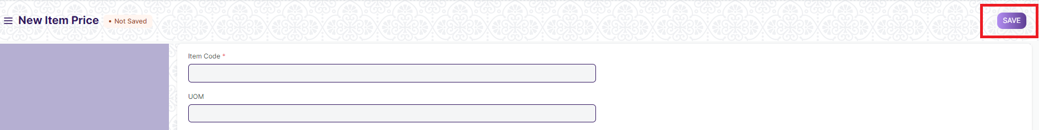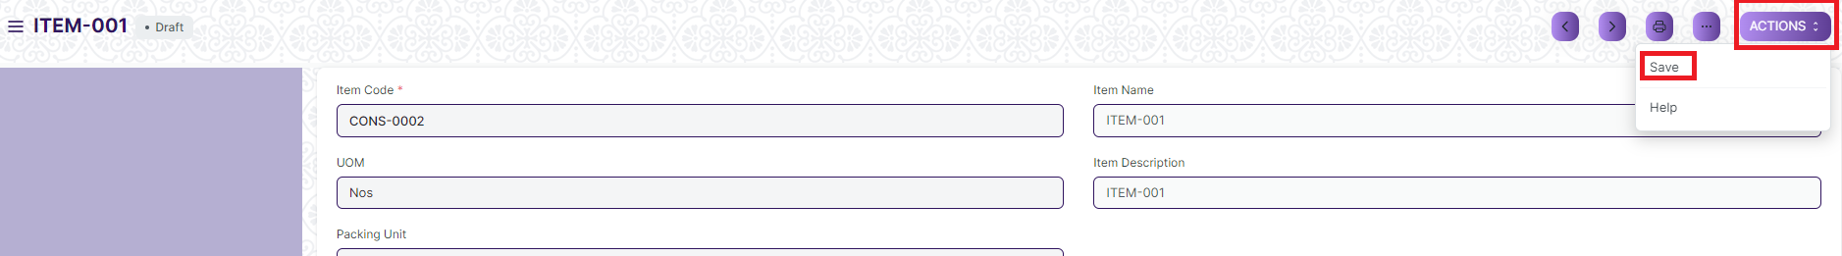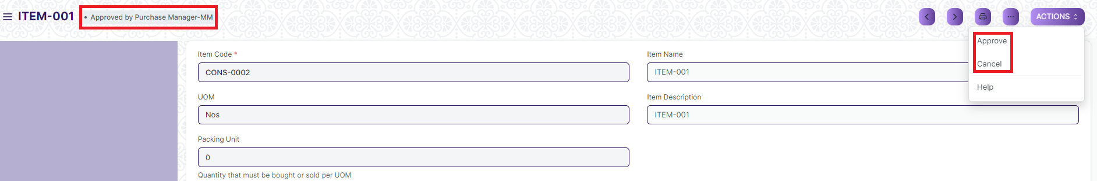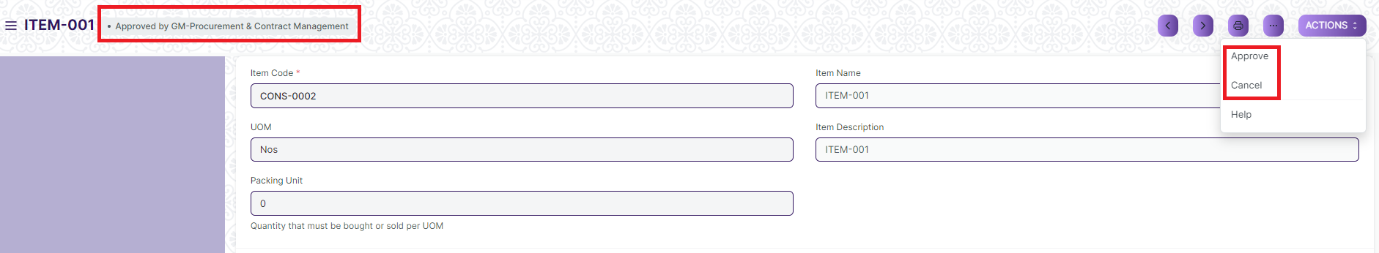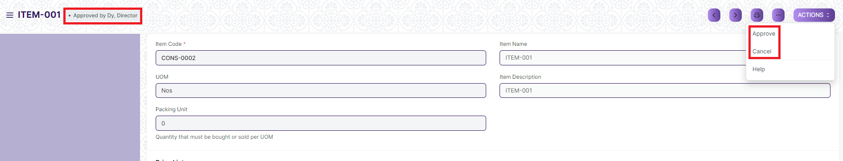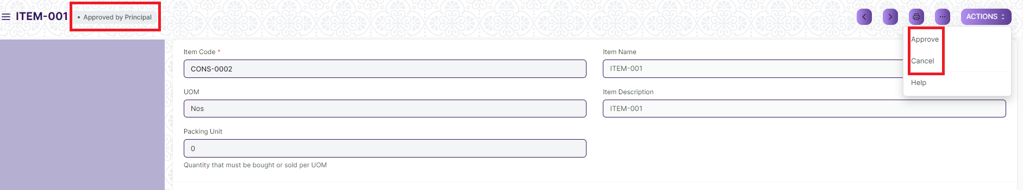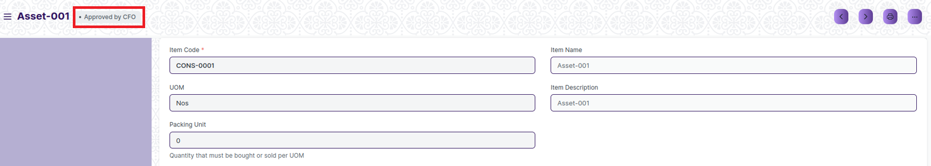

**Note**: Click the 'Save' button, and the data will be saved as a draft, and the workflow will commence. The draft status will be approved by the Purchase Manager. Following that, it will be approved or canceled by the GM. After approval by the GM, it will be reviewed and either approved or canceled by the Deputy Director. Subsequently, it will be reviewed by the Principal for approval or cancellation. Finally, it will undergo review by the CFO for approval or cancellation.

Home > Material Management > Items & Pricing > Item Price

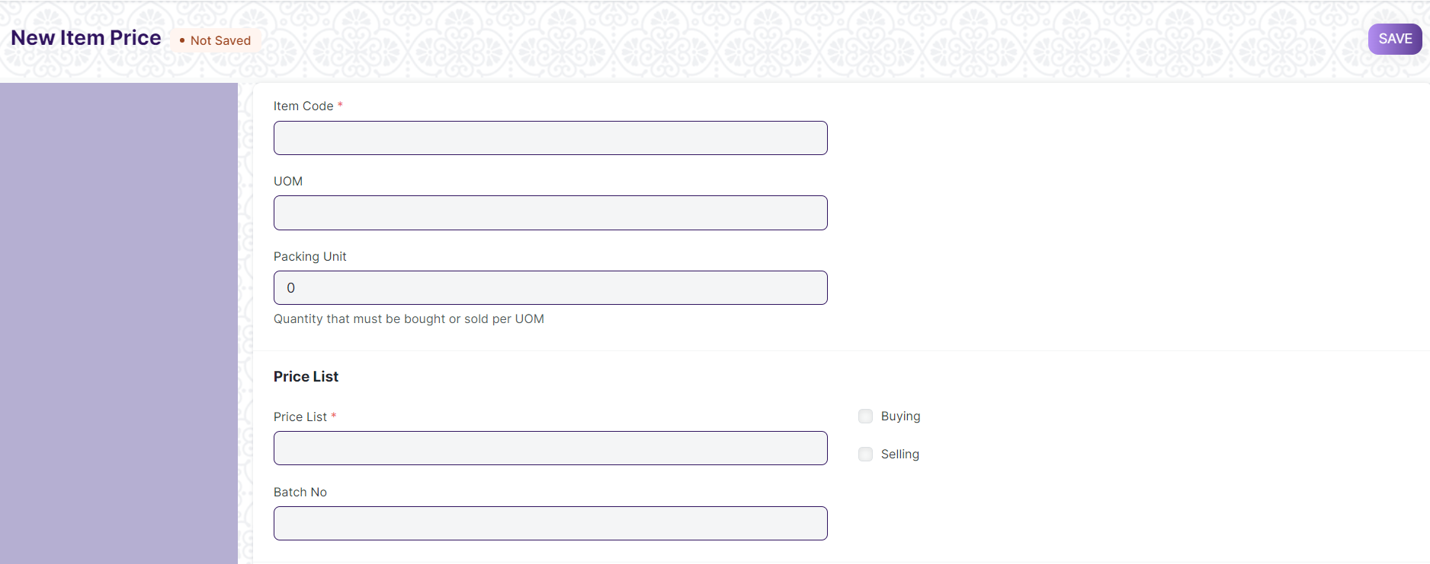

#### 3.2 Selecting the Price List

You can create multiple Price Lists for one Item in EduLead to track Selling and Buying Price of an Item separately. Also if the Item's selling prices change based on Territory or due to other criteria, you can create multiple Selling Price Lists for it.

On selection of Price List, its currency and applicability whether for selling/buying or both will be fetched as well. To have Item Price fetching in the sales or purchase transaction, you should have 'Price List' selected in the transaction under Currency and Price List.

#### 3.3 Features

**3.3.1 Packing Unit**

This is the quantity that must be bought or sold per unit of measure. For example, if Packing Unit is two, and UOM is one, two items in quantity will be transacted. The default is 0, you can use non-integer UoM like 1.5Kg Oats for 1 Packing Unit. If you leave it as 0, it'll not affect any transaction.

##### **3.3.2** Minimum quantity

This is the minimum quantity of items to be transacted for this price to be applicable and updated in the Item Price list.

##### **3.3.3** Applying Price List to a specific Customer/Supplier

If you select a Selling Price list, a customer field will appear where you can assign this Item Price to a specific customer. Likewise, if you select a Buying Price List, a Supplier field will appear where you can select a specific Supplier

##### **3.3.4** Applying Price List to a specific Batch

You can also link a specific batch to an Item Price and on the selection of that batch in the transaction, the item price for that specific batch will be applied.

##### **3.3.5** Validity

There are two fields here—'Valid From' and 'Valid Upto'. Valid from is set to the date you created the Item Price, you can also set the Valid Upto date on which the Item Price will expire.

##### **3.3.6** Lead Time in days

The approximate number of days it takes the product to reach the Store. You can set different Item Prices based on how much time the same product will reach you from different vendors.

##### **3.3.7** Note

You can add any note about the Item Price in this field.

1. **Price List**

**A Price List is a collection of Item Prices either Selling, Buying, or both. User** maintain multiple Selling and Buying [Item Prices](https://docs.erpnext.com/docs/v13/user/manual/en/stock/item-price) using Price Lists.

Home > Material Management > Items and Pricing > Price List

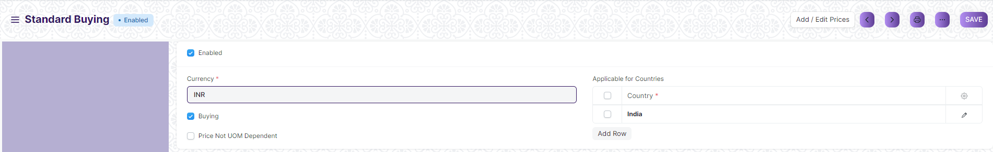

#### 4.1 How to create Price List

1. Price Lists will be used when creating an [Item Prices](https://docs.erpnext.com/docs/v13/user/manual/en/stock/item-price) to track buying price of an item.
2. Specific countries can be assigned in the Price List.
3. To disable specific Price List, un-tick the 'Enabled' checkbox. Disabled Price List will not be available for selection in the Purchase transactions.
4. ****Price Not UOM Dependent****: Consider an item, Tomatoes which you buy in Boxes and sell in Kilos. 1 Box = 10 Kilos and 1 Kilo buying price is 10rs. If this Box is unchecked and you select 1 Box in your transaction, the price will show up only for a Kilo since that's the only Item Price saved.
5. Now, if you tick this checkbox and make a transaction with a Box of Tomatoes, then the price will be automatically set as 100 since the price of 1 Box (10 Kilos) is 100.
6. Standard Buying Lists are created by default.
7. Click on Save.

****Note****: If you have multiple Price Lists, you can select a Price List or tag it to a customer (so that it is auto-selected). Your Item Prices will automatically be updated from the Price List.

1. **Supplier**

**Suppliers are companies or individuals who provide you with products or services.**

Home > Material Management > Supplier > Supplier

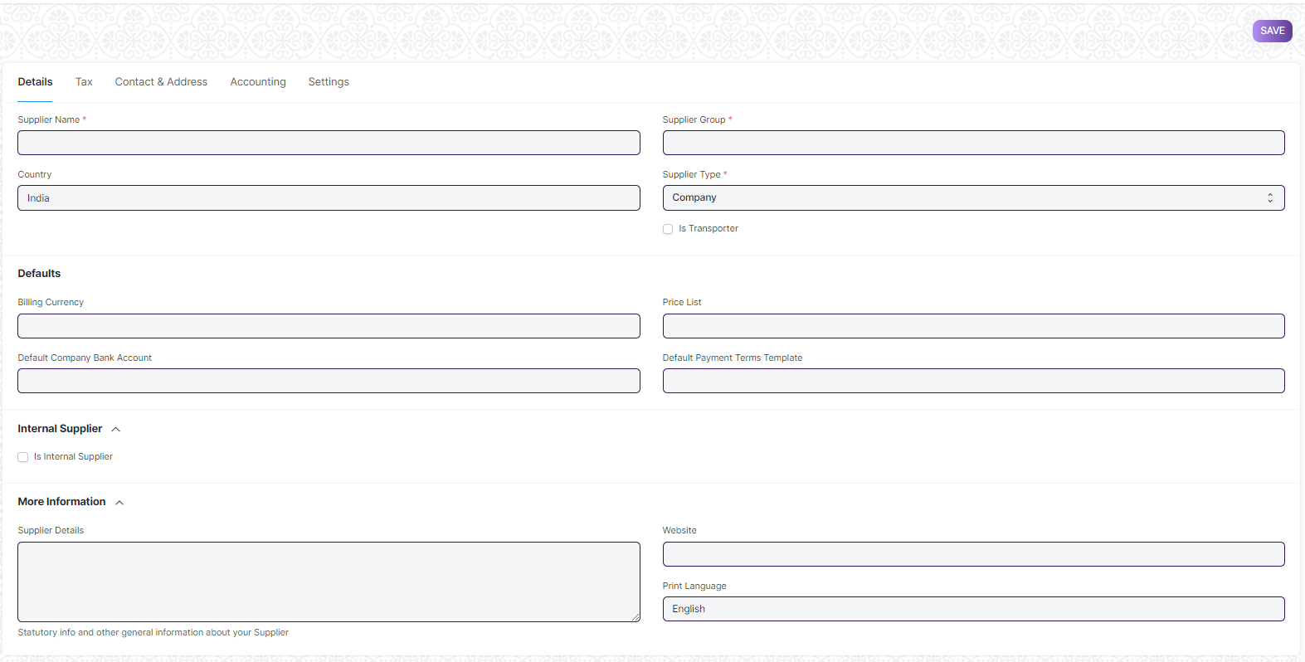

#### 5.1 How to create Supplier List

1. Go to the Supplier list and click on New.
2. Enter a name for the supplier.
3. Select the supplier group whether Pharmaceutical, Hardware etc.
4. User will maintain Supplier Contact and address and also can block.
5. Disables the Supplier and they won't be shown in the Supplier List.
6. Click on Save.

#### 5.2 **Features**

Fields in future transactions will be auto-populated if the 'Default' fields like Default Bank Account, Default Payment Terms Template etc., are set in Supplier.

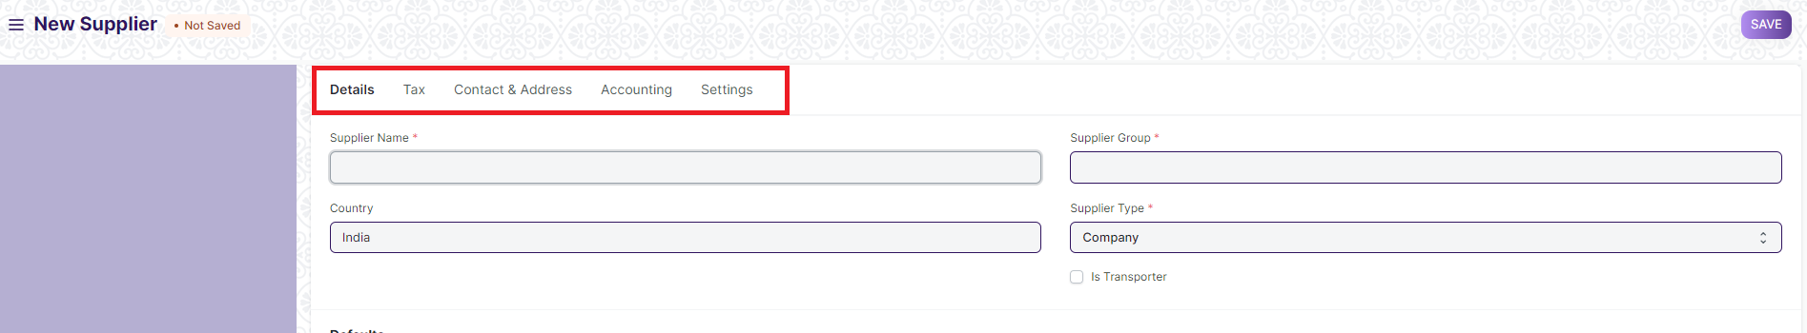

**Note**: Use Tab break to fill all type of data

### **5.2.1 Tax details**

1. ****Country****: If the supplier is from another country, you can change it here.
2. ****Tax ID****: Tax identification number of the supplier.
3. ****Tax Category****: This is linked to [Tax Rule](https://docs.erpnext.com/docs/v13/user/manual/en/accounts/tax-rule). If a Tax Category is set here, when you select this supplier, the respective Purchase Tax and Charges template will be applied. This template is linked to the Tax Rule and the Tax Rule is linked with a Tax Category. Tax Category can be used to group suppliers to whom same tax will be applied. For example: Government, commercial, etc,.
4. ****Tax Withholding Category****: For India, TDS category for the Supplier. On setting a category here, it will be fetched into the [Purchase Invoice](https://docs.erpnext.com/docs/v13/user/manual/en/accounts/purchase-invoice). For more information, visit the [Tax Withholding Category](https://docs.erpnext.com/docs/v13/user/manual/en/accounts/tax-withholding-category) page.
5. ****Is Transporter****: If the supplier is selling your transport services, tick this box. 'GST Transporter ID' field will be visible if this field is ticked.
6. ****Internal Supplier****: If the supplier is from a sister or parent/child company, tick this field and select the company which they represent.

For India:

1. ****GST Category****: Select a GST Category of the supplier.
2. ****PAN****: For India, PAN (Permanent Account Number) card details of the Supplier.

### **5.2.2 Allow creation of Purchase Invoice without Purchase Order and Purchase Receipt**

If the "Purchase Order Required" or "Purchase Receipt Required" option is configured as "Yes" in [Buying Settings](https://docs.erpnext.com/docs/v13/user/manual/en/buying/buying-settings), it can be overridden for a particular supplier by enabling the "Allow Purchase Invoice Creation Without Purchase Order" or "Allow Purchase Invoice Creation Without Purchase Receipt" in the Supplier Master.

### **5.2.3 Currency and Price List**

****Billing Currency****: Your supplier's currency can be different from your company currency. If you choose JPY for a supplier, then the currency will be filled as JPY and the exchange rate shown for future purchase transactions.

### **5.2.4 Contact and Address**

Contact and Address are stored separately so that you can create multiple Contacts and Addresses for one Supplier. Once Supplier is saved, you will find the option to create Contact and Address for that Supplier.

### **5.2.5 Accounting**

* Add the default account from which invoices against this supplier will be paid. Add additional rows for more companies, you can select only one account per company.
* You can integrate a supplier with an account. For all Suppliers, "Creditor" account is set as the default payable Account. When Purchase Invoice is created, payable towards the supplier is booked against "Creditors" account.
* If you want to customize payable account for the Supplier, you should first add a payable Account in the Chart of Account, and then select that Payable Account in the Supplier master.
* If you don't want to customize payable account, and proceed with default payable account "Creditor", then do not update any value in the Default Supplier Account's table.
* Default Payable Account is set in the Company master. If you want to set another account as Account as default for payable instead of Creditors Account, go to Company master, and set that account as "Default Payable Account".
* Depending on your plan, you can add multiple companies in your instance. One Supplier can be used across multiple companies. In this case, you should define Company-wise Payable Account for the Supplier in the "Default Payable Accounts" table, i.e, add multiple rows.

1. **Supplier Group**

**Supplier Group is an aggregation of suppliers that are similar in some way.**

Home > Material Management > Supplier > Supplier Group

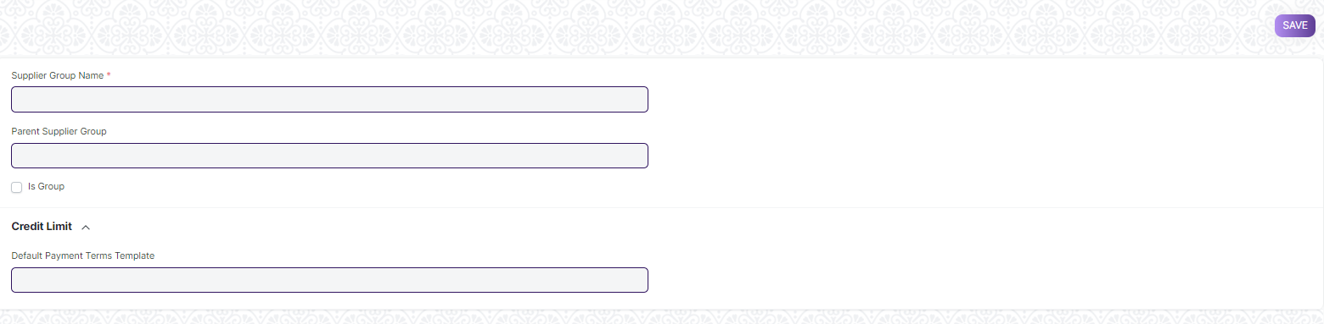

#### 6.1 Prerequisites

* Supplier

#### 6.2 How to create Supplier Group List

1. Go to the Supplier Group list, click on New.
2. Type a name for your new Supplier Category.
3. You can set a Parent Supplier Group for this Supplier Group.
4. Ticking the Is Group checkbox will make it a Parent Supplier Group.
5. You can also assign a default Payment Terms Template to the Supplier Group. Useful in a case where all your hardware suppliers take half payment on sales order and half post shipment.
6. Click on Save.
7. After save “Default Payable Account” will shown
8. You can mention if non-standard receivable account applicable on that table
9. **Quality Inspection Template**

User can mark your incoming or outgoing products for Quality Inspection.

Home > Material Management > Quality Inspection > Quality Inspection Template

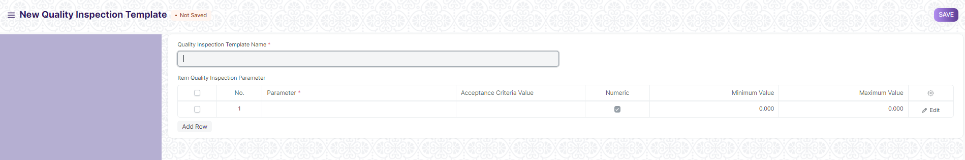

#### 7.1 Prerequisites

* **Quality Inspection Parameter**

#### 7.2 How to create Quality Inspection Template

1. Go to Quality Inspection template and click on New
2. Enter Template name
3. Enter Parameter and acceptance value and all details
4. Click on Save
5. **Quality Inspection Parameter**

Quality Inspection Parameter is master Screen for Quality Inspection Template.

Home > Material Management > Quality Inspection > Quality Inspection Parameter

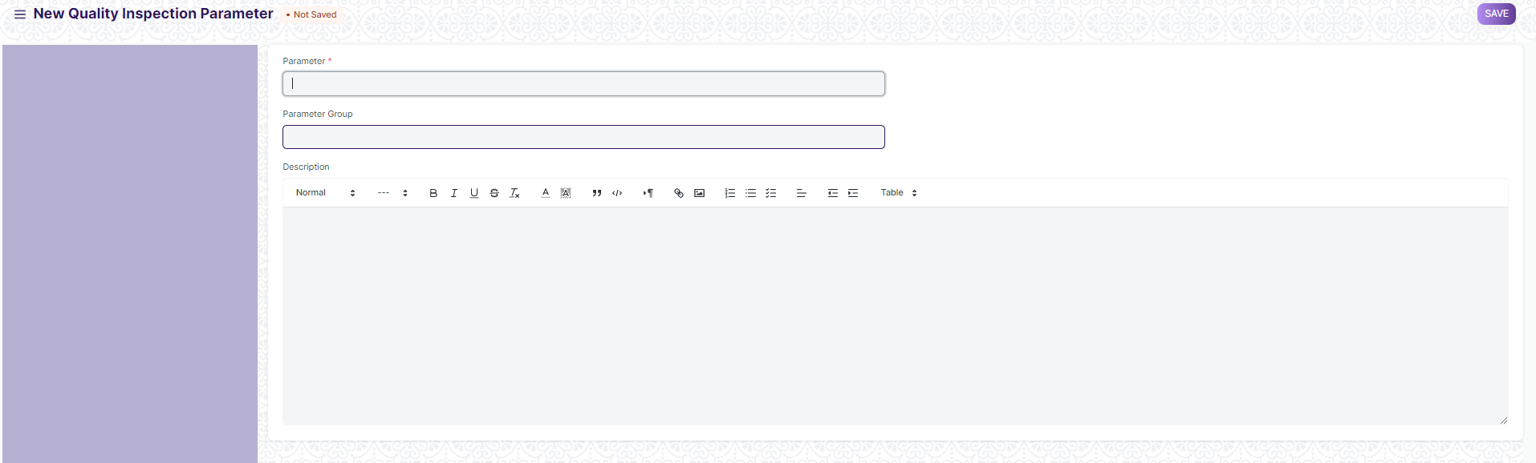

#### 8.1 Prerequisites

* **Quality Inspection Parameter Group**

#### 8.2 How to create Quality Inspection Parameter

1. Go to Quality Inspection Parameter and click on New
2. Enter Parameter Name and parameter group
3. Add description
4. Click on Save
5. **Payment Term**

**Sometimes payment is not done all at once. Depending on the agreement, half of the payment may be made before shipment and the other half after receiving the goods/services.**

Home > Material Management > Payment Term > Payment Term

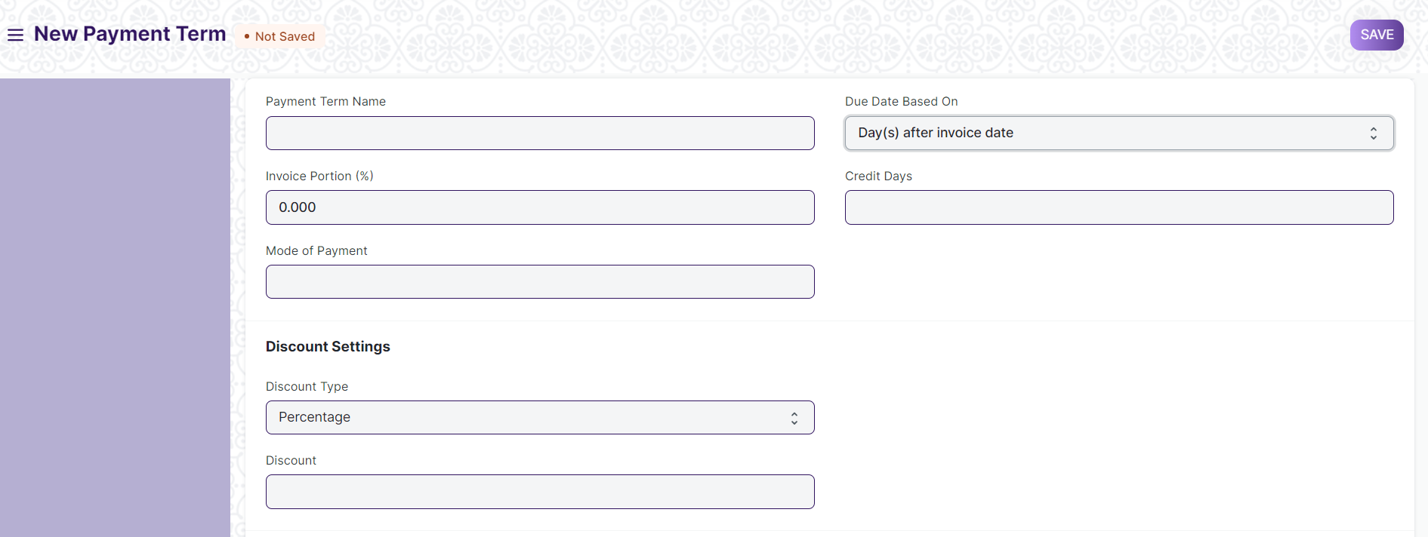

#### 9.1 How to create Payment Term

1. Go to the Payment Term list and click on New.
2. Enter a Payment term name and all other data.
3. Select Due Date Based On and Discount type.
4. Click on Save.
5. **Payment Terms Template**

**Payment Terms Template allow you to club multiple payment terms together and fetch in**

**transactions.**

Home > Material Management > Payment Term> Payment Terms Template

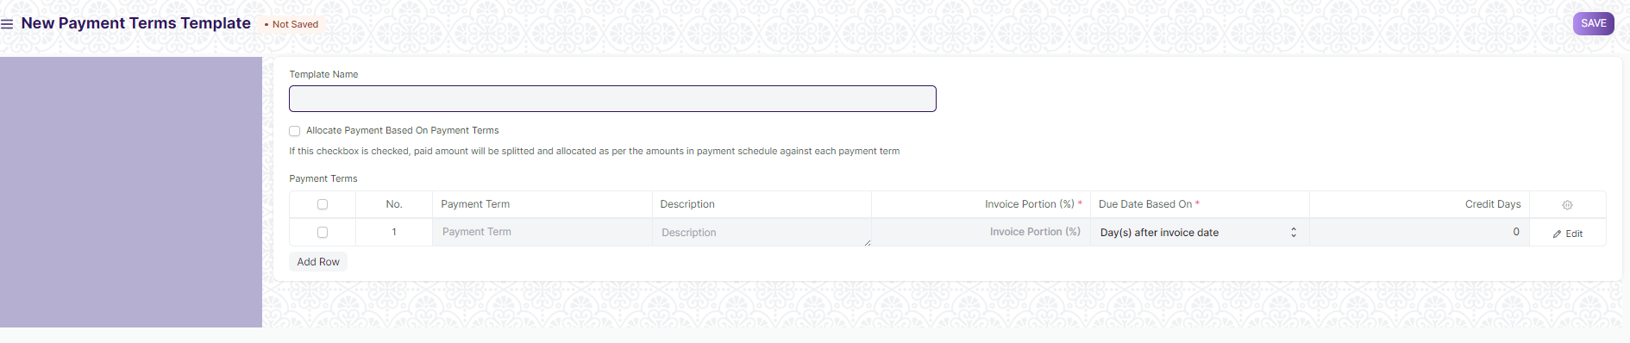

#### 10.1 Prerequisites

Payment Term

#### 10.2 How to create Payment Terms Template

1. Go to the Payment Term Template list and click on New.
2. Enter a name for the template.
3. Add the created Payment Terms in the table rows.
4. Make sure that the total Invoice Portion adds up to 100.
5. Click on Save.
6. **Unit of Measure (UoM)**

**A UoM is a unit using which an Item is measured.**By default, there are many UoMs created in form. However, more can be added depending on your business use case. In the UoM there is an option 'Must be Whole Number'. If this is checked, you cannot use fraction numbers in this UoM.

Home > Material Management> Masters> Unit of Measure (UoM)

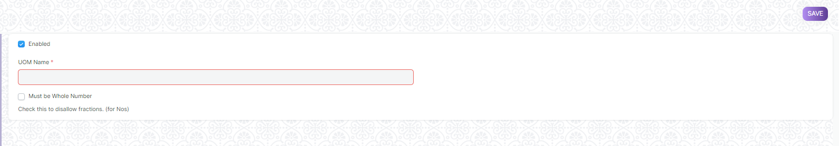

1. **Store Type**

**Store Type allow you to add type of Store.**

Home > Material Management > Masters > Store Type

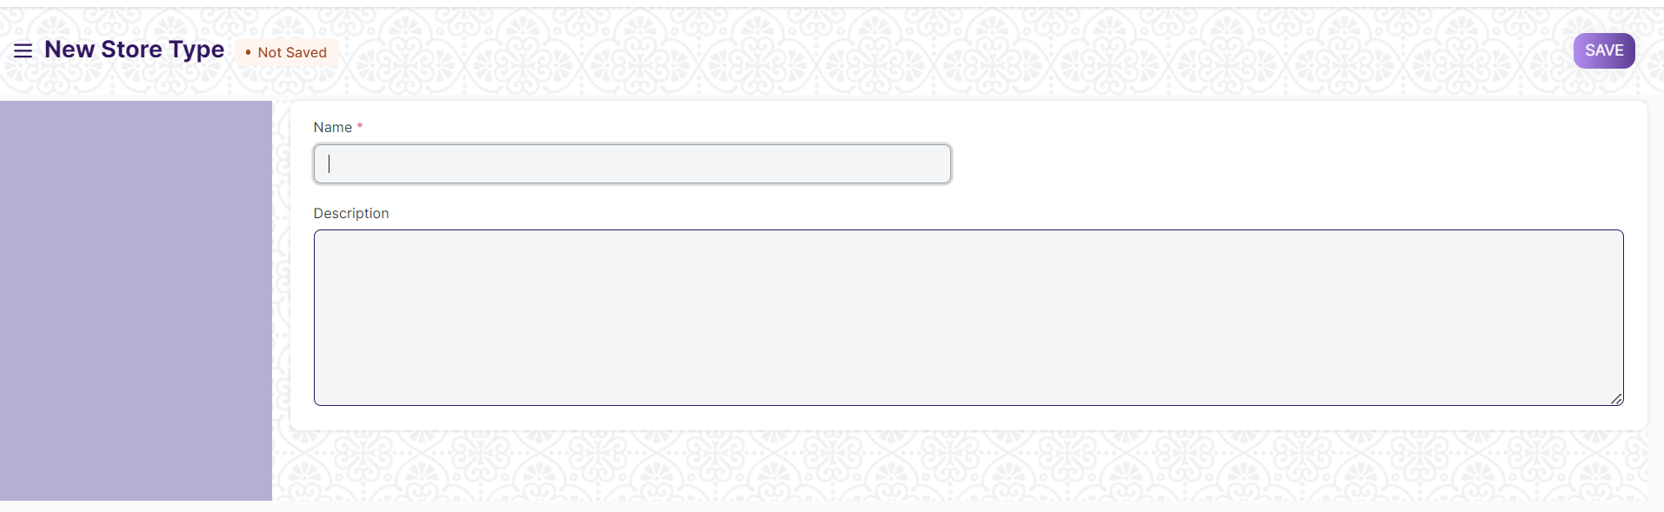

#### 12.1 How to create Store Type

1. Go to the Store Type list and click on New.
2. Enter Store Type Name and Description
3. Click On Save
4. **Store**

A Store is a commercial building for the storage of goods. Store are used by manufacturers, importers, exporters, wholesalers, transport businesses, customs, etc.

They are usually large plain buildings in industrial areas of cities, towns, and villages. They mostly have loading docks to load and unload goods from trucks.

The terminology of 'Store' in EduLead is a bit broader though and maybe can be regarded as "storage locations". You can create a sub-Store which could be a shelf inside your actual location.

To access the Store list, go to:

Home > Material Management> Masters> Store

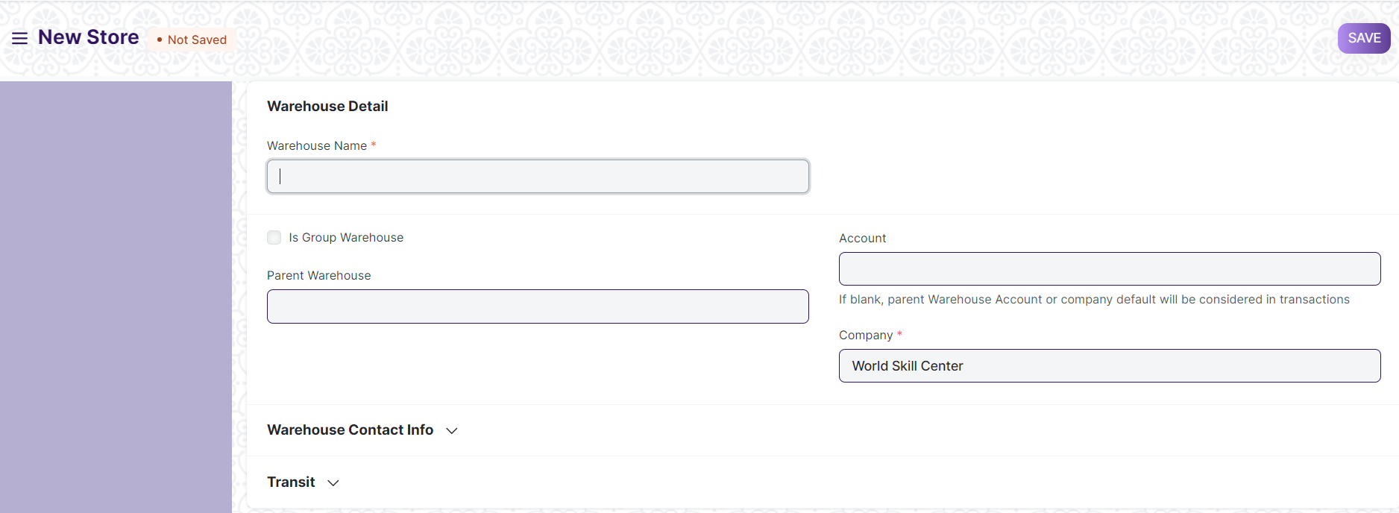

#### 13.1 How to create a Store

1. Go to the Store list, click on New.
2. Enter a name for the Store.
3. Set/check the Parent Store. If you tick on 'Is Group', you can create sub- Stores under this group Store.
4. Click on Save.

Stores are saved with their respective company’s abbreviations. This facilitates identifying which Store belongs to which company at a glance.

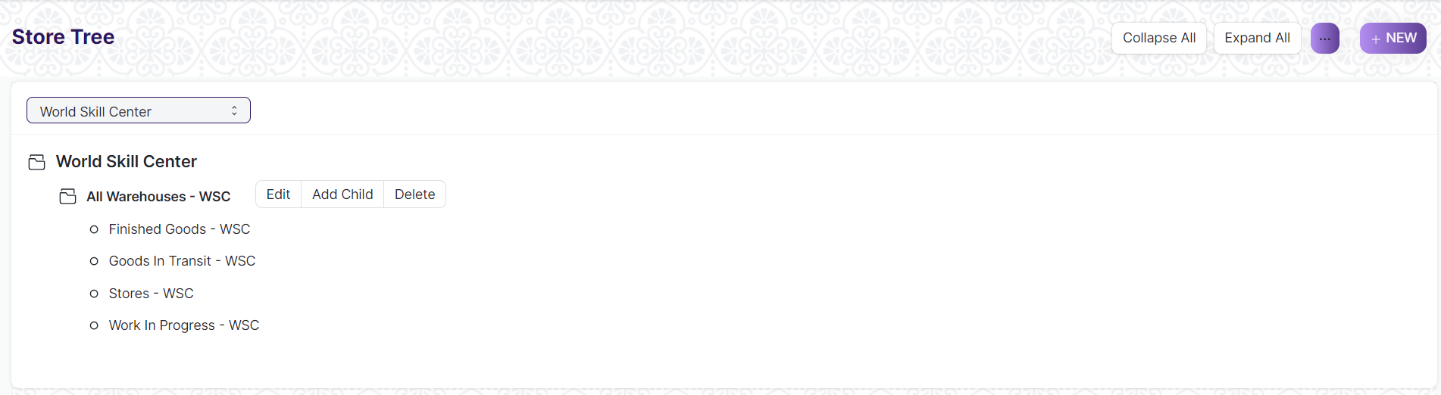

##### 13.1.1 Additional options when creating a Store

**Account:** Set a default account here for all transactions with this Store. Setting this account will show transactions from this Store in the Accounting Ledger. Store Type: You can create a Store Type to classify Stores. For example, Supplier Stores, Stock Stores, WIP Stores, Rooms, etc. can be tagged. This classification is useful when generating reports or in certain stock transactions.

**Address and contact:** You can add Billing, Shipping, and other types of addresses for the Store. You can also add a contact; this could be the Store Manager for example

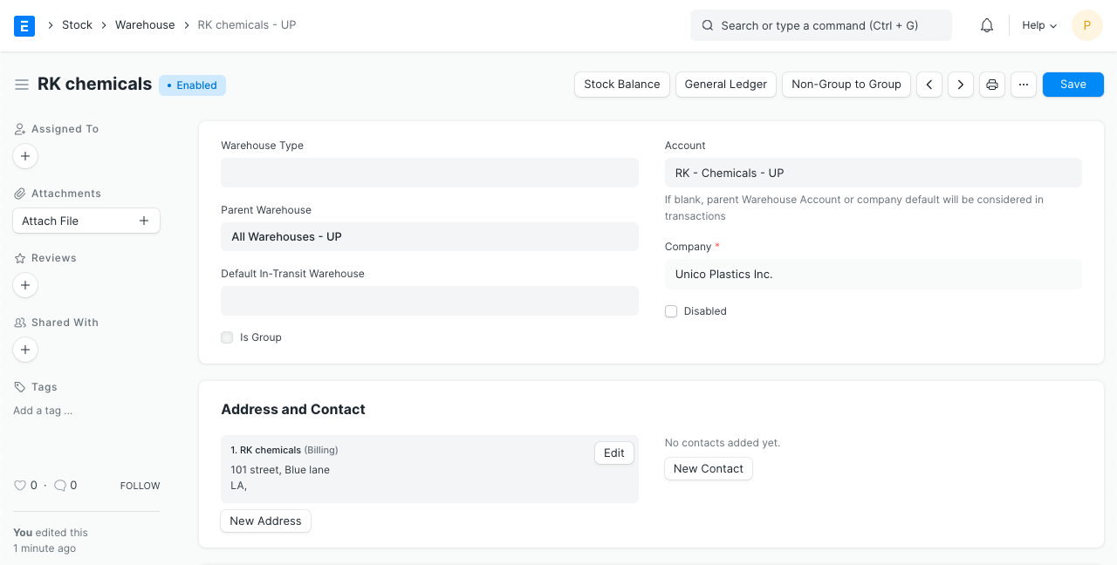

##### 13.1.2 After Saving

After saving a Store, you'll see the following options:

* Stock Balance: This will open the Stock Balance report to display the quantity, valuation, balance, etc.
* General Ledger: This will open the General Ledger to display the accounting transactions.
* Non-Group to Group: If the Store is a Non-Group Store, i.e. cannot contain other Stores under it, this button will make this a Group Store.

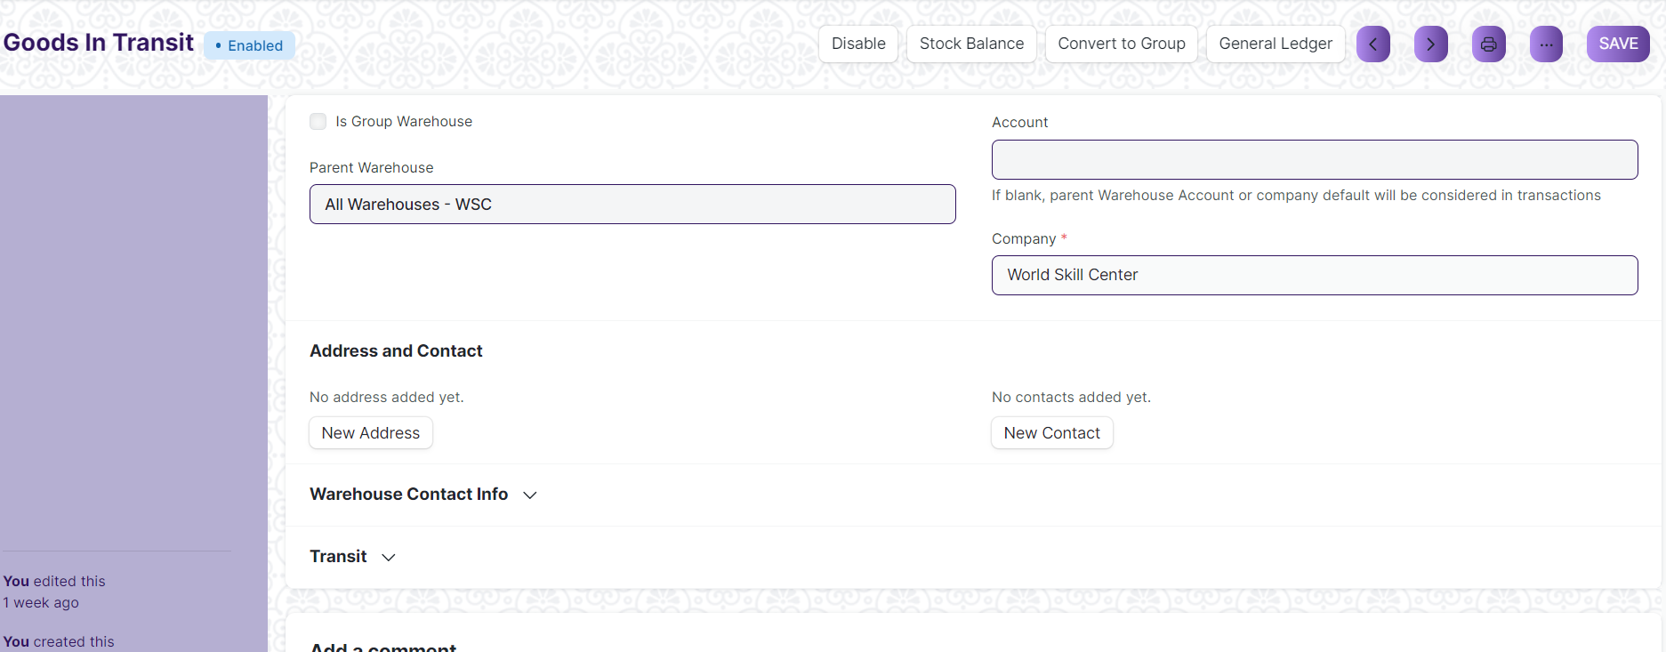

**13.2 Features**

##### 13.2.1 Tree View

You can also switch to 'Tree' View which will show all the group and child Stores.



##### 13.2.2 Store Account

In EduLead, if you enable Perpetual Inventory, every Store must belong to a specific company to maintain company-wise stock balance. To do so, each Store should be linked with an Account in the Chart of Accounts (the same name as the Store itself). This account captures the monetary equivalent of the goods or materials stored in that specific Store.

If you have a more detailed Store Tree, most likely it's a good idea to link the sub- locations (room, row, shelf, etc.) to the account of the actual Store (the root Store of that Tree) as most scenarios do not require to account for value of stock items per Shelf or Bin. For example, if you have Store A, and the room, rows are B, C, etc., then link B and C to the account of A.

Tip: EduLead maintains stock balance for every distinct combination of Item and Store. Thus you can get the stock balance for any specific Item in a particular Store on any particular date.

1. **Purchase Taxes and Charges Template**

**Purchase Taxes and Charges may be applied to any item you buy.**

Home > Material Management> Masters> Purchase Taxes and Charges Template

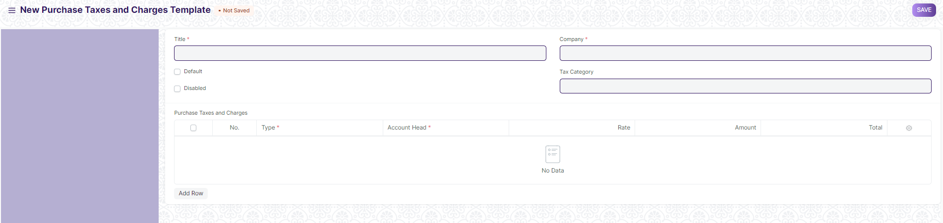

#### 14.1 How to create Purchase Taxes and Charges Template

1. Click on New.
2. Enter a title name for the Tax.
3. Under type, set on what the tax will be calculated and the tax rate. There are five options under type for which tax will be calculated.
   1. Actual: On the actual amount of each item.
   2. On Net Total: On the grand total of all the items.
   3. On Previous Row Amount: This is for compounding the charges. For example, cess charges over the amount to which tax was already applied in the previous row.
   4. On Previous Row Total: Same as above but applied on the total bill and not just the amount of an item.
4. Select an account head which has pre-set tax rates or create your own.
5. Selecting default will apply this template by default for new Purchase transactions.
6. Click on Save.

### **14.2 Purchase Taxes and Charges table**

* ****Consider Tax or Charge for****: Total - for the total of all items. Valuation - for each item. Valuation and total - apply tax/charge to both.
* ****Add or Deduct:**** Whether you want to add or deduct the tax from the item
* ****Reference Row #****: If tax is based on "Previous Row Total" you can select the row number which will be taken as a base for this calculation (default is the previous row).
* ****Is this Tax included in Basic Rate?****: If checked, the tax amount will be considered as already included in the Print Rate / Print Amount.
* ****Account Head:**** The Account ledger under which this tax will be booked. If you select VAT or any other preset heads, the rate will be automatically filled.
* ****Cost Center:**** If the tax/charge is an income (like shipping) or expense it needs to be booked against a Cost Center.
* ****Description:**** Description of the tax (that will be printed in invoices/quotes).
* ****Rate:**** The Tax rate, eg: 14 = 14% tax.
* ****Amount:**** The Tax amount to be applied, eg: 100.00 = ₹100 tax.

1. **Item Wise Tax Category**

**A** Item Wise Tax Category **allows applying one or more Tax Rules to transactions based on various criteria.**

**If you want to apply different kinds of taxes based on Item Wise Tax Categories, create Item Wise Tax Categories from**

Home > Material Management> Masters> Item Wise Tax Category

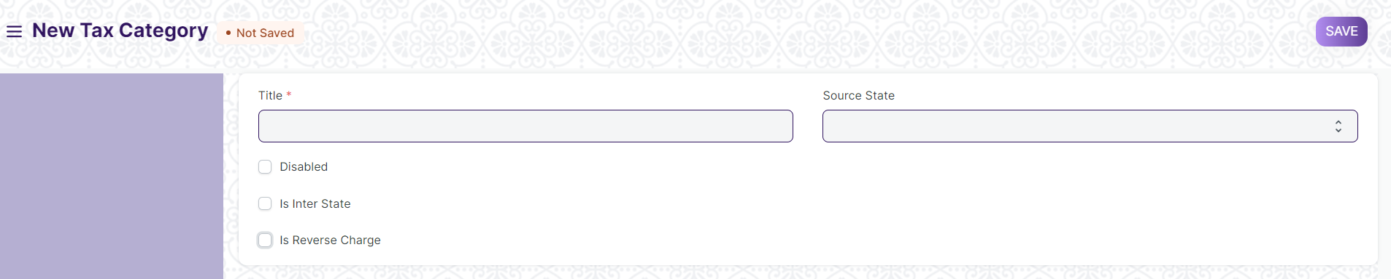

1. **Terms and Conditions**

**Terms and conditions contain the terms and conditions of a service/product offered by a seller to a buyer.**

Home > Material Management> Masters > Terms and Conditions

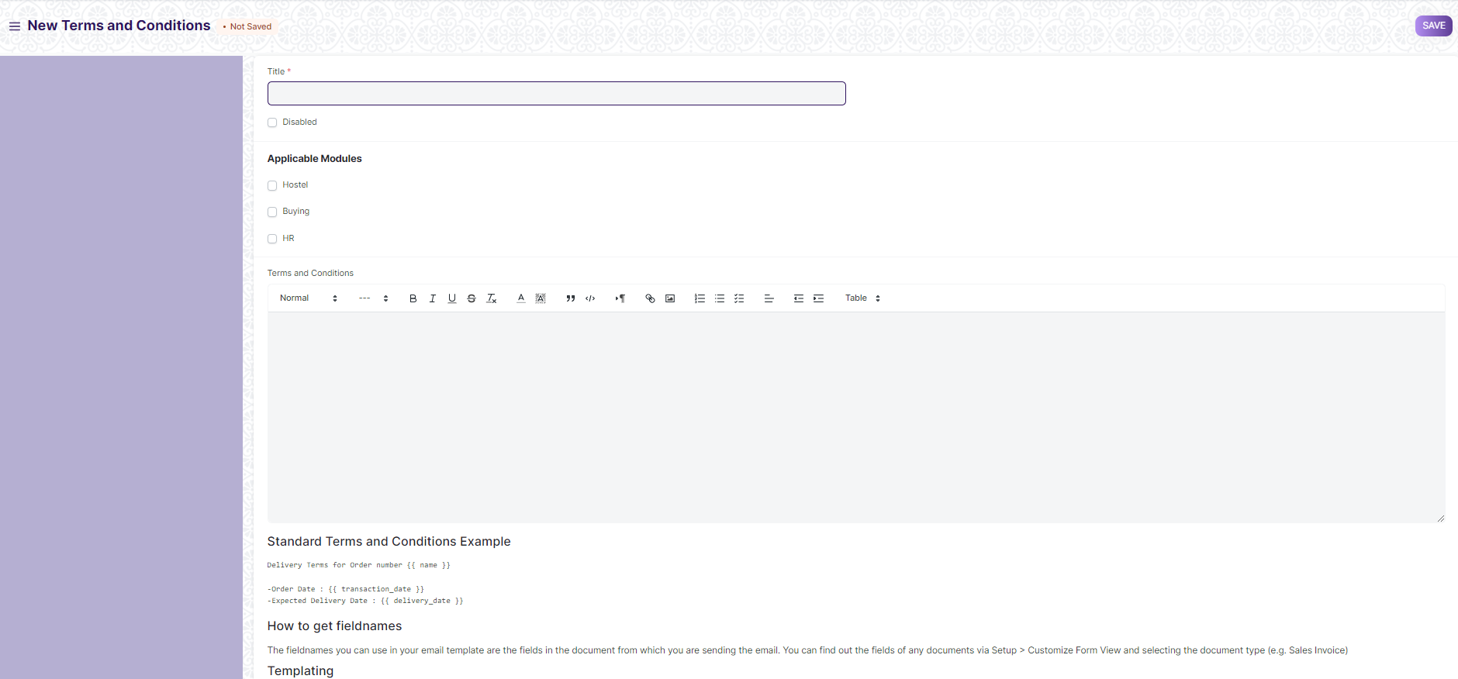

#### 16.1 How to create Terms and Conditions

1. Go to the Terms and Conditions Template list, click on New.
2. Add the Terms and Conditions.
3. **Tax Withholding Category**

**Tax Withholding Category is Tax Deducted at Source.**

Home > Material Management > Masters > Tax Withholding Category

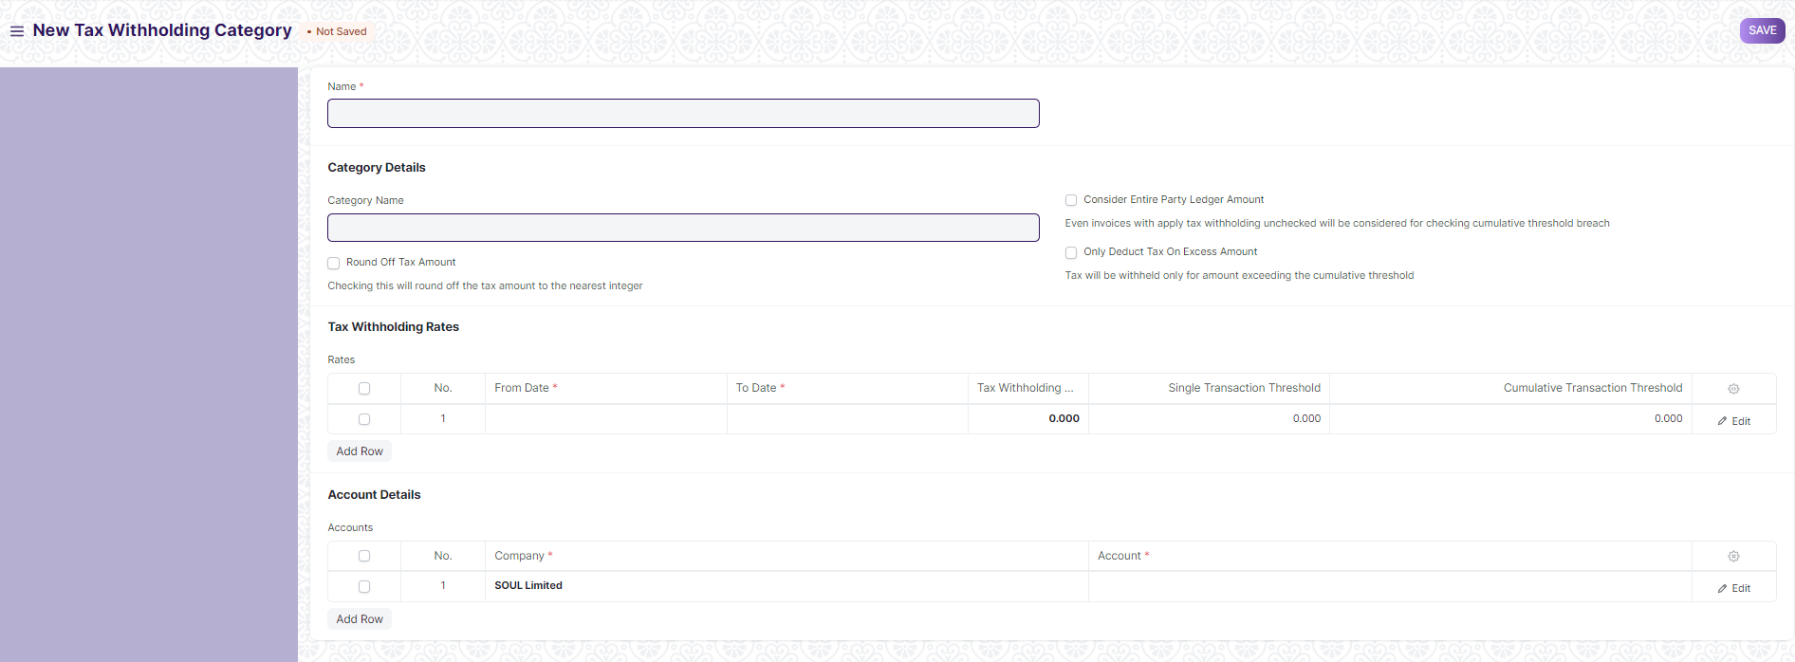

#### 17.1 How to create Tax Withholding Category

1. Go to the Tax Withholding Category list and click on New.
2. Enter a unique name.
3. Enter a Category Name (Dividends, Professional Fees, etc.).
4. Enter a Tax Withholding Rate against a [Fiscal Year](https://docs.erpnext.com/docs/v13/user/manual/en/accounts/fiscal-year).
5. You can set the threshold for a single invoice or sum of all invoices.
6. Select an account against your Company to which tax will be credited.
7. Add more companies and accounts as needed.
8. Click on Save.
9. **Purchase Requisition**

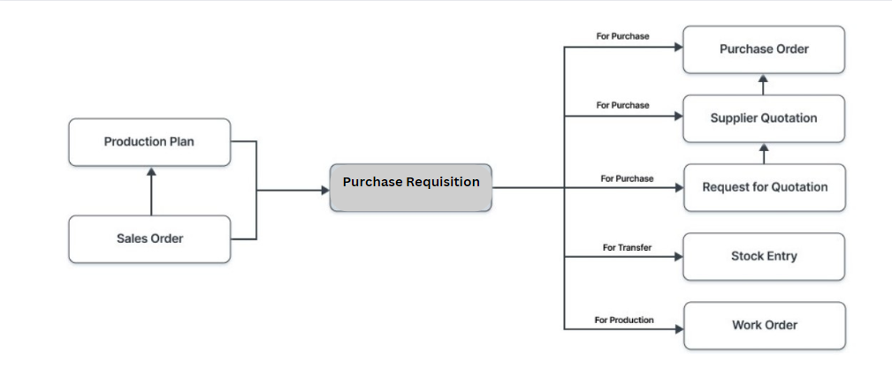

A Purchase Requisition is a simple document identifying a requirement of a set of items (products or services) for a particular reason.

A Purchase Requisition can have the following purposes:

* **Purchase**: If the material being requested is to be purchased.
* **Material Transfer**: If the material being requested is to be shifted from one Store to another.
* **Material Issue**: If the material being requested is to be Issued for some purpose like manufacturing.
* **Manufacture:** If the material being requested is to be produced.
* **Customer Provided**: If the material being requested is to be provided by the customer.

To access the Purchase Requisition list, go to:

Home > Material Management > Buying > Purchase Requisition

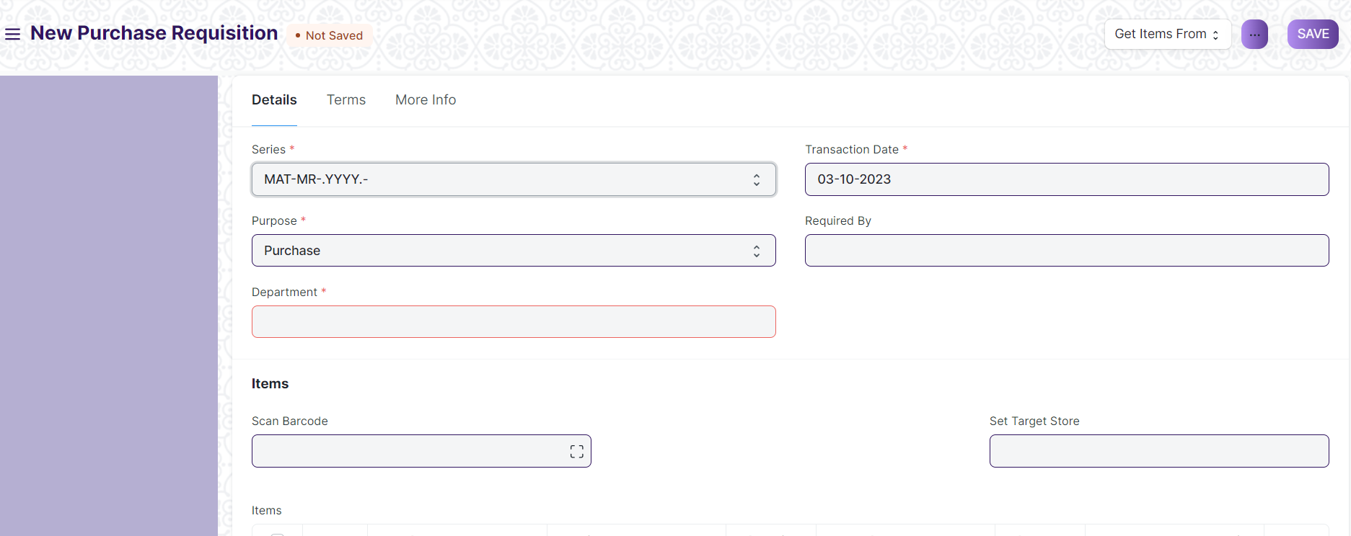

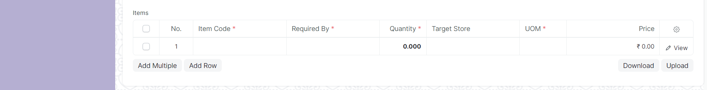

**18.1 How to create a Purchase Requisition**

1. Go to the Purchase Requisition list, click on New.
2. Enter the required by date.
3. Select from one of the purposes as listed above.
4. You can fetch Items from a BOM, Sales Order, or Product Bundle.
5. Select the Item and set the quantity.
6. Select the Store for which Items are required.
7. You can change the Required By date for individual Items in this table.
8. Click on Save and Submit.
9. After submission, a workflow will initiate, and the user will proceed to either approve or cancel based on the assignments made in the "Authorization for Requisition" table within the Item Group form.

#### 18.2 Alternate ways of creating a **Purchase Requisition**

A Purchase Requisition can be generated automatically:

* From a Sales Order.
* When the Projected Quantity of an Item in Stores (Stores) reaches a particular level.
* From there, a Production Plan to plan your manufacturing activities.

If your Items are inventory items, you must also mention the Store where you expect these Items to be delivered. This helps to keep track of the Projected Quantity for this Item.

Info: Purchase Requisition is not mandatory. It is ideal if you have centralized buying so that you can collect this information from various departments.

#### 18.3 Statuses

These are the statuses a Purchase Requisition can be in:

* **Draft**: A draft is saved but yet to be submitted to the system.
* **Submitted**: Document is submitted to the system.
* **Stopped**: If no more materials are needed the Purchase Requisition can be stopped.
* **Canceled**: The materials are not needed at all and the request is canceled.
* **Pending**: The Purchase/Manufacture is pending to complete the Purchase Requisition.
* **Partially Ordered**: Purchase Orders for some Items from the Purchase Requisition are made and some are pending.
* **Ordered**: All Items in the Purchase Requisition are ordered via Purchase Orders.
* **Issued**: The materials are issued using a Material Issue Stock Entry.
* **Transferred**: The required materials are transferred from one Store to another using a Stock Entry.
* **Received**: The materials were ordered and have been received at your Store using a Purchase Receipt.

#### 18.4 Features

**18.4.1 Items table**

* **Barcode**: You can track Items using bar codes.
* The Item Code, name, description, Image, and Manufacturer will be fetched from the Item master.
* **Scan Barcode**: You can add Items in the Items table by scanning their barcodes if you have a barcode scanner.
* The UoM, Conversion Factor, and Amount will be fetched. You change the Store for which the material is being requested.
* Accounting details like Expense Account and Accounting Dimensions can be set for the Items.

##### 18.4.2 Setting Stores

* **Set Store**: Optionally, you can set the Store where the requested Items will arrive. This will be fetched into the 'For Store' fields in the Item table rows.

##### 18.4.3 More Information

In the 'Requested For' field, you can set a Reference from where Purchase Requisition was generated

##### 18.4.4 Terms and Conditions

In Sales/Purchase transactions there might be certain Terms and Conditions based on which the Supplier provides goods or services to the Customer. You can apply the Terms and Conditions to transactions to transactions and they will appear when printing the document.

##### 18.4.5 After Submitting

You can create the following documents:

* Request for Quotation
* Purchase Order
* Supplier Quotation

##### 18.5 Automatically generate Purchase Requisition

Purchase Requisition can be generated automatically by enabling the setting in Stock Settings and setting the level in the Item form. When the stock level dips below a certain quantity, setting a reorder will automatically create Purchase Requisition for the Item.

1. **Request for quotation**

A Request for Quotation is a document that an organization sends to one or more suppliers asking for a quotation for items.

To access the Request for Quotation list, go to:

Home > Material Management > Buying > Request for Quotation

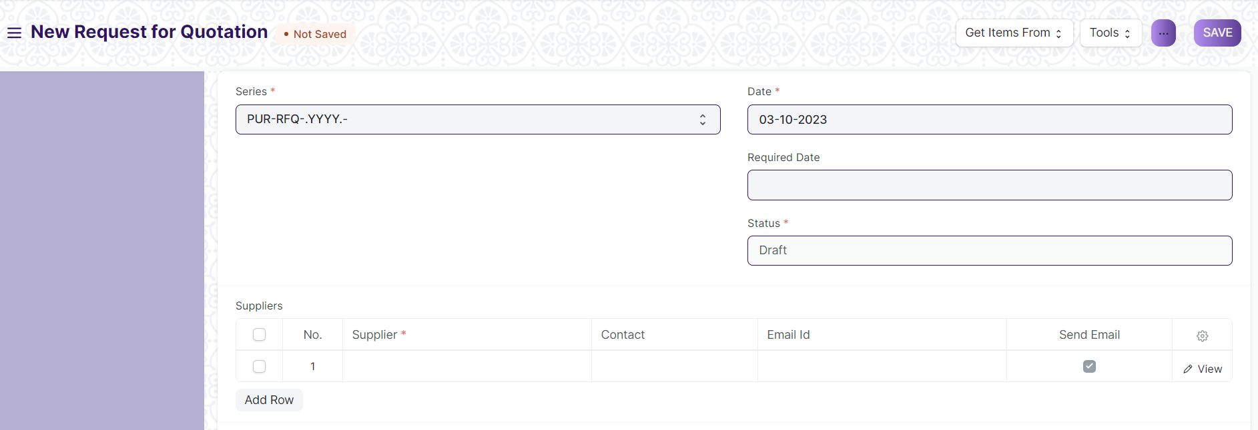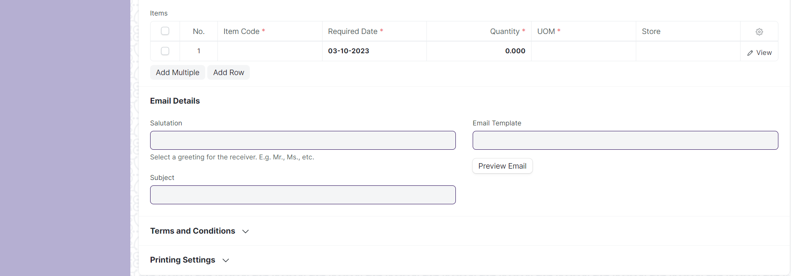

#### 19.1 How to create a Request for Quotation

1. Go to the Request for Quotation list, click on New.
2. Enter the date.
3. Choose the Supplier to whom the Request for Quotation is to be sent.
4. In the next table, enter items, quantity and the target Store where you'll be sending the items.
5. Stores can be left blank if 'Maintain Stock' is unticked for the item.
6. Click on Save and submit.

A Request for Quotation (RFQ) can also be created from a submitted Purchase Requisition. Once an RFQ is created, you can print and send suppliers the PDF which will have all the details you entered relevant to the RFQ.

1. **Supplier quotation**

After creation of Request for Quotation, there are two ways to generate Supplier Quotation from Request for Quotation.

To access the Supplier Quotation list, go to:

Home > Material Management > Buying > Supplier Quotation

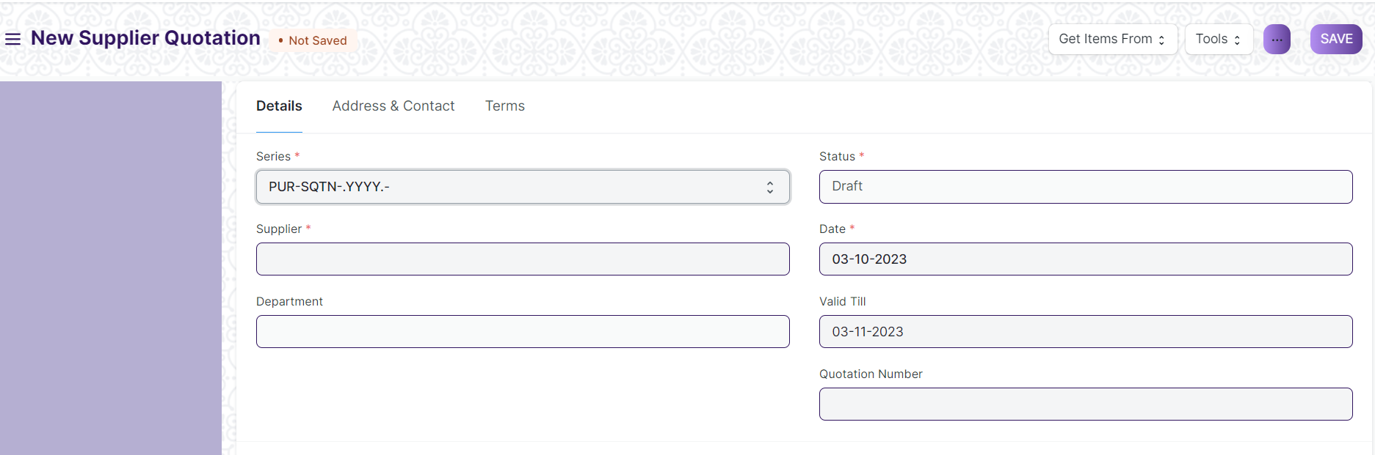

#### 20.1 Prerequisites

Supplier

Item

#### 20.2 Creating a Supplier Quotation

1. Go to the Supplier Quotation list, click on New.
2. The Address and Contact will be fetched if you've saved it in the supplier master.
3. **Enter** the Item code, select the quantity. Rate will be fetched if you've set the Standard Buying rate for the item in Item Price.

**If you have multiple Suppliers who supply you with the same Item, you usually send out a Request for Quotation to various Suppliers. In many cases, especially if you have centralized buying, you may want to record all the quotes so that:**

* **You can easily compare prices in the future**
* **Audit whether all Suppliers were given the opportunity to quote.**

**Supplier Quotations are not necessary for most small businesses. Always evaluate the cost of collecting information to the value it really provides! As a recommendation, you can do this only for high value items.**

#### 20.3 After Submitting

**The following records can be created after submitting a Supplier Quotation:**

* **Purchase Order - A Purchase Order if you agree with the supplier's quotation.**
* **Quotation - A quotation to your customer.**
* **Auto Repeat - Auto Repeat the supplier quotation at specified intervals.**

1. ****Purchase Order****

A Purchase Order is a binding contract with your Supplier that you promise to buy a set of items under given conditions.

Home > Material Management > Buying > Purchase Order

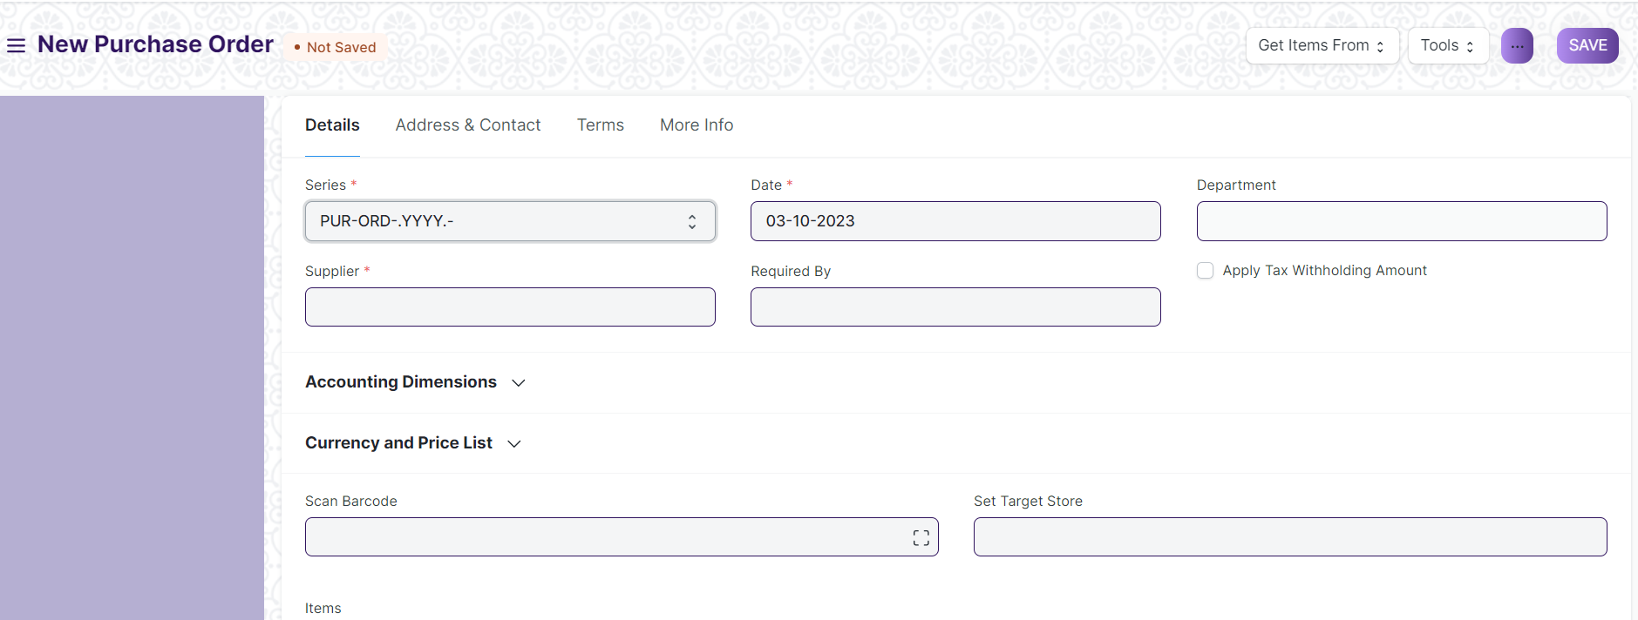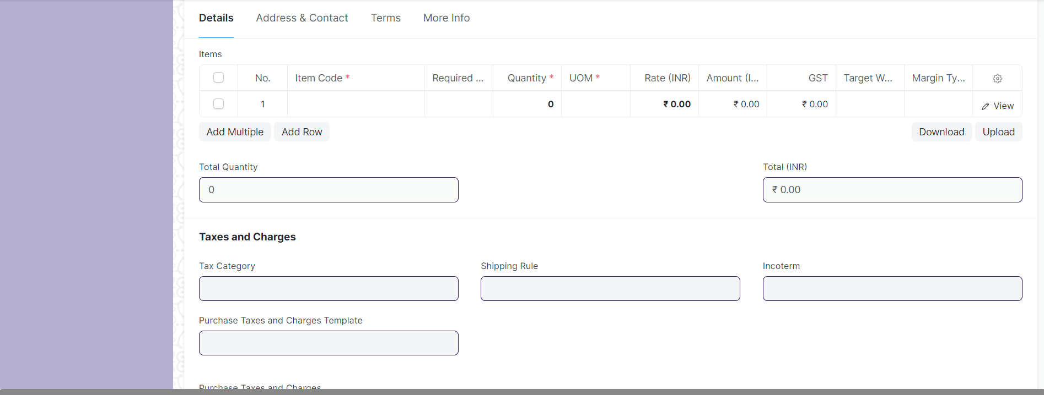

#### 21.1 Prerequisites

Before creating and using a Purchase Order, it is advised that you create the following first:

* Supplier
* Item

#### 21.2 How to create a Purchase Order

A Purchase Order can be automatically created from a Purchase Requisition or Supplier Quotation.

1. Go to the Purchase Order list, click on New.
2. Select the Supplier, required by date.
3. In the items table, select the item by code, you can change the required by date for each item.
4. Set the quantity and the price will be fetched automatically if set in the Item master.
5. Set taxes.
6. Click on Save and Submit

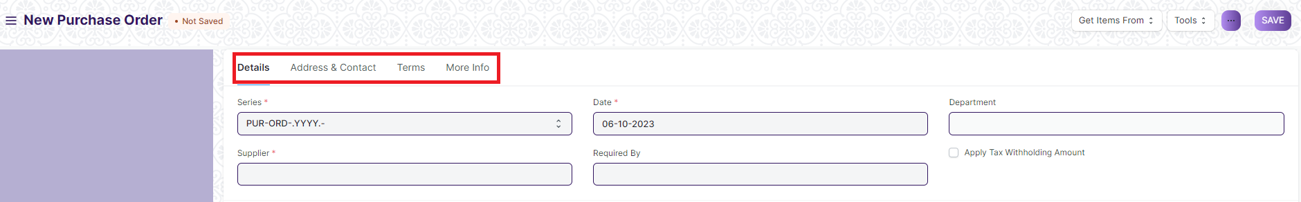

**Note**: Use Tab Break to fill all type of data

#### 21.3 Setting Stores

Set Target Store: Optionally, you can set the default target Store where the purchased Items will be delivered. This will be fetched into the Item table rows.

##### **21.4 Fetching Items from Open Purchase Requisition**

Items can be fetched into the Purchase Order automatically from open Purchase Requisition. For this to work, the following steps need to be done:

1. Select a Supplier in the Purchase Order.
2. Set default Supplier in the Item form under Item Defaults.
3. A Purchase Requisition needs to be present of type 'Purchase'.
4. Click on the Get Items from open Purchase Requisition button below the Supplier name.
5. Now a dialog will appear with Purchase Requisition containing Items for which the default Supplier is the same as the one selected in the Purchase Order.
6. On selecting the Purchase Requisition and clicking on Get Items, the Items will be fetched from the Purchase Requisition.
7. ****Purchase Receipt****

Purchase Receipts are made when you accept Items from your Supplier usually against a Purchase Order.

You can also accept Purchase Receipts directly without the need for a Purchase Order. To do this, set Purchase Order Required as “No” in Buying Settings.

#### 22.1 To access the Purchase Receipt list, go to:

Home > Material Management > Buying > Purchase Receipt.

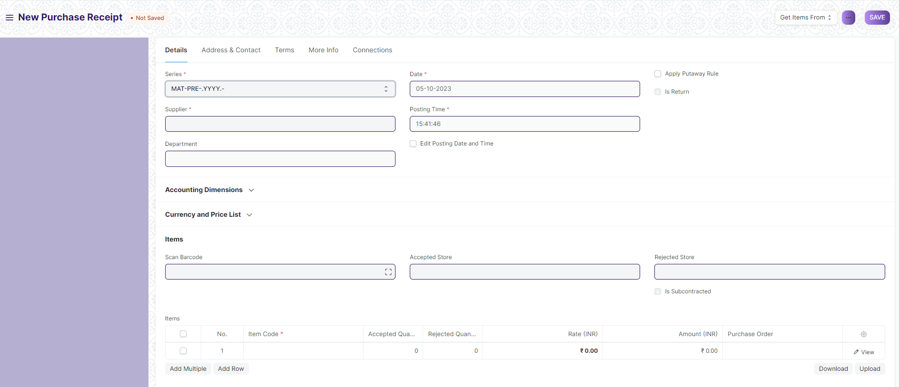



**Note**: Use Tab break to fill all data

#### 22.2 Prerequisites

Before creating and using a Purchase Receipt, it is advised that you create the following first:

* Purchase Order

#### 22.3 How to create a Purchase Receipt

A Purchase Receipt is usually created from a Purchase Order. In the Purchase Order, click on Create > Purchase Receipt.

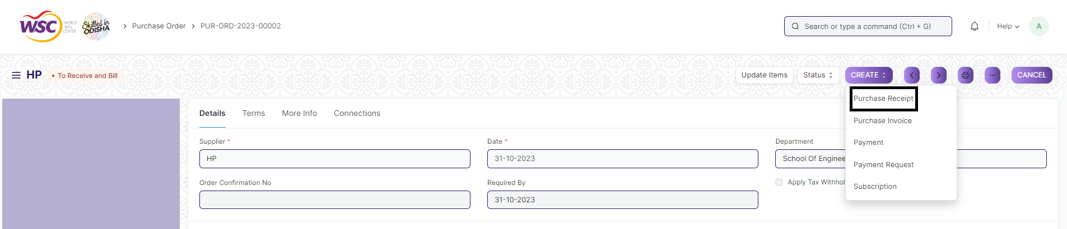

To create a Purchase Receipt manually (not recommended), follow these steps:

1. Go to the Purchase Receipt list, click on New.
2. The Supplier name and the Items can be fetched from the Purchase Order
3. You can set the Accepted Store for all items in this Purchase Receipt. This is fetched if set in Purchase Order.
4. In case any Items are defective, set the Rejected Store where those Items will be stored.
5. Select the Item and enter the quantity in the Items table.
6. The rate will be fetched and the amount will be calculated automatically.
7. Enter Address and Contact.
8. You can expand the item row to change the Accepted Store for an Item.
9. Click on Save and submit.

#### 22.4 Statuses

These are the statuses a Purchase Receipt can be in:

* Draft: A draft is saved but yet to be submitted to the system.
* To Bill: Yet to be billed using a Purchase Invoice.
* Completed: Submitted and received all the Items.
* Return Issued: All the Items have been returned.
* Cancelled: Cancelled the Purchase Receipt.
* Closed: The purpose of the Close is to manage short-closing. For example, you ordered 20 qty, but closed at 15 qty. The remaining 5 is not to be received or billed,

1. ****P********urchase Invoice****

A Purchase Invoice is a bill you receive from your Suppliers against which you need to make the payment.

Purchase Invoice is the exact opposite of your Sales Invoice. Here you accrue expenses to your Supplier. Making a Purchase Invoice is very similar to making a Purchase Order.

#### 23.1 To access the Purchase Invoice list, go to:

Home > Material Management > Buying > Purchase Invoice

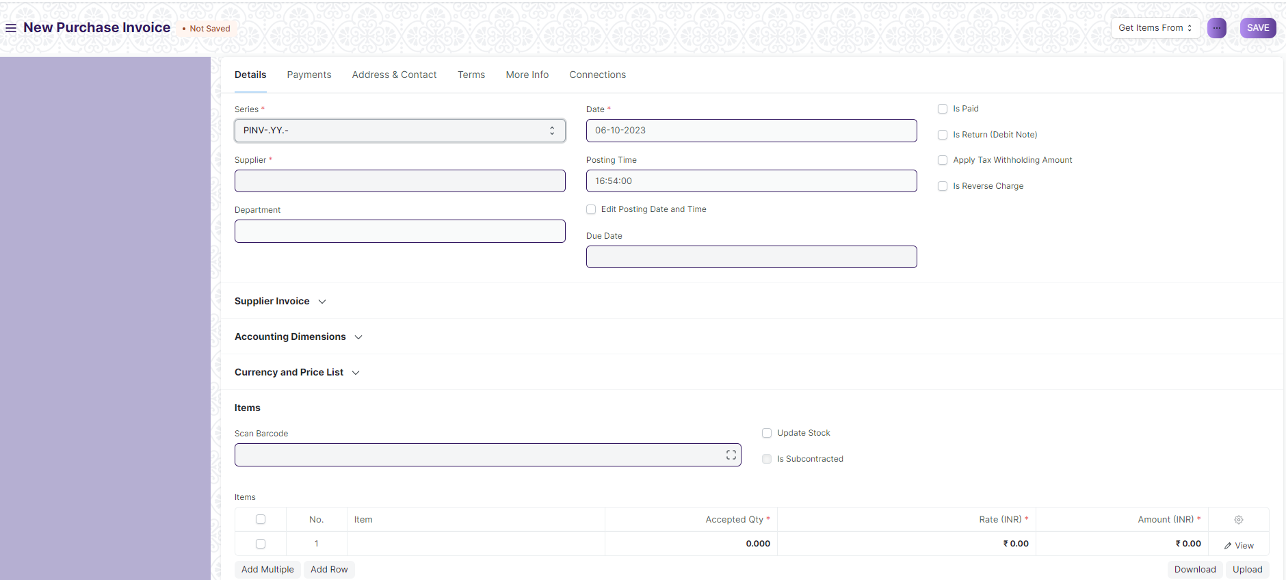

**23.2 Prerequisites**

Before creating and using a Purchase Invoice, it is advised to create the following first:

* Item
* Supplier
* Purchase Order
* Purchase Receipt (optional)

#### 23.3 How to create a Purchase Invoice:

A Purchase Invoice is usually created from a Purchase Order or a Purchase Receipt. The Supplier's Item details will be fetched into the Purchase Invoice. However, you can also create a Purchase Invoice directly.

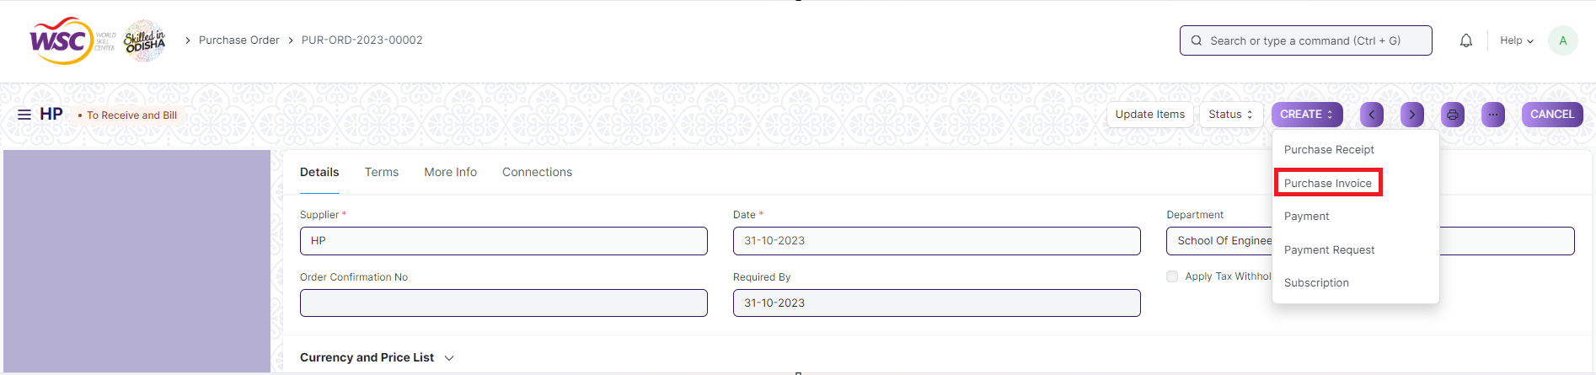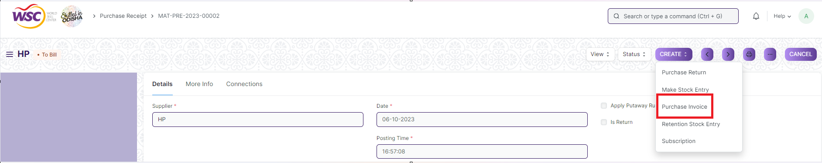

To fetch the details automatically in a Purchase Invoice, click on the Get Items from. The details can be fetched from a Purchase Order or Purchase Receipt.

For manual creation, follow these steps:

1. Go to the Purchase Invoice list, click on New.
2. Select the Supplier.
3. The posting date and time will be set to current, you can edit after you tick the checkbox below Posting Time.
4. Set the Due Date for payment.
5. Add Items and quantities in the Items table.
6. The Rate and Amount will be fetched.
7. Click on Save and Submit.

#### 23.4 Additional options when creating a Purchase Invoice

* Is Paid: You can tick 'Is Paid' if the amount has already been paid via an Advance Payment Entry. This should be ticked if there is full or partial payment.
* Is Return (Debit Note): Tick this if the customer has returned the Items.
* Apply Tax Withholding Amount: If the selected Supplier has a Tax Withholding Category set, this checkbox will be enabled.

#### 23.5 Statuses

* Draft: A draft is saved but yet to be submitted to the system.
* Return: The Items have been returned to the Supplier.
* Debit Note Issued: The Items have been returned and a Debit Note has been issued against the invoice.
* Submitted: The Purchase Invoice has been submitted to the system and the general ledger has been updated.
* Paid: Supplier has been fully paid the invoice amount and the corresponding Payment Entries have been submitted.
* Partly Paid: Supplier has been paid a part of the invoice amount and the corresponding Payment Entries have been submitted.
* Unpaid: The Purchase Invoice is yet to be paid.
* Overdue: The due date has passed for payment.

Cancelled: The invoice has been canceled due to some reason.

1. ****Stock Entry****

A Stock Entry lets you record Item movement between Stores.

To access the Stock Entry list, go to:

Home>Material management>Stock Transaction>Stock Entry

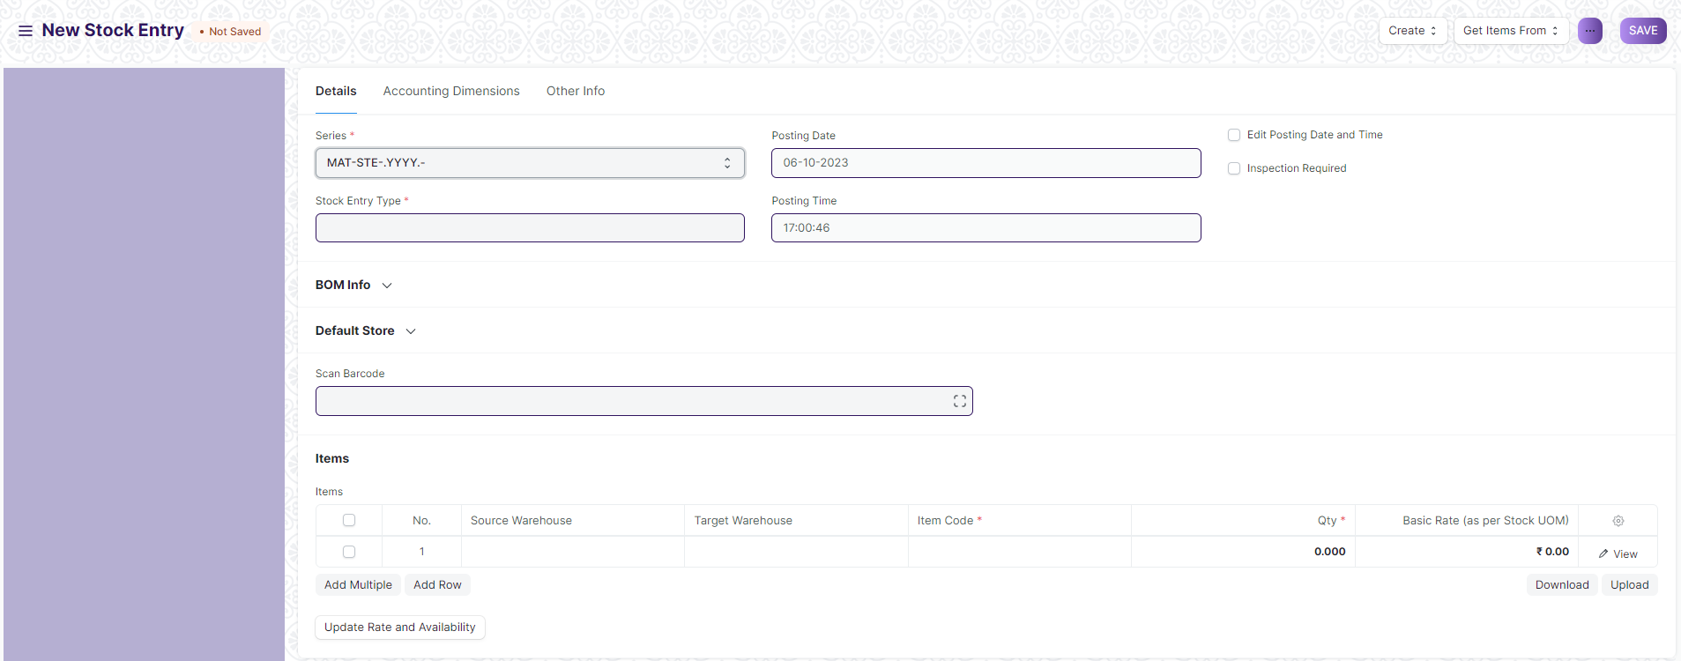

* Material Issue: If the material is being issued to someone in or outside the company (Outgoing Material). The Items will be deducted from the Store set under Source Store.
* Material Receipt: If the material is being received (Incoming Material). The Items will be added to the Store set under Target Store.
* Material Transfer: If the material is being moved from one internal Store to another.
* Material Transfer for Manufacturing: If raw materials are being transferred for manufacturing. The transfer can happen against a Work Order or a Job Card.

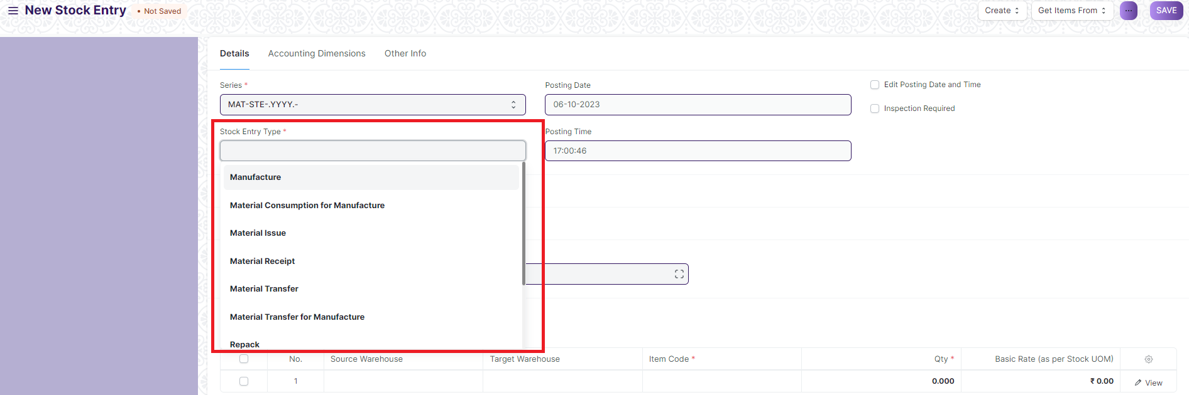

* Material Consumption for Manufacture: There can be multiple consumption stock entries against a manufacturing Work Order. Refer this link for more details
* Manufacture: If the Material is being received from a Manufacturing/Production Operation.
* Repack: If the Original item/items are being repacked into new item/items.
* Send to Subcontractor: If the Material is being issued for a sub-contract activity. This entry is made from a Purchase Order.

### 24.1 Prerequisites

Before creating and using a Stock Entry, it is advised that you create the following first:

* Store
* Item

#### 24.2 How to create a Stock Entry

Stock Entries for Manufacturing purposes are usually created from a Work Order. To create a Stock Entry manually for other purposes, follow these steps:

1. Go to the Stock Entry list, click on New.
2. Select the Stock Entry Purpose from the ones listed above.
3. If you set the Default Source or Target Stores, they'll be automatically filled for the rows in the Items table.
4. Source/Target Stores will be available as per the Stock Entry Purpose you selected.
5. Select Items and enter a quantity.
6. The basic rate will be fetched and the amount will be calculated automatically.
7. Click on Save and Submit.

Usually, "Source Store" and "Target Store" both are set for recording a movement.

##### 24.2.1 Additional options when creating a Stock Entry

* Work Order: If this is a Manufacturing entry, the Work Order will be shown in this field.
* Edit Posting Date and Time: Will allow you to edit the Stock Entry's date and time.
* Inspection Required: If a Quality Inspection needs to be performed on the Items before submitting the Stock Entry.
* From BOM: If this is a Manufacturing entry, the associated BOM for the Item being manufactured will be shown.

#### 24.3 Stock Entry Type

You can also create a Stock Entry Type where only the name will be different, for example 'Scrap Entry'. The purpose will be Material Transfer but the name will be different. This is useful if you want certain Users to have access only to specific actions related to stock.

#### 24.4 Features

##### 24.4.1 The Items table

Details about the Item, Rate, Quantity, etc. will be shown here.

Ticking on 'Allow Zero Valuation Rate' will allow submitting the Purchase Receipt even if the Valuation Rate of the Item is 0. This can be a sample item or due to a mutual understanding with your Supplier.

Different Source and Target Stores can be set for different Items.

##### 24.4.2 Additional Costs

If the stock entry is an incoming entry i.e any item is receiving at a target Store, you can add related additional costs (like Shipping Charges, Customs Duty, Operating Costs, etc) associated with the process. The additional costs will be considered to calculate the Valuation Rate of the items.

To add additional costs:

1. Select the Expense Account to which the expense from this Stock Entry will be recorded.
2. Enter the description and amount of the cost in the Additional Costs table.

The added Additional Costs will be distributed among the receiving items (where the Target Store mentioned) proportionately based on the Basic Amount of the items. And the distributed additional cost will be added to the basic rate of the item, to calculate Valuation Rate.

Quantity and Rate is shown as follows when you expand the Items table.

##### 24.4.3 Accounting Dimensions

You can tag different transactions based on different dimensions. By default, Projects can be considered as a dimension as it is a common practice to track costs of different projects.

##### 24.4.4 More Information

* Is Opening: If this entry is the opening stock entry for the Items.
* Remarks: Any additional remarks about the Item.
* Percentage Transferred: The percentage of Items transferred depending on Stock Entry purpose.
* Total Amount: The total amount of Items transferred.

##### 24.4.5 Perpetual Inventory

If the perpetual inventory system is enabled, additional costs will be booked in Expense Account mentioned in the Additional Costs table.

##### 24.4.6 After Submitting

After submitting a Stock Entry, you can go to the stock ledger or the accounting ledger from the dashboard.

1. ****Stock Settings****

You can set default settings for your stock related transactions from the Stock Settings page.

Home>Material management>Stock Transaction>Stock Settings

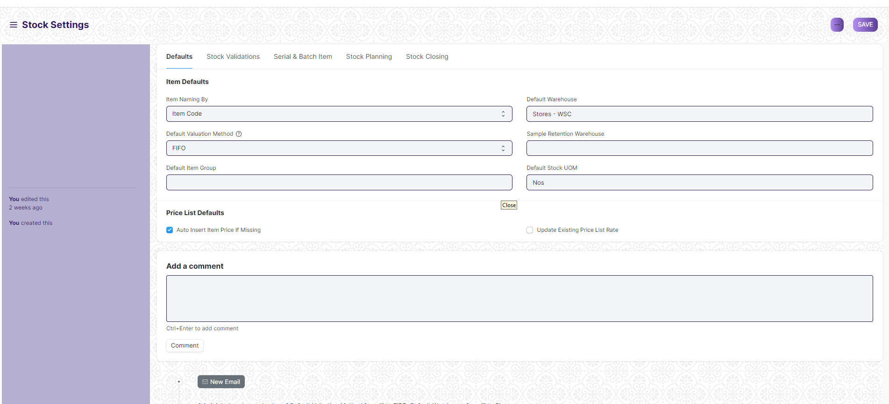

**25.1. Item Naming By**

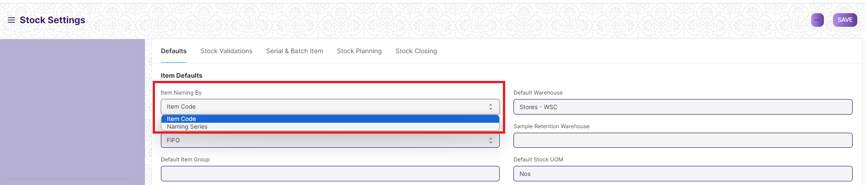

By default, the Item Name is set as per the Item Code entered. If you want Items to be named by a set [Naming Series](https://docs.erpnext.com/docs/v13/user/manual/en/setting-up/settings/naming-series) choose the 'Naming Series' option .

**25.2. Defaults**

**25.2.1 Default Item Group**

This will be the default item group allocated to a newly created item. Item groups are useful for classification and setting properties for the whole group. To know more visit the Item Group page.

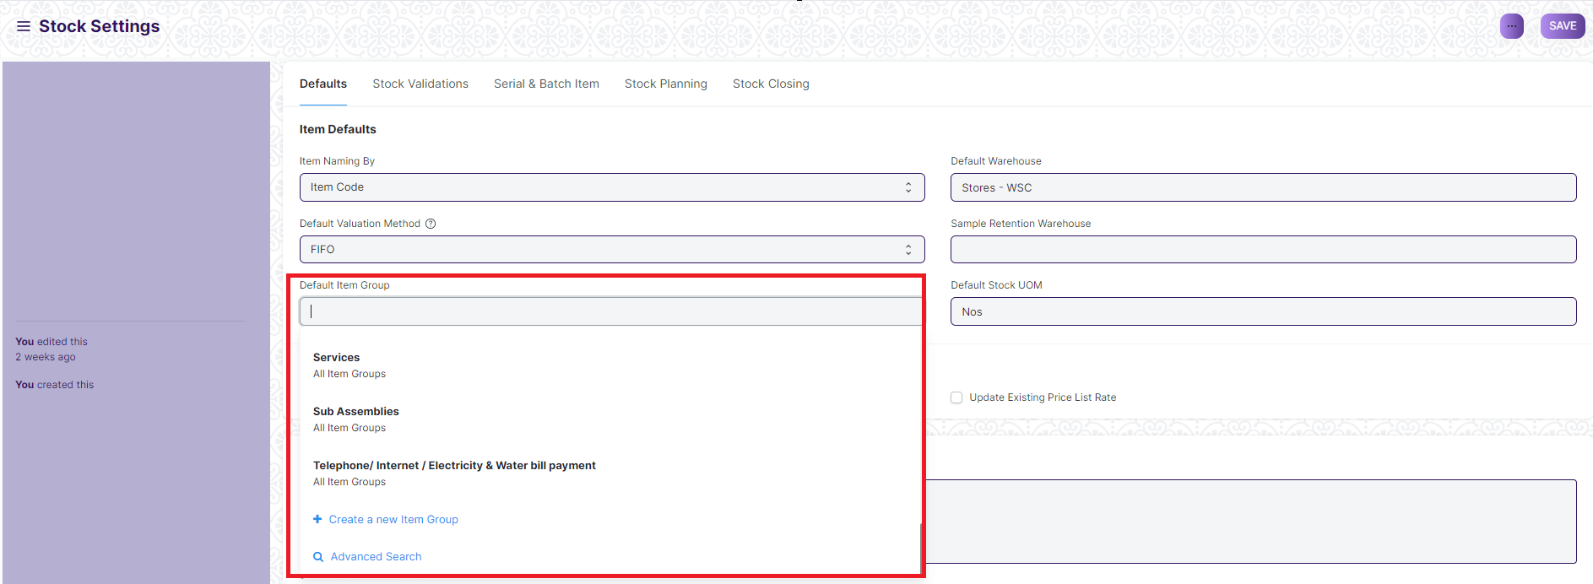

**25.2.2 Default Stock UOM**

The default unit of measure for stock is set as numbers (Nos), it can be changed from here.

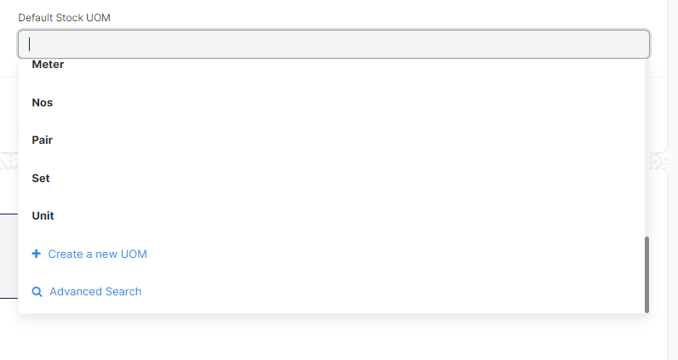

**25.2.3 Default Store/Warehouse**

Set the default Store from which the stock transactions are done. This will be fetched into the Default Store in the Item master:

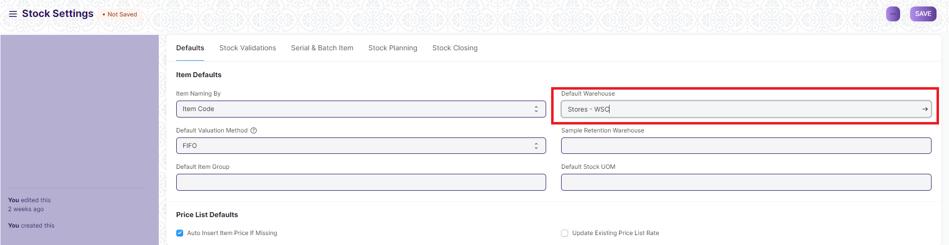

**25.2.4 Sample Retention Store/Warehouse**

This is the Store where sample retention's are stored.

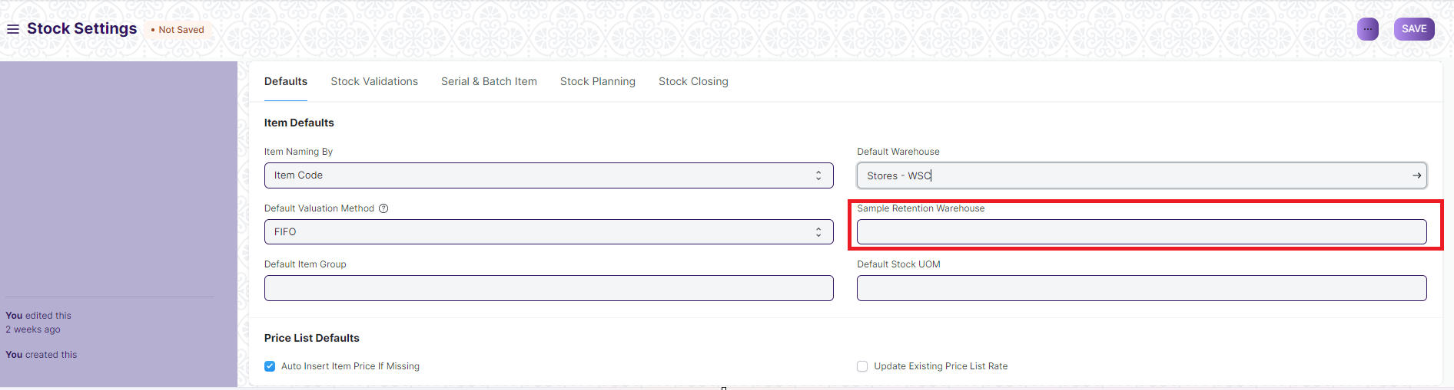

**25.2.5 Default Valuation method**

FIFO - first in first out or moving average valuation for your items. The default method is FIFO. If you select Moving Average, new Items will be valuated on Moving Average. You can change this when creating new Items in the Item form. Once the Item is saved, the Valuation Method cannot be changed.

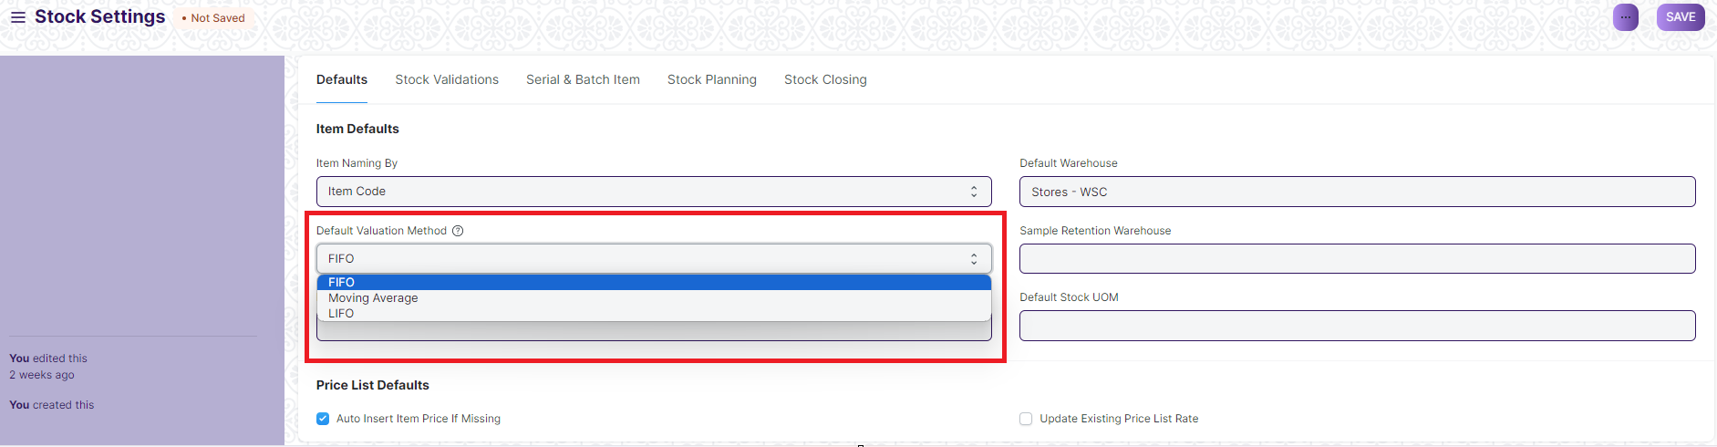

**25.3. Limit Percent**

This is the percentage you are allowed to receive or deliver more against the quantity ordered. For example: If you have ordered 100 units, Supplier sends 120 units and the percentage is set to 10% then you are allowed to receive 110 units. By default, this is set to 0.

**25.4. Role Allowed to Over Deliver/Receive**

Users with this role are allowed to over deliver/receive against orders above the allowance percentage

**25.5. Show Barcode Field**

A field to enter Barcode details for an item. If unticked, the field won't be visible in the Item form.

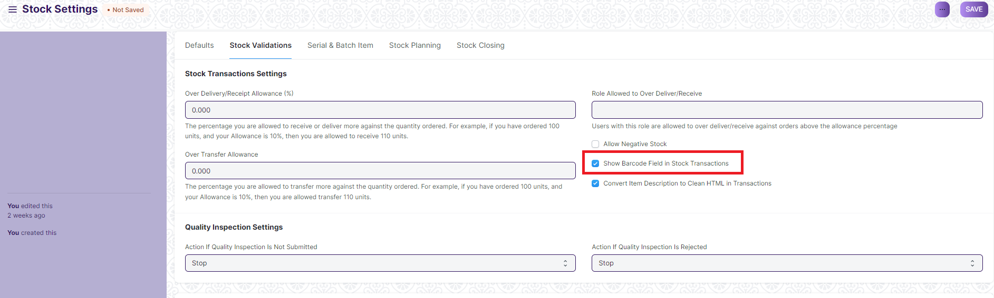

**25.6. Convert Item Description to Clean HTML**

Usually, descriptions are copy-pasted from a website or Word/PDF file and they contain a lot of embedded styles. This messes up the Print view of your invoices or quotes.

To fix this, you can check "Convert Item Description to Clean HTML" in Stock Settings. This will ensure that when you save the Items, their descriptions will be cleaned up.

If you want to control your description, views, and allow any HTML to be embedded, you can uncheck this property.

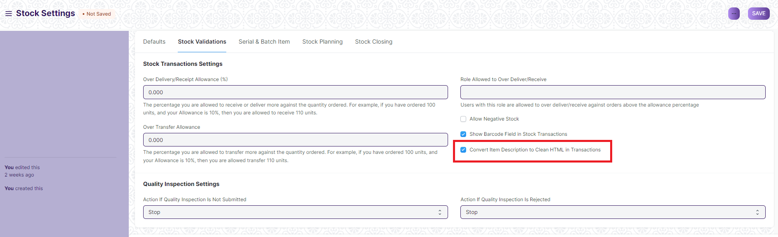

**25.7. Auto insert**

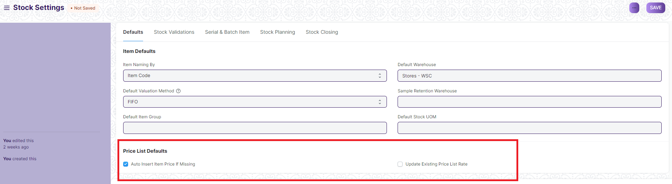

**25.7.1 Auto insert Price List rate if missing**

Enabling this will insert an Item Price to the Price List of an Item automatically when using the Item in its first transaction. This price is fetched from the 'Rate' set in the first transaction with the Item. The Price List depends on whether you're using a Purchase or Sales transaction.

Note that, the Item Price will be automatically inserted only in the first transaction if not already present.

If this is unticked, the 'Standard Selling Rate' set in the Item when creating the Item will be added as Item Price.

**25.7.2 Automatically Set Serial Nos based on FIFO**

Serial numbers for stock will be set automatically based on the Items entered based on first in first out. The Serial Numbers will be set automatically in transactions like Purchase/Sales Invoices, Delivery Notes, etc.

**25.8. Allow Negative Stock**

This will allow stock items to be displayed in negative values. Using this option depends on your use case. For example, the stock transaction entries are entered at the weekend or month-end. In this case, negative stock needs to be enabled so that you can continue with your purchase/sales transaction entries.

**25.9. Set Qty in Transactions based on Serial No Input**

The quantity of items will be set according to the serial numbers. For example, if the user has added serial nos like A001, A002, and A003 then the system will set the quantity as 3 in the transaction.

**25.10. Automatic Material Request**



**25.10.1 Raise Material Request when the stock reaches re-order level**

This option is useful if you want to ensure a constant supply of raw materials/products and avoid shortage. A Material Request will be raised automatically when stock reached the re-order level defined in the Item form.

**25.10.2 Notify by Email on the creation of automatic Material Request**

An email will be sent to notify the User with the role 'Purchase Manager' when an automatic Material Request is created.

**25.11. Inter Store/Warehouse Transfer Settings**

**25.11.1 Enable customer Store for material transfer from Delivery Note and Sales Invoice**

This option is useful when material transfer needs to be presented as a Delivery Note. For example, if there are statutory requirements where taxes are to be applied on each transfer of Material. It is easier to manage in a transaction like Delivery Note, than in the Stock Entry

**25.11.2 Enable supplier Store for material transfer from Purchase Receipt and Purchase Invoice**

Similar to above option this option is useful when material transfer needs to be presented as Purchase Receipt.

To know more about inter Store material transfer via Delivery Note and Purchase Invoice please refer this article Material Transfer From Delivery Note

**25.12. Freeze Stock Entries**

The User will not be allowed to make stock postings beyond this date.

* ****Stock Frozen Upto****: A threshold date till which stocks will be frozen.
* ****Freeze Stocks Older Than [Days]****: Stocks older than x days will be frozen. This is calculated based on the creation date of the item.
* ****Role Allowed to edit frozen stock****: The role you choose here will be allowed to edit frozen stock.

1. ****Serial No****

As discussed in the Item page, if an Item is *serialized*, a Serial Number (Serial No) record is maintained for each quantity of that Item. This information helps track the location of the Serial No, it’s warranty and end-of-life (expiry) information.

Serial Nos are also useful to maintain fixed assets. Maintenance Schedules can also be created against Serial Numbers for planning and scheduling maintenance activity for these assets (if they require maintenance).

You can also track from which Supplier you purchased the Serial No and to which Customer you have sold it. The Serial No status will tell you its current inventory status.

If your Item is *serialized,* you will have to enter the Serial Nos in the related column with each Serial No in a new line. You can maintain single units of serialized items using Serial Number.

To access the Serial Number list, go to:

Home > Material Management > Serial No and Batch > Serial No

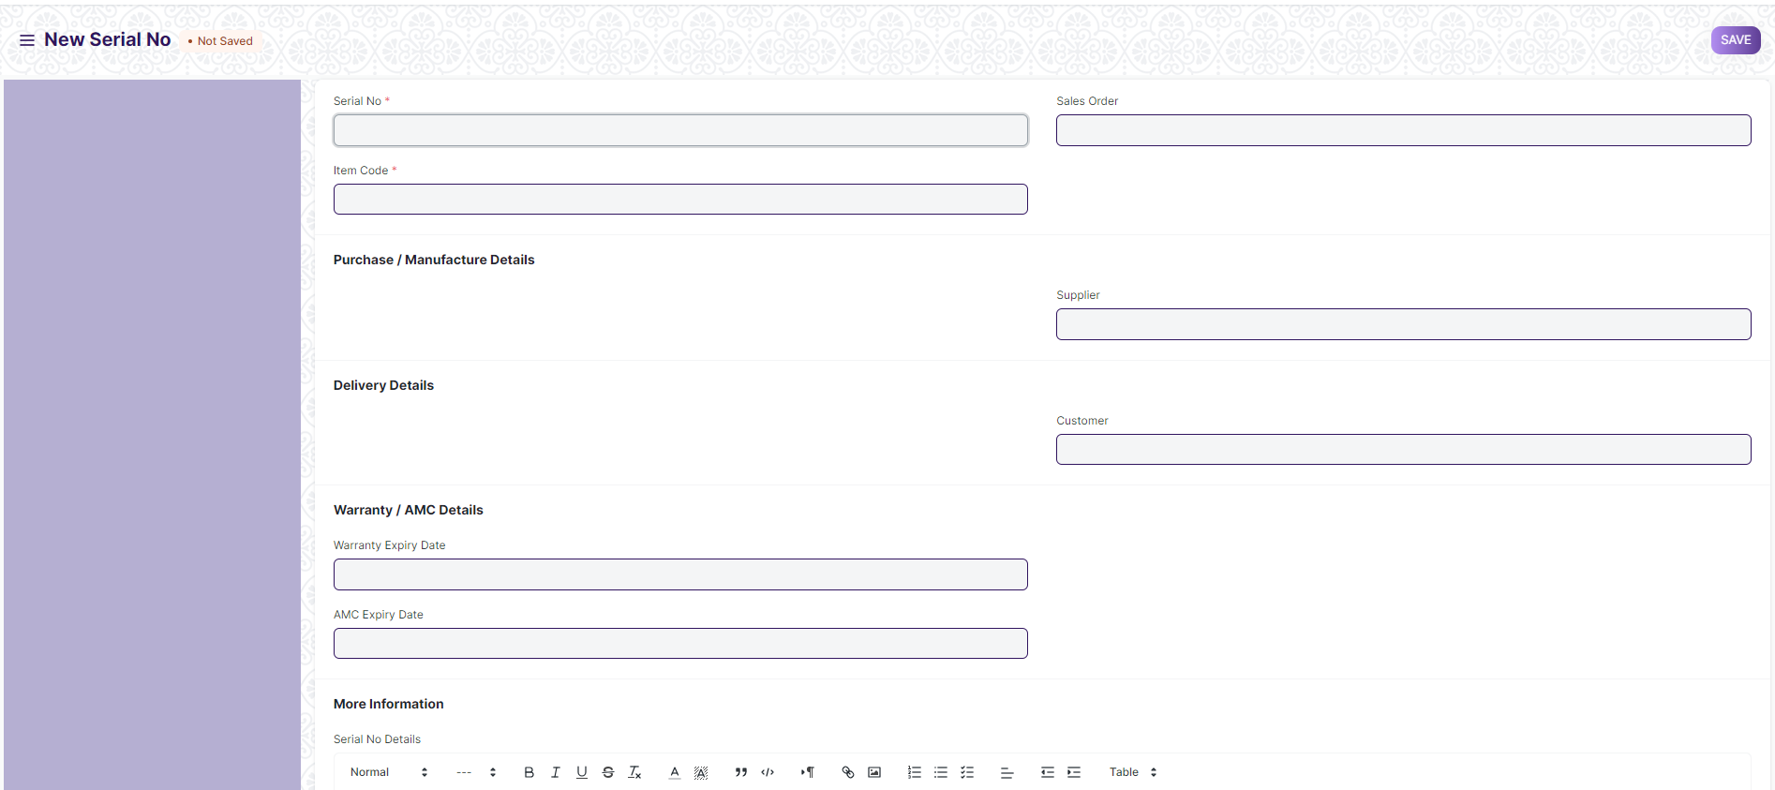

**26.1 Prerequisites**

Before creating and using a Serial Number, it is advised that you create the following first:

* Item
* Enable 'Has Serial No' in the Item master

#### 26.2 How to create a Serial Number

Usually, Serial Numbers are auto-created when transactions are made against a serialized Item. This works only when 'Has Serial No' is enabled and a series is set in the Item master.

For example, a series was set for the following Item as 'PB2L.#####'. Then a Stock Entry was submitted to receive the Item. The Serial Numbers were created accordingly.

However, if you want to create a Serial No *manually* follow these steps:

1. Go to the Serial Number list, click on New.
2. Enter a Serial Number.
3. Enter the Item Code and details will be fetched.
4. If any transaction is done with an item, Serial No cannot be set or unset.
5. Click on Save.

Inventory of an Item can only be affected if the Serial No is transacted via a Stock transaction. When a new Serial No is created directly, its Store cannot be set.

##### 26.2.1 Notes about Serial Number

* The Status is set based on Stock Entry.
* Only Serial Numbers with status 'Available' can be delivered.
* Serial Nos can automatically be created from a Stock Entry or Purchase Receipt. If you mention Serial No in the Serial Nos column, it will automatically create those serial Nos.
* If in the Item Master, the Serial No Series is mentioned, you can leave the Serial No column blank in a Stock Entry / Purchase Receipt. Serial Nos will automatically be set from that series.

#### 26.3 Features

##### 26.3.1 Purchase/Manufacture details

The document from which the Serial No was created will be shown. If you purchased it from

a Supplier, it'll be linked here.

##### 26.3.2 Delivery Details

If the Serial No was generated from a Sales Order, the Customer will be linked here.

##### 26.3.3 Warranty/AMC Details

If the Item is under warranty or AMC (Annual Maintenance Contract), the expiry dates for

these can be set.

##### 26.3.4 More Information

Any additional information about this specific Item unit can be set under 'Serial No Details'.

1. ****Batch****

Batch feature allows you to group multiple units of an Item and assign them a unique value/number/tag called Batch No.

This is done based on the Item. If the Item is batched, then a Batch number must be mentioned in every stock transaction. Batch numbers can be maintained manually or automatically. This feature is useful to set the expiry date of multiple Items or move them together to different Stores.

Home > Material Management > Serial No and Batch > Batch

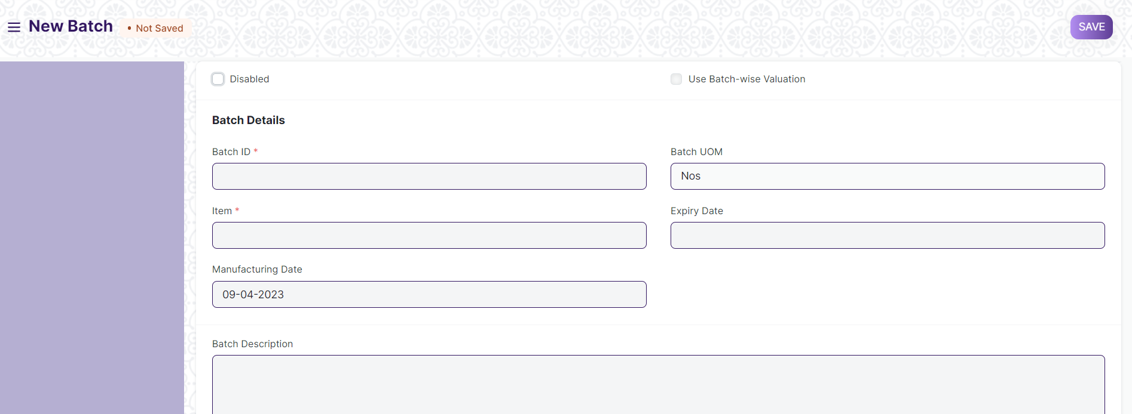

**27.1 Prerequisites**

* [Item](https://docs.erpnext.com/docs/v13/user/manual/en/stock/item)
* Enable 'Has Batch No' in the Item master

#### **27.2 How to create a new Batch**

To set item as a batch item, "Has Batch No" field should be checked in the Item master. If you have not selected "Automatically Create New Batch" when creating an Item, you will have to make Batches Manually as you go along.

To create new Batch No. master for an item, go to:

1. Go to the Batch list, click on New.
2. Set the Batch ID.
3. Select the Item.
4. If any transaction is done with an item, the batch cannot be set or unset.
5. Save.

When Batches are enabled for an Item, the option to [retain sample stock](https://docs.erpnext.com/docs/v13/user/manual/en/stock/retain-sample-stock) also becomes available.

##### **27.2.1 Batch Auto Creation**

If you want automatic batch creation at the time of Purchase Receipt, you must tick 'Automatically Create New Batch' in the Item master:

#### **27.3 Features**

##### **27.3.1 Splitting and Moving Batches**

When you open a batch, you will see all the quantities that belong to that batch on the page.

* To move the batch from one Store to another, you can click on the **Move** button.
* You can also split the batch into smaller one by clicking on the **Split** button. This will create a new Batch based on this Batch and the quantities will be split between the batches.
* If you set expiry date, the Batch will show 'Not Expired' until the expiry date, after which it'll show 'Expired'. If a date is not set, the Batch will show 'Not Set'.

##### **27.3.2 Transacting Items with Batches**

A Batch master should be created before the creation of Purchase Receipt. Hence, every time a Purchase Receipt or Work Order is being made for a batch item, you will first create its Batch No, and then select it in the Purchase order or Stock Entry.

On every stock transaction (Purchase Receipt, Delivery Note, Invoice) with a batch item, you should provide the Item's Batch No.

1. ****Assets****

**An Asset is any valuable Item owned by a Company.**

Furniture, computers, mobile phones, printers, cars, manufacturing equipment are examples of assets. Generally, an asset is a tangible item that is located on the company premises or is carried by an employee. In some cases, an asset could be an intangible item.

An asset's useful life spans across multiple years and hence its economic value is spread over corresponding years from the accounting perspective. If you buy a printer for $300 and it is expected to be useful for three years, from the accounting perspective $100 is recorded as the expense for three years each instead of all the $300 in the first year. Most countries have rules for such calculations.

The Asset record is the heart of asset management module. All the transactions related to an Asset like purchasing, depreciation, maintenance, movement, scrapping, sales will be recorded against the Asset record.

Home > Material Management > Assets > Asset

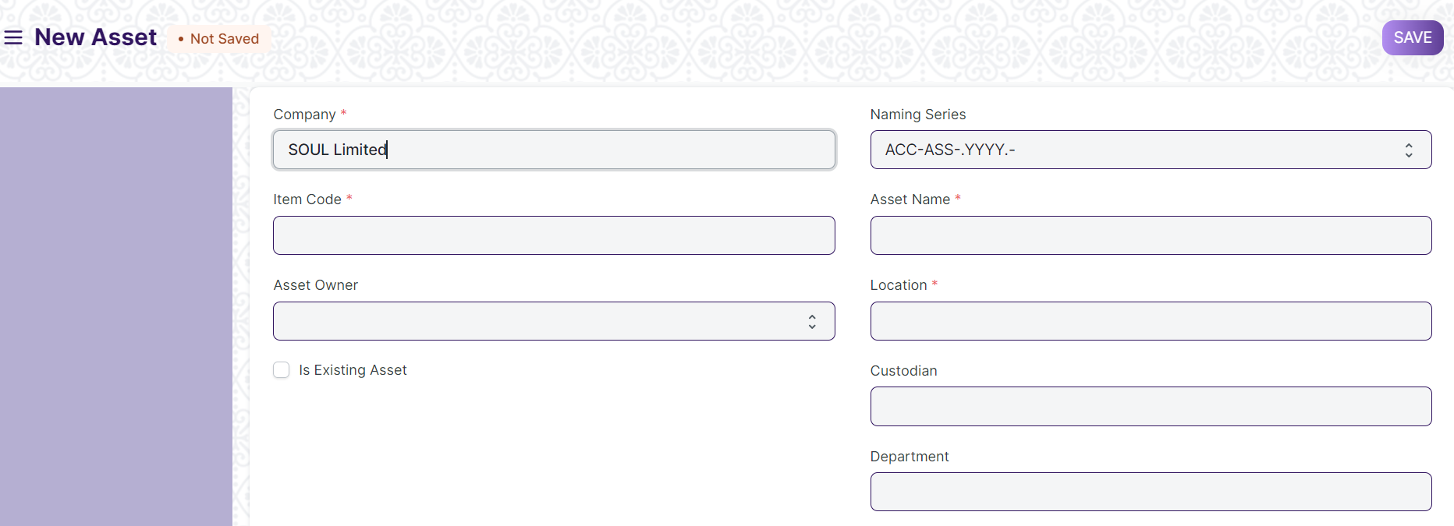

#### 28.1 Prerequisites

* [Item](https://docs.erpnext.com/docs/v13/user/manual/en/stock/item) with 'Is Fixed Asset' enabled.
* [Asset Category](https://docs.erpnext.com/docs/v13/user/manual/en/asset/asset-category)

#### 28.2 How to create an Asset

An Item representing the asset should be created. The **'Maintain Stock'** should be **unchecked** and **'Is Fixed Asset'** must be **checked**.

##### 28**.2.1 Auto creation of assets**

You can automatically create assets on submission of Purchase Receipt by enabling **'Auto Create Assets on Purchase'** in Item.

If you have enabled auto asset creation for the item representing an asset, you will have to provide the asset location while submitting the Purchase Receipt.

A message confirming the creation of assets is displayed on submission of Purchase Receipt.

##### 28**.2.2 Manual creation of assets**

If you would like to create assets manually, create an Item with 'Is Fixed Asset' enabled and leave 'Auto Create Assets on Purchase' unchecked . On submission of a Purchase Receipt/Purchase Invoice with that Item a message is shown indicating that you need to create assets manually.

Follow below steps to create assets manually.

1. Go to the Assets list, click on New.
2. Enter a name for the asset.
3. Select the Item Code. Item Name and Asset Category will be fetched automatically.
4. Select the Asset Owner, i.e. Company, Supplier, or Customer.
5. Select the Company/Supplier/Customer.
6. Select the Purchase Receipt/Purchase Invoice. Purchase Date and Gross Purchase Amount will be fetched automatically.
7. Select a Location. Eg: Mumbai Office. This will be fetched automatically if specified in Purchase Receipt items table
8. Set Available-for-use Date. The depreciation will be calculated starting from this date.
9. Click on Save and Submit.

Please note you need create **one asset record for each asset you have bought**. If you have bought five computers and have created just one Purchase Receipt with quantity set to five then you will have to create five asset records manually.

##### 28**.2.3 Importing existing assets**

You will have to add details of all the assets your company has purchased previously along with depreciation details of each asset.

For an existing asset, you can create the asset record directly by checking **"Is Existing Asset"** checkbox and provide below details.

* Gross Purchase Amount
* Purchase Date
* Available-for-use Date
* Opening Accumulated Depreciation: The accumulated depreciation amount which has already been booked for an existing asset.
* Number of Depreciation's Booked: Number of depreciation entries already booked.

Based on these details the schedule for depreciation of remaining amount will be created automatically.

##### 28**.2.4 Additional options when creating an Asset**

1. ****Custodian****: The employee who will carry the asset.
2. ****Department****: The department of the Custodian.
3. ****Next Depreciation Date****: Mention the next depreciation date, even if it is the first one. If the asset is an existing one and depreciation has already been completed, leave it blank.
4. ****Calculate Depreciation****: Enable this checkbox to calculate depreciation of Assets.
5. ****Allow Monthly Depreciation****: Enable this checkbox to distribute depreciation amount of an asset into 12 months of the year. Depreciation entries will be made every month on the date provided as Depreciation Start Date. For example, if Available for Use date is 22nd Nov 2019 and depreciation Start Date is 31st March 2020, first depreciation will be done on 30th Nov 2019 second on 31st Dec 2019 and so on. Amount will be distributed based on days left until next depreciation.

#### 28**.3. Features**

##### 28**.3.1 Depreciation**

* ****Frequency of Depreciation (Months)****: The number of months between depreciation's.
* ****Total Number of Depreciation's****: The total number of depreciation's during the useful life of the Asset. In case of existing assets which are partially depreciated, mention the number of pending depreciation's. For example, if you set frequency as 12 months and no. of depreciation's as 3, 1 depreciation will be booked every 12 months for 3 years.
* ****Depreciation Method****: These are three methods used for depreciation :
  + ****Straight Line****: This method spreads the cost of the fixed asset evenly over its useful life.
  + ****Double Declining Method****: An accelerated method of depreciation, it results in higher depreciation expense in the earlier years of ownership.
  + ****Written Down Value****: In this method, the depreciation percentage is fixed but it is applied on the current value of the asset which we get after each depreciation.
* ****Depreciation Start Date****: The date from which booking of depreciation will be started.
* ****Expected Value After Useful Life****: Useful Life is the time period over in which the company expects that the asset will be productive. After that period, either the asset is scrapped or sold. In case it is sold, mention the estimated value here. This value is also known as Salvage Value, Scrap Value, or Residual Value.
* ****Rate of Depreciation****: This will be calculated based on the amount entered in expected value after useful life.

##### 28**.3.2 Depreciation Schedule**

On booking depreciation's against this Asset, the Depreciation Schedule section will be visible. This table has columns for Finance Book, Schedule Date, Depreciation Amount, Amount Depreciated, and Journal Entry.

##### 28**.3.3 Insurance Details**

If Insurance has been taken for the Asset you're recording, you can store the following Insurance details:

* Policy number
* Insurer
* Insured value
* Insurance Start Date
* Insurance End Date
* Comprehensive Insurance

##### 28**.3.4 Accounting Entries**

On submission of an asset, "Capital Work in Progress" account will be credited and the asset account related to the asset will be debited. Submission is only possible after entering "Available-to-use Date". If "Available-to-use Date" is a future date, then accounting entry will be booked automatically on that date via the scheduler.

##### 28**.3.5 Maintenance**

Ticking on Maintenance Required allows recording Asset Maintenance entries for this Asset.

##### 28**.3.6 After Submitting**

Once you create an Asset, you'll see options to transfer, scrap, or sell the asset. From the Make button, you can adjust its value and make a depreciation entry.

1. ****Location****

**Asset Location shows where an Asset is located.**

The assets that your organization owns can be located at various facilities like administrative offices, manufacturing plants, Stores, etc. You can create a 'Location' for each of your facilities and track the assets which are present in these locations.

You can also add Latitude and Longitude of the location. When an asset is moved from one location to another, you need to create an Asset Movement record.

Home > Material Management > Assets > Location

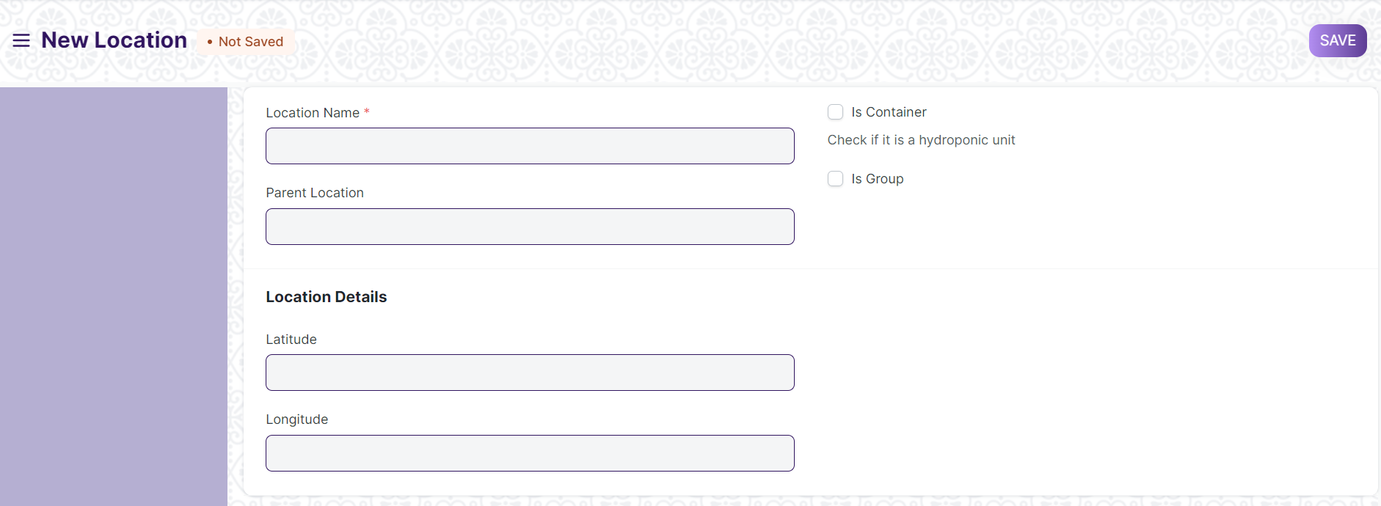

1. ****Asset Category****

**An Asset Category classifies different assets of a Company.**

The first step towards asset management is creating an Asset Category based on the type of assets. For example, all your desktops and laptops can be part of an Asset Category named "Electronic Equipment's".

In Asset Category, you can set default a depreciation method, periodicity and depreciation related accounts, which will apply to all the assets under the category.

Home > Material Management > Assets > Asset Category

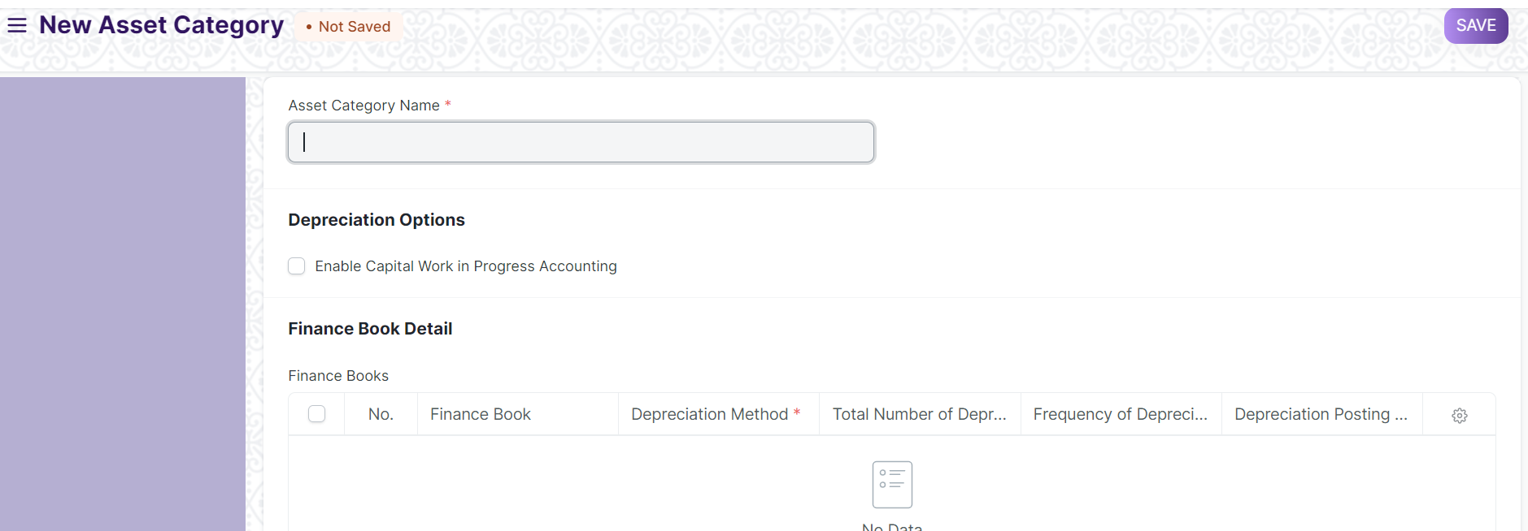

#### **30.1 How to create an Asset Category**

1. Enter a name for the Asset Category.
2. Check 'Enable Capital Work in Progress Accounting' if you want to maintain records of assets under a temporary balance sheet account instead of the corresponding asset account.
3. Click on Save

##### **30.1.1 Additional options when creating an Asset Category**

1. ****Enable Capital Work in Progress Accounting****: On enabling this, accounting entry for assets under this category which are not in use are posted in the Capital Work in Progress accounts. This happens when you own the Asset but it isn't being used yet, i.e. 'Available for Use Date' is set at a later date. If you use all your assets immediately, disable this feature. On disabling this, CWIP accounting will be skipped.

#### **30.2 Features**

##### **30.2.1 Finance Book details**

You can link a Finance Book if you report depreciation in different ways. You can enter the following fields:

* ****Depreciation Method****: Choose a depreciated method on which you'll record the depreciation of assets in this category.
* ****Frequency of Depreciation (Months)****: The number of months within which the depreciation will be booked. The asset may be scrapped after this period.
* ****Total Number of Depreciation's****: The number of deprecation's to be booked in the selected time frame.
* ****Rate of Depreciation****: The rate of deprecation applied over the selected period. This will be calculated based on the Depreciation Method selected.

##### **30.2.2 Accounting Details**

The following account details can be set to record asset values in the ledger:

* Company
* Fixed Asset Account
* Accumulated Depreciation Account
* Depreciation Expense Account
* Capital Work In Progress Account

1. ****Asset Movement****

**Asset Movement refers to moving an Asset from one Location to another.**

You can track the location of an asset or to whom it is issued. For tracking, you need to create an Asset Movement transaction, whenever the asset is moved from one location to another. You can also keep a track of issuance of an asset to any employee.

Home > Material Management > Assets > Asset Movement

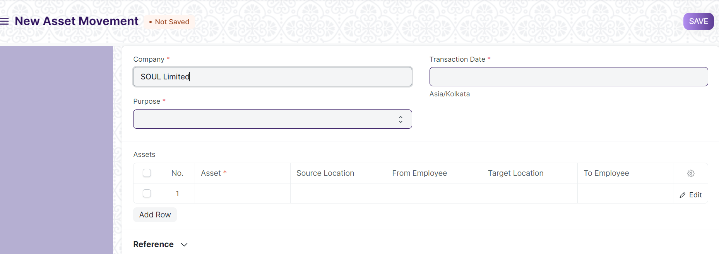

#### **31.1 Prerequisites**

* Asset
* Asset location

#### **31.2 How to create an Asset Movement**

1. Go to the Asset Movement list, click on New.
2. Select the Purpose from 'Issue', 'Receipt', or 'Transfer'. Mandatory fields will be changed based on purpose.
3. Select a date.
4. Select Assets you want to move. Current Location / Custodian will be automatically fetched.
5. Select Reference Document Type (Optional).
6. Select Reference Document Name (Optional).
7. Click on Save and Submit

To make an Asset Movement of a number of assets, it is advised to go to Asset List, select assets to be moved and click on **Make Asset Movement** from Actions menu on the top left.

There is also a **Transfer Asset** button on the top right of the Asset form to initiate Asset Movement. It auto fills available fields from Asset Form.

1. ****Asset Maintenance Team****

**The Asset Maintenance Team is responsible for carrying out maintenance activities on the Asset.**

The maintenance activities can be cleaning, polishing, servicing, or any other activity required to maintain the Asset in good condition.

Home > Material Management > Maintenance > Asset Maintenance Team

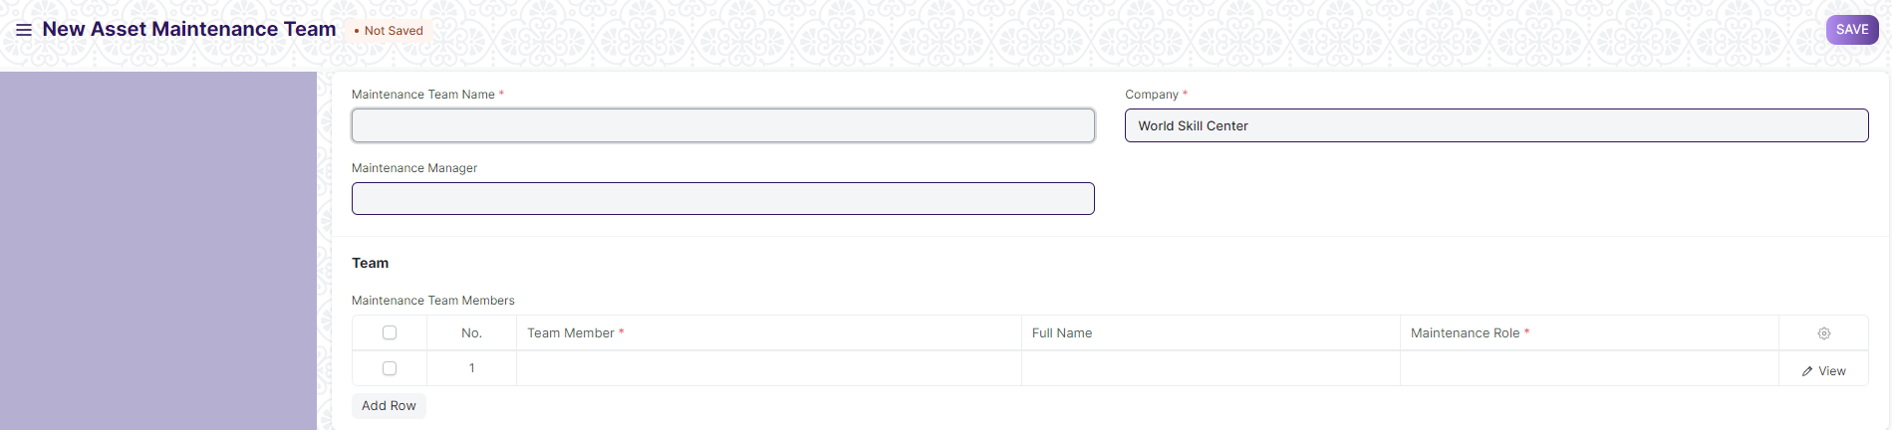

#### **32.1 Prerequisites**

* Employee
* Asset

#### **32.2 How to create an Asset Maintenance Team**

1. Go to the Asset Maintenance Team list, click on New.
2. Enter a name for the team.
3. Select a manager for the team.
4. In the Maintenance Team Members table, add the team members and select their maintenance [roles](https://docs.erpnext.com/docs/v13/user/manual/en/setting-up/users-and-permissions/role-and-role-profile).
5. Save.
6. ****Asset Maintenance****

**Asset Maintenance refers to any activity done on Assets to maintain their performance or condition.**

To track the details of individual maintenance/calibration tasks for an asset by date, the person responsible for the maintenance, and future maintenance due date.

To perform Asset Maintenance:

1. Enable 'Maintenance Required' from the Asset master.
2. Create an Asset Maintenance Team.
3. Create the Asset Maintenance.
4. An Asset Maintenance Log is created.
5. Create Asset Repair Log.

Home > Material Management > Maintenance > Asset Maintenance

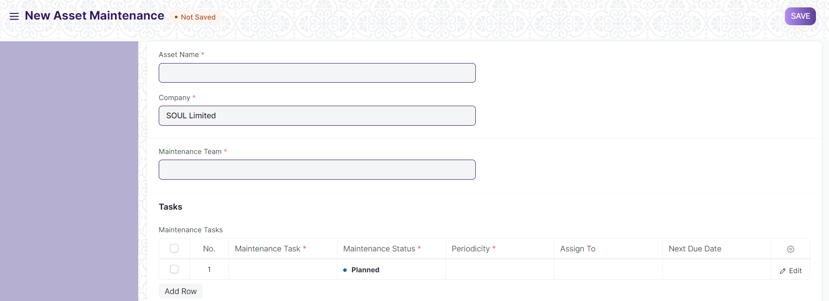

#### **33.1 Prerequisites**

* Asset with ‘Maintenance Required’ Checked
* Asset Maintenance Team

#### **33.2. How to create Asset Maintenance**

For each asset, create an Asset Maintenance record listing all the associated maintenance tasks, maintenance type (Preventive Maintenance or Calibration), periodicity, assign to and start and end date of maintenance

1. Go to the Asset Maintenance list, click on New.
2. Select the Asset.
3. Select the Asset Maintenance Team.
4. Add Maintenance Tasks in the table.
5. Set the Maintenance Status whether 'Planned', 'Overdue', or 'Canceled'.
6. Select a periodicity for which the task needs to be carried out. The next due date will be calculated.
7. Click on Save.
8. After saving, you can assign the task to a user.
9. If the Item is serialized, the Serial Number can be entered.

#### **33.3 Features**

##### **33.3.1 Maintenance Tasks**

* ****Maintenance Type****: Whether this is a 'Preventive' maintenance activity or 'Calibration' to restore accurate functioning.
* ****Start and End Date****: Set the start date and end date when the maintenance is supposed to begin and end.
* ****Last Completion Date****: If the maintenance was not carried out on or before the scheduled date, the actual date of maintenance can be recorded here.

1. ****Asset Maintenance Log****

**Asset Maintenance Log logs the tasks carried out in an Asset Maintenance.**

For each task in Asset Maintenance, Asset Maintenance Log is **auto created** to keep track of the upcoming maintenance's. It will have a status, completion date and actions performed. Based on completion date here, next due date is calculated automatically and new Asset Maintenance Log is created.

Home > Material Management > Maintenance > Asset Maintenance Log

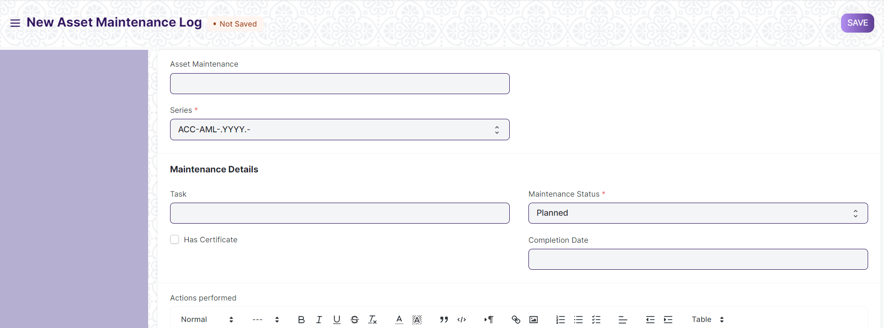

#### **34.1 Prerequisites**

* Asset Maintenance

#### **34.2 Options in Asset Maintenance Log**

A Draft of the Asset Maintenance Log is created as scheduled in the Asset Maintenance form. In order to submit an Asset Maintenance Log, the Asset Maintenance status has to either 'Completed' or 'Canceled'.

* The status of the Asset Maintenance Log can be 'Planned', 'Completed', 'Canceled', or 'Overdue'.
* Additional notes can be added in the Actions performed section to describe the activity in detail.

1. ****Asset Repair****

**Asset Repair refers to any activity carried to repair a broken Asset to restore full functionality.**

You can also maintain the records of Repair/Failures of Assets which are not listed in Asset Maintenance.

Home > Material Management > Maintenance > Asset Repair

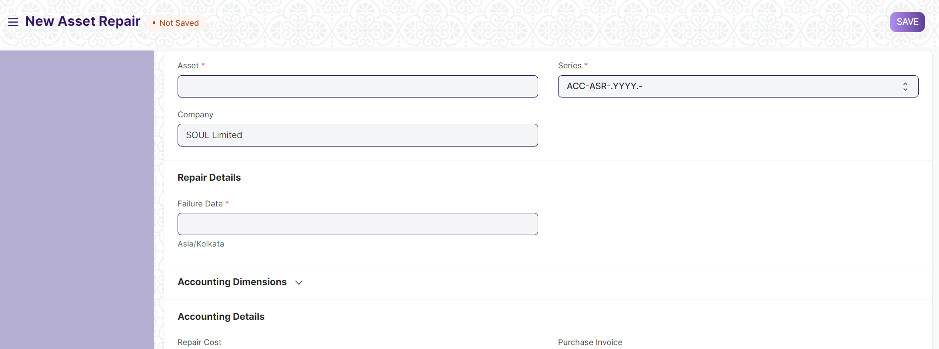

#### **35.1 Prerequisites**

* Asset

#### **35.2 How to create an Asset Repair**

1. Go to the Asset Repair list, click on New.
2. Select the Asset.
3. Select the Failure Date.
4. Enter the Repair Cost.
5. Click on Save.
6. Change the Repair Status from 'Pending' to 'Completed', or 'Canceled'.
7. Select a Purchase Invoice if Repair Cost is greater than zero.
8. Click on Save and Submit.

##### **35.2.1 Additional options when creating an Asset Repair**

* ****Capitalize Repair Cost****: If checked, the Repair Cost will be added to the Asset's value. This could also allow you to increase the Asset's life.
* ****Increase In Asset Life(Months)****: The number of months by which the Asset's life might be extended by the repair can be added here. This will modify the Depreciation Schedule of the Asset. This field will only be visible if Capitalize Repair Cost is checked.
* ****Stock Consumed During Repair****: Checking this will allow you to make a note of all the Stock Items consumed during the repair.
* ****Store****: The Store from which the Stock Items consumed during the repair were taken should be entered here, if Stock Consumed During Repair is checked.
* ****Stock Items****: Entering Stock Items consumed during the repair here will create a Stock Entry record of type Material Issue for them, thereby decreasing their quantity. GL Entries will also be created for each Item in the table. This table will only be visible if Stock Consumed During Repair is checked. In case of Serialized Items, the Item row can be expanded to reveal the Add Serial No button.
* ****Error Description****: A detailed description of the problem can be entered here.
* ****Actions Performed****: A sequence of actions performed to carry out the repair can be noted down here.

#### **35.3 Features**

##### **35.3.1 Accounting Dimensions**

Accounting Dimensions let you tag transactions based on a specific Territory, Branch, Customer, etc. This helps in viewing accounting statements separately based on the selected dimension(s).

##### **35.3.2 Purchase Invoice**

A Purchase Invoice can be linked with the Asset Repair, to account for any Items that need to be purchased to carry out the repair or the repair service offered.

##### **35.3.3 Total Repair Cost**

If Stock Consumed During Repair is checked, the Total Repair Cost will be computed based on the value of the consumed Stock Items and the Repair Cost entered.

1. ****Asset Capitalization****

The Asset Capitalization feature lets you do the following:

* Convert one or more stock items into a new asset
* Convert one or more stock items into a new asset and capitalize the service expenses cost
* Convert one or more assets into a new asset
* Convert one or more assets into a new stock item

Home > Material Management > Maintenance > Asset Capitalization

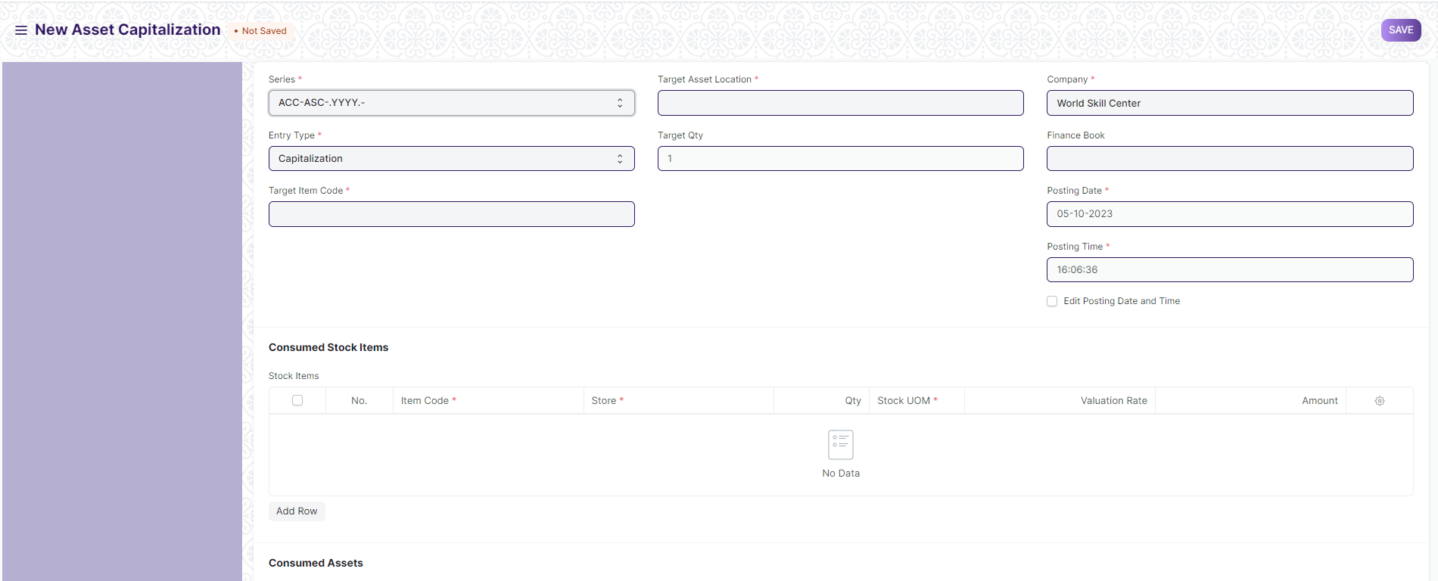

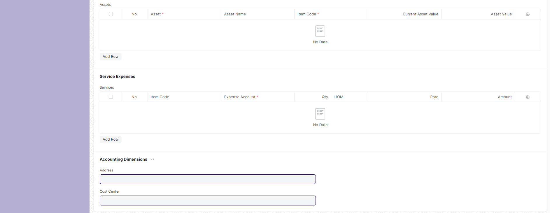

**36.1 Convert one or more stock items into a new asset**

A new fixed asset Item (with Is Fixed Asset checkbox ticked) since it would be the item linked with the new asset.

Steps:

* Create a new Asset Capitalization
* Set the Target Item Code to the Item to be linked with the new asset
* Set the Target Asset Location to the Location of the new asset
* Change the Naming Series, Company, Finance Book and Posting Date if needed
* Enter the stock items to be converted in Consumed Stock Items
* Click on Save and Submit
* Set the depreciation details (if any) of the newly created asset and submit it.

**Accounting effect:**

The Consumed Stock Items will be reduced by the selected qty from the selected Store and the Store Stock Accounts will be credited with the issued stock value amount. The Fixed Asset account of the created Asset will be debited by the Total Value.

**36.2 Convert one or more stock items into a new asset and capitalize the service expenses cost**

The prerequisites, steps and accounting effect for this is almost the same as the previous one, the only addition being that you can add the Service Expenses, and the Expense Accounts of the services would be credited with the service’s amount.

**36.3 Convert one or more assets into a new asset**

A new fixed asset Item (with Is Fixed Asset checkbox ticked) since it would be the item linked with the new asset.

Steps:

* Create a new Asset Capitalization
* Set the Target Item Code to the Item to be linked with the new asset
* Set the Target Asset Location to the Location of the new asset
* Change the Naming Series, Company, Finance Book and Posting Date if needed
* Enter the assets to be converted in Consumed Assets
* Click on Save and Submit
* Set the depreciation details (if any) of the newly created asset and submit it.

**Accounting effect:**

The Consumed Assets will be depreciated (if configured for depreciation) till the posting date and Depreciation Journal Entries will be created in the background. Then they would be disposed of and their status would be set to "Capitalized". The Fixed Asset accounts of the Consumed Assets will be credited by their gross purchase amount and the Accumulated Depreciation accounts will be debited by their total accumulated depreciation. The Fixed Asset account of the created Asset will be debited by the Total Value.

**36.4 Convert one or more assets into a new stock item**

A new stock Item (with Maintain Stock checkbox ticked) to which the

Steps:

* Create a new Asset Capitalization
* Set Entry Type to Decapitalization
* Set the Target Item Code to the new Item
* Set the Target Warehouse and Target Qty
* Change the Naming Series, Company, Finance Book and Posting Date if needed
* Enter the assets to be converted in Consumed Assets
* Click on Save and Submit
* Set the depreciation details (if any) of the newly created asset and submit it.

**Accounting effect:**

The Consumed Assets will be depreciated (if configured for depreciation) till the posting date and Depreciation Journal Entries will be created in the background. Then they would be disposed of and their status would be set to "Decapitalized". The Fixed Asset accounts of the Consumed Assets will be credited by their gross purchase amount and the Accumulated Depreciation accounts will be debited by their total accumulated depreciation. The new stock Item will be added by the Target Qty in the Target Warehouse and Target Warehouse Account will be debited by the Total Value.

1. ****Buying Settings****

Buying Settings is where you can define properties which will be applied in the Buying

module's transactions.

Home > Material Management > Settings > Buying Setting

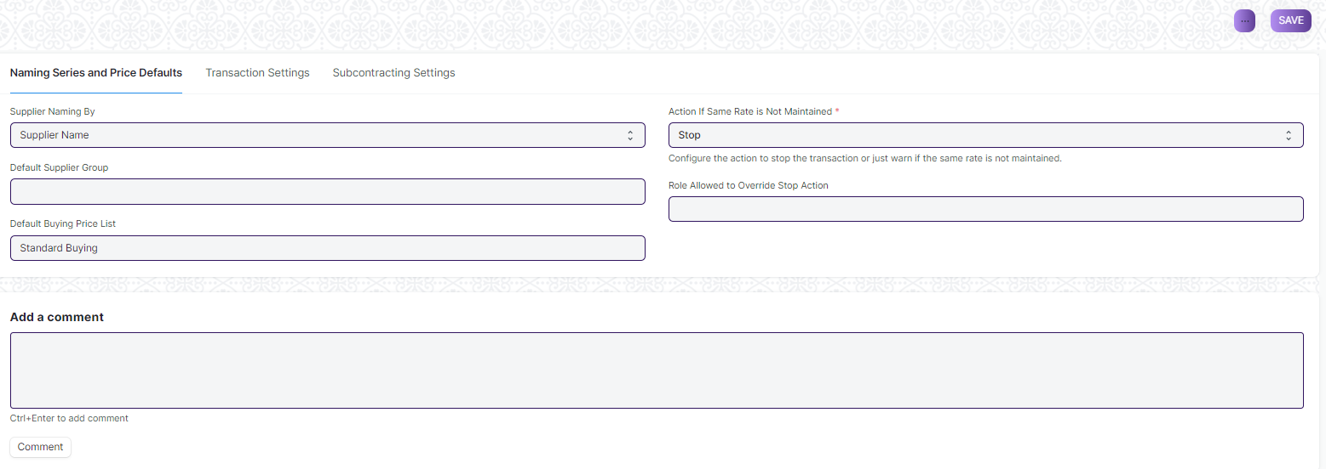

**37.1 Supplier Naming By:**

When a Supplier is saved, system generates a unique identity or name for that Supplier which can be used to refer the Supplier in various Buying transactions.

If not configured otherwise, It uses the Supplier's Name as the unique name. If you want to identify Suppliers using names like SUPP-00001, SUPP-00002, or such other patterned series, select the value of Supplier Naming By as "Naming Series".

**37.2 Default Supplier Group:**

Configure what should be the default value of Supplier Group when creating a new Supplier. For example, if most of your suppliers supply you hardware, you can set the default as 'Hardware'.

**37.3 Default Buying Price List:**

Configure what should be the default Price List when creating a new Buying transaction, the default is set as 'Standard Buying'. Item prices will be fetched from this Price List. You can modify the 'Price List' by using the arrow at the right-end of the field to change the currency and country.

**37.4 Maintain Same Rate Throughout Purchase Cycle:**

If this is enabled, It will validate whether an Item's price is changing in a Purchase Invoice or Purchase Receipt created from a Purchase Order, i.e. it will help you maintain the same rate throughout the purchase cycle.

You can configure the action that system should take if the same rate is not maintained in the "Action If Same Rate is Not Maintained" field:

* Stop: It will stop you from changing the price by throwing a message.
* Warn: The system will let you save the transaction but warn you with a message if the rate is changed.

**Note**: This field will only be visible if Maintain Same Rate Throughout Purchase Cycle is enabled.

**37.5 Set Landed Cost Based on Purchase Invoice Rate:**

If the purchase receipt rate and purchase invoice rate are not same and users wants to set the landed cost as per the purchase invoice then this feature will be useful.

Use Case

* Created Purchase Receipt for item A with rate as 100
* System has booked Stock In Hand with 100 rate
* After 2 days, user has created purchase invoice against the above purchase receipt
* After 2 days because of change in exchange rate the rate in the invoice changed to 150
* Now purchase receipt has rate 100 where as Purchase invoice has rate 150
* If you want to adjust the Stock In Hand with Purchase invoice Rate (150) then this feature will be helpful

**37.6 Allow Item to be added multiple times in a transaction :**

When this checkbox is unchecked, an item cannot be added multiple times in the same Purchase Order. However, you can still explicitly change the quantity. This is a validation checkbox for preventing accidental purchase of the same item. This can be checked for specific use cases where there are multiple sources for the same material.

1. ****Procurement & Inventory Management Department Email****

In this user maintain Procurement & Inventory Management Department Email because when user do any transaction or any thing then mail will trigger to department.

Home > Material Management > Settings > Procurement & Inventory Management Department Email

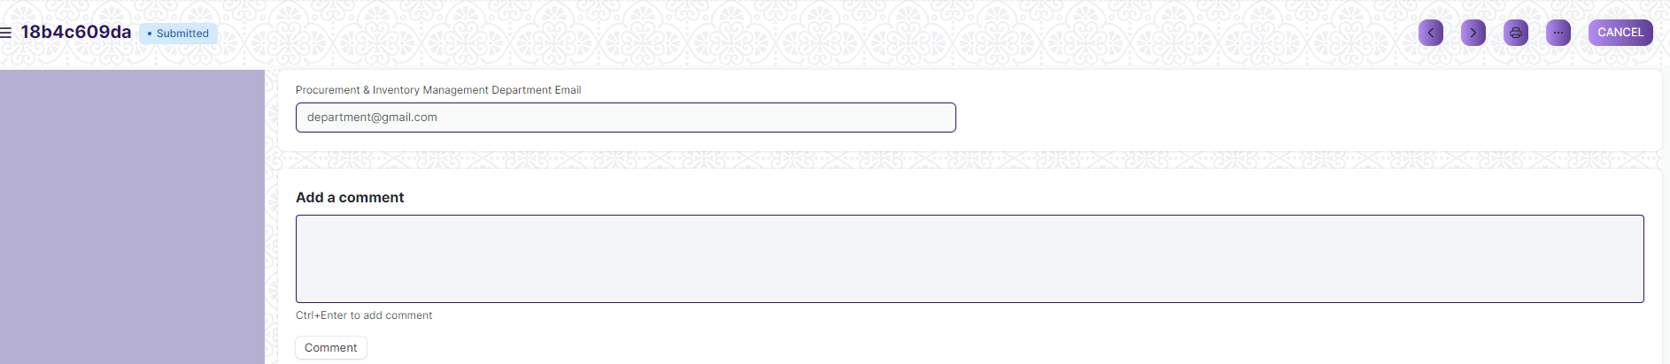

#### **38.2 How to create an Procurement & Inventory Management Department Email**

1. Go to the Procurement & Inventory Management Department Email list, click on New.
2. Enter Procurement & Inventory Management Department Email
3. Click on save and Submit.
4. ****Stock Balance****

Stock Balance report is a detailed report showing details regarding the balance of Item wise stock in different Stores.

Home>Material management>Stock Transaction>Stock Balance

Here is how Stock Balance Report looks like:

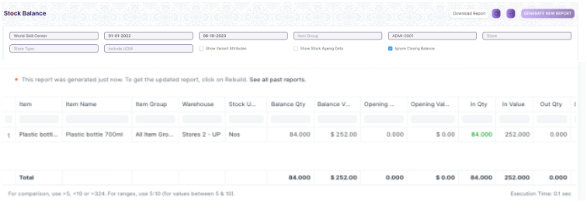

**Stock Balance Report Attributes**

* **Balance Qty:** It reflects the total no of items left in the Store.
* ****Balance Value****: It represents the total value of the remainder stock in the inventory. It is the product of Valuation Rate and Balance Quantity of a stock item.
* **Opening Qty:** It reflects Opening quantity of item in the Store during Opening stock entry.
* **Opening Value:** It represents the total value of the stock during stock opening.
* **In Qty:** It reflects total number of stocks brought to any Store.
* **In value:** It represents the total value of the stock during the In transaction.
* **Out Qty:** It reflects total number of stocks transferred from any Store.
* **Out value:** It represents the total value of the stock transferred from any Store.
* ****Valuation Rate****: It is calculated based upon the valuation method selected.
* **Reorder Level:** It reflects the total number of item that need to be checked while reordering an Item.
* **Reorder Qty:** It reflects the total number of items to be reordered.

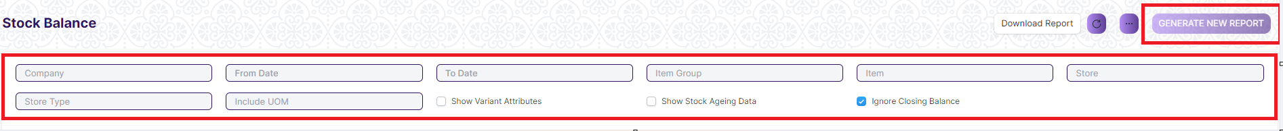

**Note**: User will filter data through given field and checkbox and Generate New Report

1. ****Stock Ledger****

**A Stock Ledger Report is a detailed record that keeps track of stock movements for a company.**

Inward or outward transactions related to Manufacturing, Purchasing, Selling, and Stock Transfers are recorded in the Stock Ledger which then is reflected in the Stock Ledger Report.

It reflects the quantity and value of stock **issued, received, or transferred** along with the stock item and its Store details.

It can be referred when the **Perpetual Inventory** system is enabled, as this report reflects the history of all your stock transactions. It presents a more granular view of the stock transactions.

**Stock Ledger Report Attributes**

* **Incoming Rate:** It reflects the actual value of the stock at which it was brought under your inventory. It reflects the same value as entered in the Rate field of the document.
* **Balance Value:** It represents the total value of the remainder stock in the inventory. It is the product of Valuation Rate and Balance Quantity of a stock item.
* **Valuation Rate:** It is calculated based upon the valuation method selected.

Home>Material management>Stock Transaction>Stock Ledger

Here is how Stock Ledger Report represents a **Stock Entry** of type Purchase Requisition.

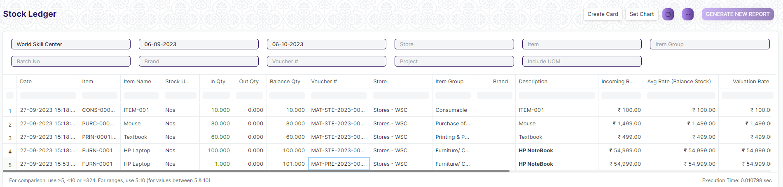

1. ****Stock Summary****

**Stock Summary report is a detailed report of Total stock present across different Stores.**

**It all Items present in different Stores, their description and current quantity.**

Home>Material management>Stock Transaction>Stock Summary

Here is how Stock Summary report looks like:

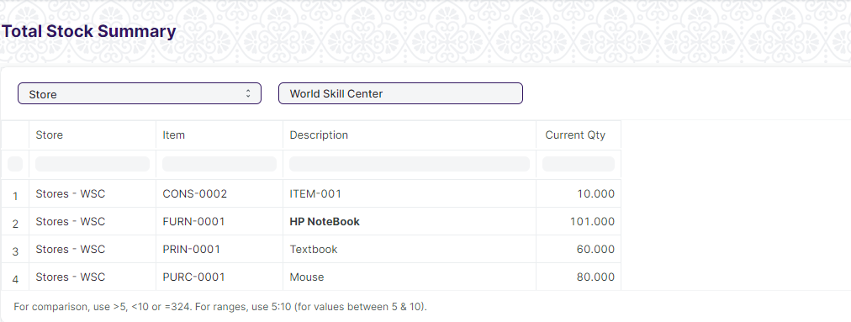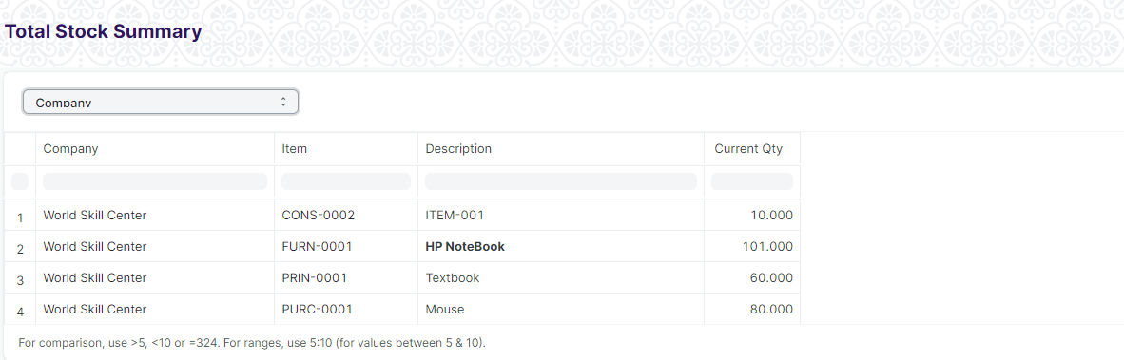

**Note**: When user select Store then all store related stock will show and when user select Company then all company stock will show

1. ****Price Impanelement Report****

Price Impanelement Report **is a detailed report of Total Item Price list**

Home>Material management>Report>Price Impanelement Report

Here is how Price Impanelement Report looks like:

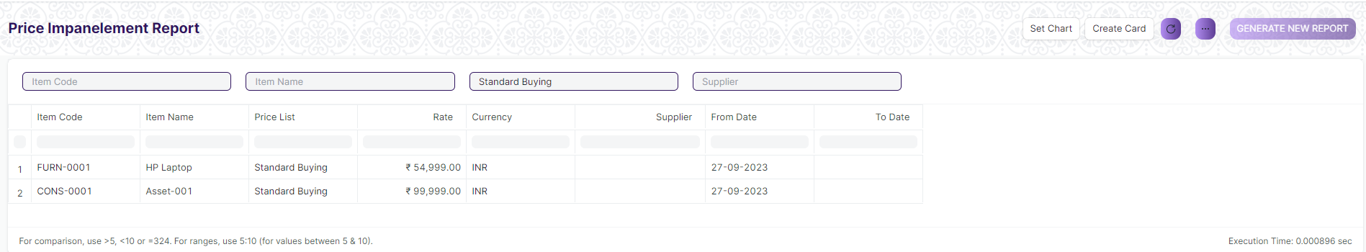

1. ****Asset Summary Report****

Asset Summary Report **is a detailed report of Total Asset list**

Home>Material management>Report>Asset Summary Report

Here is how Asset Summary Report looks like:

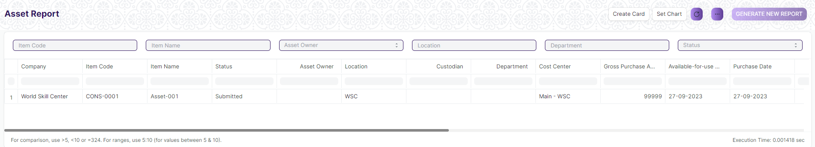

1. ****L1 Vendor Selection****

L1 Vendor Selection **is a detailed report of Purchase Requisition, Request for quotation and Supplier list**

Home>Material management>Report>L1 Vendor Selection

Here is how L1 Vendor Selection looks like:

